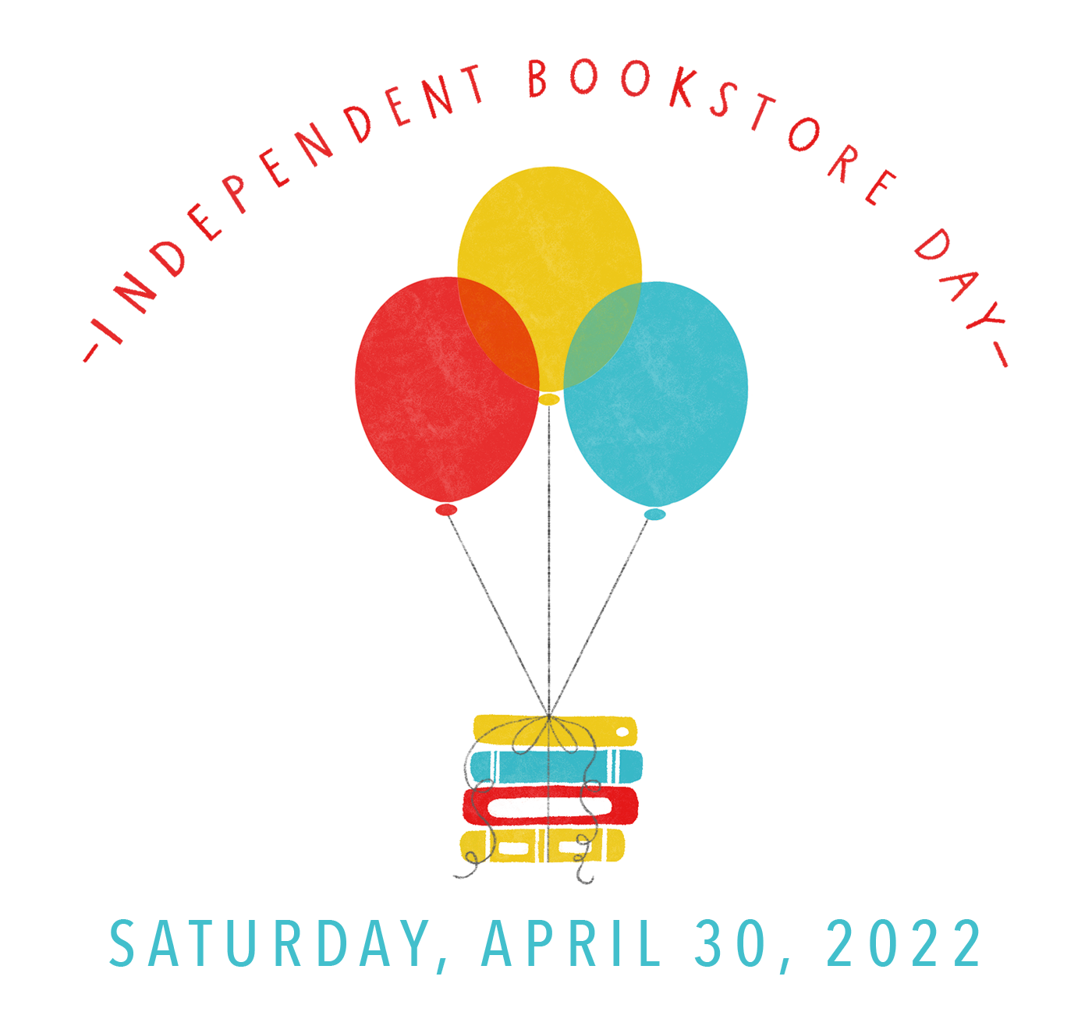
[Insert Your Name]
[Insert Bookstore Name]
[Insert email address]

Angie Thomas Selected as Ambassador for Independent Bookstores Day

Annual Day Celebrated on April 30, 2022

White Plains, NY: The American Booksellers Association (ABA) is happy to announce that Bestselling Author Angie Thomas was selected as ambassador for Independent Booksellers Day (IBD). Angie Thomas is the #1 New York Times bestselling, award-winning author of the novels The Hate U Give, On the Come Up, and Concrete Rose as well as Find Your Voice: A Guided Journal for Writing Your Truth. She is also a co-author of the New York Times bestselling novel Blackout. Angie divides her time between Atlanta and her native Mississippi. You can find her online at www.angiethomas.com.

When asked about the importance of IBD, Thomas said “Indie bookstores are the heart of our industry, and we must continue to support them in the same way that they support and champion books. With the immense impact that indie stores have made on my career, I couldn't be more honored to be the ambassador for this year’s Independent Bookstore Day.”

Independent Bookstore Day was established in 2013 to promote, celebrate, and highlight the value of the Independent bookstore community. The day has been observed on the last Saturday of April every year since 2013. This year there are 872 stores participating across the country.

[insert your bookstore information/events here]

ABOUT

The American Booksellers Association, a national not-for-profit trade organization, works with booksellers and industry partners to ensure the success and profitability of independently owned book retailers, and to assist in expanding the community of the book.

