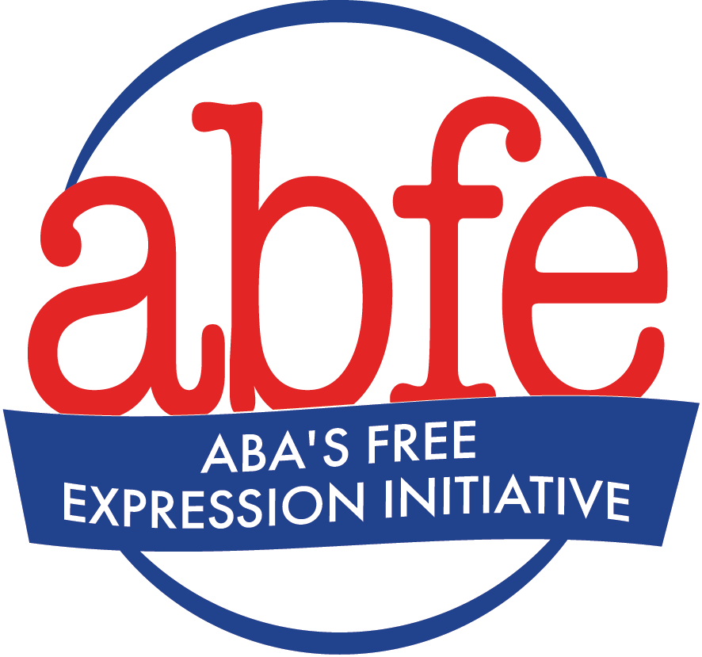

Sample Freedom of Expression, Equity, Access, and Representation, & Customer Privacy Statements

Freedom of Expression Statement
The shelves of our bookstore hold a wide array of titles containing ideas as diverse as the world in which we live. We believe a diverse selection of books is crucial to a bookstore’s role of sharing ideas to bring people together, helping individuals see themselves in the stories of others, enhancing empathy and understanding of differences, and providing diverse viewpoints to broaden perspectives. We hope we have provided a broad selection of books that make that possible for you, and we hope you support our efforts to make that possible for everyone. If you disagree with our curation, we welcome your constructive and productive feedback conducive with our values and appreciate your understanding that we won’t respond to hatred, threats, or harassment about what we carry or don’t carry or the authors we invite to speak. We trust that you will make your own decisions about which of these books you choose to read or not to read and let others do the same.

Equity, Access, and Representation/Freedom of Expression Statement
Our store has a strong commitment to diversity, equity, and inclusion that we demonstrate in a variety of ways, including ensuring representation in our inventory and equity in our business practices. At the same time, we may carry some titles that offend some people or that may seem to some people to be counter to that commitment. We believe a diverse selection of books is crucial to a bookstore’s role of sharing ideas to bring people together, helping individuals see themselves in the stories of others, enhancing empathy and understanding of differences, and providing diverse viewpoints to broaden our perspectives. If you disagree with our curation, we welcome constructive and productive feedback conducive with our values and appreciate your understanding that we won’t respond to hatred, threats, or harassment about what we carry or don’t carry or the authors we invite to speak. We believe our role is to make books available and we trust that you will make your own decisions about which of these books you choose to read or not to read and let others do the same.

Perspective-Driven Freedom of Expression Statement
Our store is committed to the following principles that inform our curation: [your own list of principles]. That means our store will not be for everyone, and we’re fine with that. We are not a library, and therefore do not have an obligation to be a public forum reflecting all viewpoints in the curation of our inventory or events. We are a private organization with a right to express ourselves and our opinions like anyone else, just as you have a right to shop where you please. If our store is for you, welcome! If it’s not, there are plenty of other great independent bookstores that might suit you better. We welcome opinions and feedback delivered respectfully and with awareness of our perspective. We do not welcome threats, harassment, intimidation, or demands to fundamentally change who we are or what we believe in. Thank you for understanding our position.

Customer Privacy Statement
We believe that it is our responsibility to respect the privacy of your choice of books, magazines, and other material. We will not sell information identifying your purchases to a third party without your permission or otherwise disclose it to anyone, including the government, on our own initiative.

