RANK | FICTION



- Funny Story
Emily Henry, Berkley, $19
- Deep End
Ali Hazelwood, Berkley, $20
- The Frozen River
Ariel Lawhon, Vintage, $18
- Martyr!
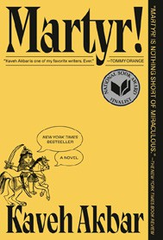

Kaveh Akbar, Vintage, $18
- Demon Copperhead
Barbara Kingsolver, Harper Perennial, $21.99
- Fourth Wing
Rebecca Yarros, Entangled: Red Tower Books, $20.99
- Parable of the Sower
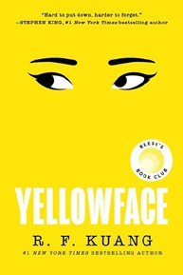

Octavia E. Butler, Grand Central, $19.99
- Orbital
Samantha Harvey, Grove Press, $17
- The Handmaid’s Tale
Margaret Atwood, Anchor, $18
- The Crash


Freida McFadden, Poisoned Pen Press, $17.99
- North Woods
Daniel Mason, Random House Trade Paperbacks, $18
- A Court of Thorns and Roses
Sarah J. Maas, Bloomsbury Publishing, $19
- The Housemaid
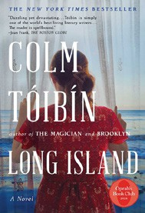

Freida McFadden, Grand Central, $12.99
- Yellowface
R. F. Kuang, William Morrow Paperbacks, $18.99
- The Berry Pickers
Amanda Peters, Catapult, $17.95
18 Long Island

Colm Tóibín, Scribner, $18.99

OTHER PAPERBACK INDIE FAVORITES
Wandering Stars: A Novel
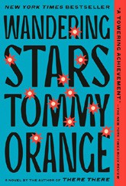

Tommy Orange, Vintage, $18
“Wandering Stars is an epic tale grounded in truth and elevated by Tommy Orange’s phenomenal storytelling. He brings a gruesome slice of US history to life and gives voice to a generation of Native people who live its legacy.”
—Claire Benedict, Bear Pond Books, Montpelier, VT
March 5, 2025
For the week ending March 2, 2025 based on sales in hundreds of independent bookstores nationwide.
PAPERBACK

RANK | NONFICTION
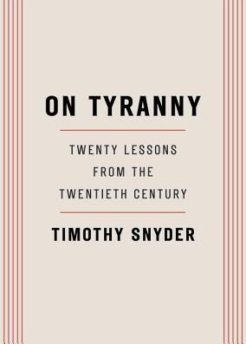
- On Tyranny: Twenty Lessons from the Twentieth Century
Timothy Snyder, Crown, $12
- The Wager: A Tale of Shipwreck, Mutiny and Murder
David Grann, Vintage, $21
- Braiding Sweetgrass
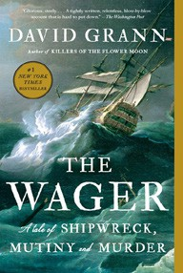

Robin Wall Kimmerer, Milkweed Editions, $20
- The Backyard Bird Chronicles
Amy Tan, Knopf, $36
- All About Love: New Visions
bell hooks, Morrow, $16.99
- The Art Thief
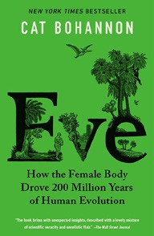

Michael Finkel, Vintage, $18
- The Body Keeps the Score
Bessel van der Kolk, M.D., Penguin, $19
- Democracy Awakening
Heather Cox Richardson, Penguin, $18

- A People’s History of the United States
Howard Zinn, Harper Perennial Modern Classics, $22.99
- Eve: How the Female Body Drove 200 Million Years of Human Evolution
Cat Bohannon, Vintage, $20
- Mutual Aid
Dean Spade, Verso, $15.95
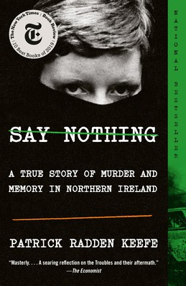

- The Hundred Years’ War on Palestine
Rashid Khalidi, Metropolitan Books, $19.99
- The Artist’s Way: 30th Anniversary Edition
Julia Cameron, TarcherPerigee, $20
- Greenlights
Matthew McConaughey, Crown, $20
- Say Nothing
Patrick Radden Keefe, Vintage, $20
Debut
On the Rise


MASS MARKET Indies Introduce
- 1984 George Orwell, Signet, $10.99
- Animal Farm George Orwell, Signet, $9.99
- The Diary of a Young Girl Anne Frank, Bantam, $8.99
- Mistborn: The Final Empire Brandon Sanderson, Tor, $10.99
- Slaughterhouse-Five Kurt Vonnegut, Laurel Leaf, $9.99
- Reacher: Persuader Lee Child, Dell, $10.99
- The Catcher in the Rye J.D. Salinger, Little, Brown, $9.99
- The Way of Kings Brandon Sanderson, Tor, $12.99
- The Exchange John Grisham, Vintage, $10.99
- I Know Why the Caged Bird Sings Maya Angelou, Ballantine, $8.99

