RANK | HARDCOVER

- The Let Them Theory: A Life-Changing Tool That Millions of People Can’t Stop Talking About
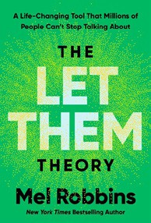



Mel Robbins, Hay House LLC, $29.99
- The Serviceberry
Robin Wall Kimmerer, John Burgoyne (Illus.), Scribner, $20

- One Day, Everyone Will Have Always Been Against This
Omar El Akkad, Knopf, $28
- How We Learn to Be Brave
Mariann Edgar Budde, Avery, $28
- Memorial Days: A Memoir

Geraldine Brooks, Viking, $28
- The Message
Ta-Nehisi Coates, One World, $30
- The Creative Act: A Way of Being
Rick Rubin, Penguin Press, $32
- I’ll Have What She’s Having
Chelsea Handler, The Dial Press, $32
- Atomic Habits


James Clear, Avery, $27
- The Sirens’ Call
Chris Hayes, Penguin Press, $32
- On the Hippie Trail
Rick Steves, Rick Steves, $30
- The Anxious Generation


Jonathan Haidt, Penguin Press, $30
- Revenge of the Tipping Point
Malcolm Gladwell, Little, Brown and Company, $32
- The Little Frog’s Guide to Self-Care
Maybell Eequay, Summersdale, $11.99
- The Harder I Fight the More I Love You
Neko Case, Grand Central Publishing, $30
March 5, 2025
For the week ending March 2, 2025 based on sales in hundreds of independent bookstores nationwide.
NONFICTION

RANK | PAPERBACK

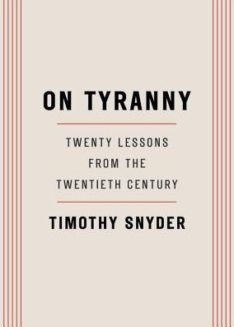
  - On Tyranny: Twenty Lessons from the Twentieth Century
Timothy Snyder, Crown, $12
  - The Wager: A Tale of Shipwreck, Mutiny and Murder
David Grann, Vintage, $21
  - Braiding Sweetgrass


Robin Wall Kimmerer, Milkweed Editions, $20
  - The Backyard Bird Chronicles
Amy Tan, Knopf, $36
  - All About Love: New Visions
bell hooks, Morrow, $16.99
  - The Art Thief


Michael Finkel, Vintage, $18
  - The Body Keeps the Score
Bessel van der Kolk, M.D., Penguin, $19
  - Democracy Awakening
Heather Cox Richardson, Penguin, $18

  - A People’s History of the United States
Howard Zinn, Harper Perennial Modern Classics, $22.99
  - Eve: How the Female Body Drove 200 Million Years of Human Evolution
Cat Bohannon, Vintage, $20
  - Mutual Aid
Dean Spade, Verso, $15.95
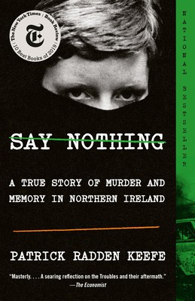

  - The Hundred Years’ War on Palestine
Rashid Khalidi, Metropolitan Books, $19.99
  - The Artist’s Way: 30th Anniversary Edition
Julia Cameron, TarcherPerigee, $20
  - Greenlights
Matthew McConaughey, Crown, $20
  - Say Nothing
Patrick Radden Keefe, Vintage, $20

Debut
On the Rise Indies Introduce

