RANK | EARLY & MIDDLE GRADE
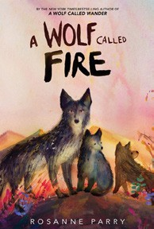
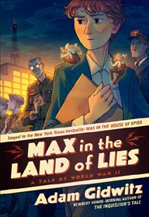


- A Wolf Called Fire
Rosanne Parry, Mónica Armiño (Illus.), Greenwillow Books, $18.99
- Impossible Creatures
Katherine Rundell, Ashley Mackenzie (Illus.), Knopf Books for Young Readers, $19.99
- Max in the Land of Lies: A Tale of World War II
Adam Gidwitz, Dutton Books for Young Readers, $18.99
- The Lost Library
Rebecca Stead, Wendy Mass, Square Fish, $8.99
- Warriors Graphic Novel #1
Erin Hunter, Natalie Riess (Illus.), Sara Goetter (Illus.), HarperAlley, $15.99
- The Squad: A Graphic Novel
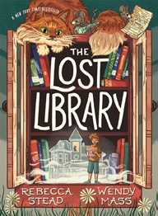

Christina Soontornvat, Joanna Cacao (Illus.), Graphix, $12.99
- Super Duper Extra Deluxe Essential Handbook (Pokémon)
Scholastic, $16.99
- Away
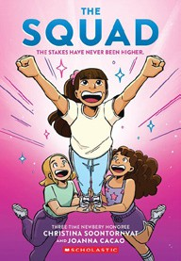

Megan E. Freeman, Aladdin, $18.99
- The Bletchley Riddle
Ruta Sepetys, Steve Sheinkin, Viking Books for Young Readers, $18.99
- Smile: A Graphic Novel
Raina Telgemeier, Graphix, $12.99
- Bluey 5-Minute Stories
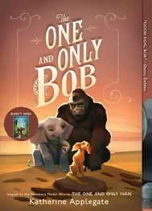

Penguin Young Readers, $14.99
- The New Girl: A Graphic Novel
Cassandra Calin, Graphix, $12.99
- The One and Only Bob
Katherine Applegate, Patricia Castelao (Illus.), Harper, $10.99
- Max in the House of Spies: A Tale of World War II
Adam Gidwitz, Dutton Books for Young Readers, $9.99
- Sisters: A Graphic Novel
Raina Telgemeier, Graphix, $12.99
March 5, 2025
For the week ending March 2, 2025 based on sales in hundreds of independent bookstores nationwide.
CHILDREN’S

RANK | YOUNG ADULT
  - Rebel Witch: The Crimson Moth: Book 2
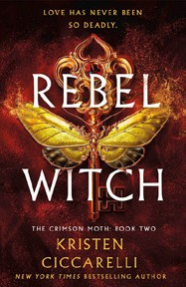

Kristen Ciccarelli, Wednesday Books, $20
  - Powerless
Lauren Roberts, Simon & Schuster Books for Young Readers, $19.99
  - Under the Same Stars
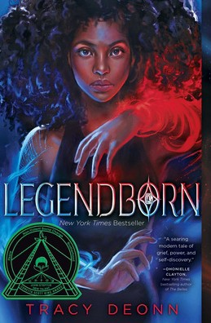

Libba Bray, Farrar, Straus and Giroux BYR, $24.99
  - Heartless Hunter: The Crimson Moth: Book 1
Kristen Ciccarelli, Wednesday Books, $20
  - Legendborn
Tracy Deonn, Margaret K. McElderry Books, $13.99
  - All Better Now
Neal Shusterman, Simon & Schuster Books for Young Readers, $21.99
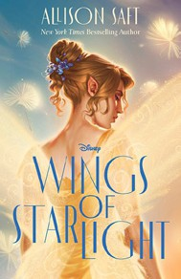

  - Heavenly Tyrant
Xiran Jay Zhao, Tundra Books, $20.99
  - If He Had Been with Me
Laura Nowlin, Sourcebooks Fire, $10.99
  - Better Than the Movies
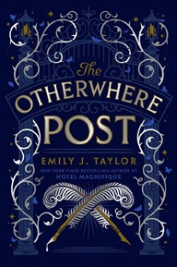

Lynn Painter, Simon & Schuster Books for Young Readers, $12.99
  - Wings of Starlight
Allison Saft, Disney Press, $18.99
  - Pride and Prejudice
Jane Austen, Anna Bond (Illus.), Puffin Books, $17
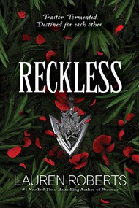
  - The Otherwhere Post
Emily J. Taylor, G.P. Putnam’s Sons Books for Young Readers, $20.99
  - The Perks of Being a Wallflower
Stephen Chbosky, MTV Books, $15.99
  - Reckless
Lauren Roberts, Simon & Schuster Books for Young Readers, $21.99
  - Iron Widow
Xiran Jay Zhao, Tundra Books, $11.99
Debut


OTHER CHILDREN’S INDIE FAVORITES
Indies Introduce

AGES 8 TO 12 TEEN READERS
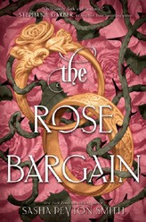

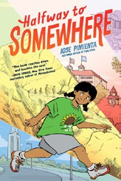

Halfway to Somewhere
Jose Pimienta, Random House Graphic, $21.99, Hardcover; $13.99,
Paperback
“Moving as a kid is always tough, but it’s even more complicated when you’re navigating a new language and new family dynamics. Halfway to Somewhere does such a great job honoring all the different facets of Ave’s experience. Strongly recommend for classrooms!”
—Milo Michels, University Book Store, Seattle, WA
The Rose Bargain
Sasha Peyton Smith, HarperCollins, $19.99
“I am obsessed with this book and cannot stop talking about it even weeks after reading it. Set in an alternate Victorian era
England, The Rose Bargain is gripping from the very first page.”
—Tara Leimkuehler, Parnassus Books, Nashville, TN

