RANK | FICTION
- James
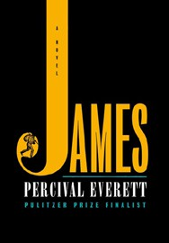



Percival Everett, Doubleday, $28
- The God of the Woods
Liz Moore, Riverhead Books, $30
- Three Days in June
Anne Tyler, Knopf, $27
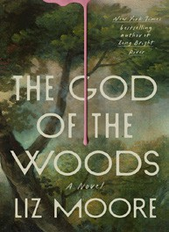
- The Wedding People
Alison Espach, Henry Holt and Co., $28.99
- Small Things Like These
Claire Keegan, Grove Press, $20
- Swordheart
T. Kingfisher, Bramble, $28.99
- Iron Flame
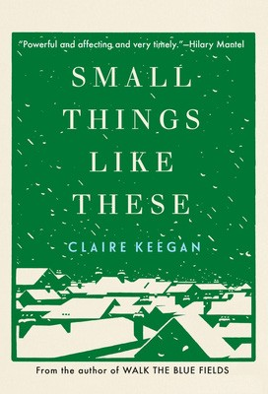

Rebecca Yarros, Entangled: Red Tower Books, $29.99
- Onyx Storm (Deluxe Limited Edition)
Rebecca Yarros, Entangled: Red Tower Books, $32.99
- Onyx Storm (Standard Edition)
Rebecca Yarros, Entangled: Red Tower Books, $29.99
- All Fours
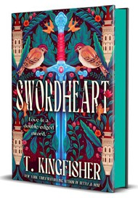

Miranda July, Riverhead Books, $29
- The Bones Beneath My Skin
TJ Klune, Tor Books, $29.99
- Witchcraft for Wayward Girls
Grady Hendrix, Berkley, $30
- The Women


Kristin Hannah, St. Martin’s Press, $30
- Isola
Allegra Goodman, The Dial Press, $28.99
- Emily Wilde’s Compendium of Lost Tales
Heather Fawcett, Del Rey, $29
March 5, 2025
For the week ending March 2, 2025 based on sales in hundreds of independent bookstores nationwide.
HARDCOVER

RANK | NONFICTION
  - The Let Them Theory: A Life-Changing Tool That Millions of People Can’t Stop Talking About
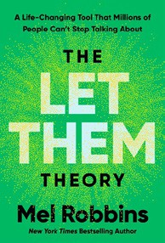

Mel Robbins, Hay House LLC, $29.99
  - The Serviceberry
Robin Wall Kimmerer, John Burgoyne (Illus.), Scribner, $20
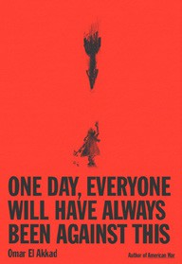
  - One Day, Everyone Will Have Always Been Against This
Omar El Akkad, Knopf, $28
  - How We Learn to Be Brave
Mariann Edgar Budde, Avery, $28
  - Memorial Days: A Memoir
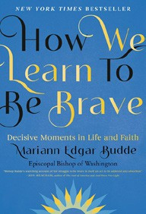
Geraldine Brooks, Viking, $28
  - The Message
Ta-Nehisi Coates, One World, $30
  - The Creative Act: A Way of Being
Rick Rubin, Penguin Press, $32
  - I’ll Have What She’s Having
Chelsea Handler, The Dial Press, $32
  - Atomic Habits


James Clear, Avery, $27
  - The Sirens’ Call
Chris Hayes, Penguin Press, $32
  - On the Hippie Trail
Rick Steves, Rick Steves, $30
  - The Anxious Generation


Jonathan Haidt, Penguin Press, $30
  - Revenge of the Tipping Point
Malcolm Gladwell, Little, Brown and Company, $32
  - The Little Frog’s Guide to Self-Care
Maybell Eequay, Summersdale, $11.99
  - The Harder I Fight the More I Love You
Neko Case, Grand Central Publishing, $30

The Garden: A Novel
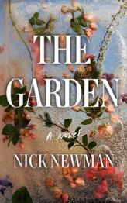

OTHER HARDCOVER INDIE FAVORITES
Mutual Interest
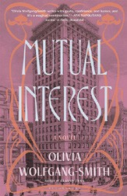

Debut
On the Rise


Indies Introduce

Nick Newman, G.P. Putnam’s Sons, $29
“This book is creepy. It has a ton of twists and turns. What is actually happening and what comes from the mother’s twisted imagination? Should the sisters keep going the way they always have, or take a look at the outside?”
—Andrea Iriarte, Molly’s Bookstore, Melrose, MA
Olivia Wolfgang-Smith, Bloomsbury Publishing, $28.99 “Using a marriage of convenience as the framework for this
layered portrait of queer love, Wolfgang-Smith’s historical fiction feels timeless yet speaks perfectly to the present. Mutual Interest feels new and unexpected in the best way.”
—David Vogel, Literati Bookstore, Ann Arbor, MI

