RANK | HARDCOVER

- James
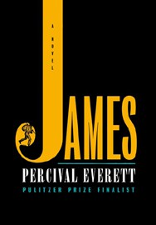



Percival Everett, Doubleday, $28
- The God of the Woods
Liz Moore, Riverhead Books, $30
- Three Days in June
Anne Tyler, Knopf, $27
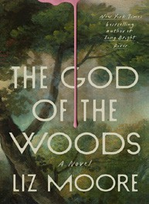
- The Wedding People
Alison Espach, Henry Holt and Co., $28.99
- Small Things Like These
Claire Keegan, Grove Press, $20
- Swordheart
T. Kingfisher, Bramble, $28.99
- Iron Flame
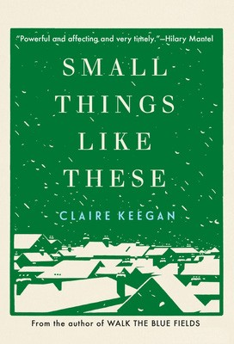

Rebecca Yarros, Entangled: Red Tower Books, $29.99
- Onyx Storm (Deluxe Limited Edition)
Rebecca Yarros, Entangled: Red Tower Books, $32.99
- Onyx Storm (Standard Edition)
Rebecca Yarros, Entangled: Red Tower Books, $29.99
- All Fours
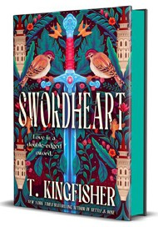

Miranda July, Riverhead Books, $29
- The Bones Beneath My Skin
TJ Klune, Tor Books, $29.99
- Witchcraft for Wayward Girls
Grady Hendrix, Berkley, $30
- The Women


Kristin Hannah, St. Martin’s Press, $30
- Isola
Allegra Goodman, The Dial Press, $28.99
- Emily Wilde’s Compendium of Lost Tales
Heather Fawcett, Del Rey, $29
March 5, 2025
For the week ending March 2, 2025 based on sales in hundreds of independent bookstores nationwide.
FICTION

RANK | PAPERBACK
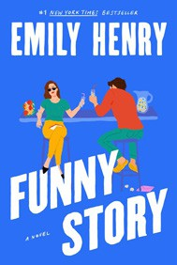
  - Funny Story
Emily Henry, Berkley, $19
  - Deep End
Ali Hazelwood, Berkley, $20
  - The Frozen River
Ariel Lawhon, Vintage, $18
  - Martyr!
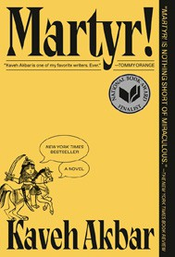

Kaveh Akbar, Vintage, $18
  - Demon Copperhead
Barbara Kingsolver, Harper Perennial, $21.99
  - Fourth Wing
Rebecca Yarros, Entangled: Red Tower Books, $20.99
  - Parable of the Sower
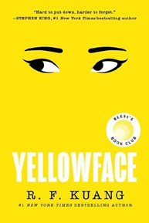

Octavia E. Butler, Grand Central, $19.99
  - Orbital
Samantha Harvey, Grove Press, $17
  - The Handmaid’s Tale
Margaret Atwood, Anchor, $18
  - The Crash


Freida McFadden, Poisoned Pen Press, $17.99
  - North Woods
Daniel Mason, Random House Trade Paperbacks, $18
  - A Court of Thorns and Roses
Sarah J. Maas, Bloomsbury Publishing, $19
  - The Housemaid
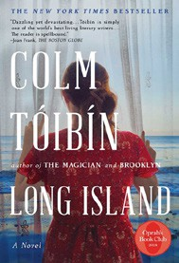

Freida McFadden, Grand Central, $12.99
  - Yellowface
R. F. Kuang, William Morrow Paperbacks, $18.99
  - The Berry Pickers
Amanda Peters, Catapult, $17.95
18 Long Island

Colm Tóibín, Scribner, $18.99

Debut
On the Rise Indies Introduce

