March 5, 2025


For the week ending March 2, 2025 based on sales in hundreds of independent bookstores nationwide.
CHILDREN’S

RANK | SERIES

RANK | ILLUSTRATED

- Goodnight Moon
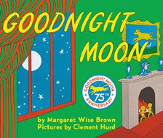

Margaret Wise Brown, Clement Hurd (Illus.), Harper,
$10.99
- The Very Hungry Caterpillar
Eric Carle, World of Eric Carle, $10.99
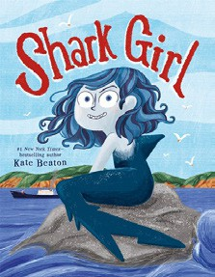
- Shark Girl
Kate Beaton, Roaring Brook Press, $18.99
- Where the Wild Things Are
Maurice Sendak, Harper, $21.99
- I Am Elphaba (Little Golden Book)
Mary Man-Kong, Elsa Chang (Illus.), Golden Books,
$5.99
- The Snowy Day
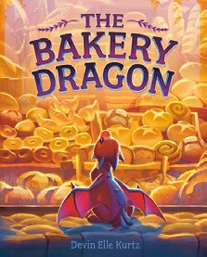

Ezra Jack Keats, Viking Books for Young Readers,
$19.99
- The Bakery Dragon
Devin Elle Kurtz, Knopf Books for Young Readers,
$18.99
- I Am Glinda (Little Golden Book)
Mary Man-Kong, Elsa Chang (Illus.), Golden Books,
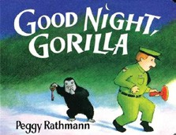

$5.99
- Girls on the Rise
Amanda Gorman, Loveis Wise (Illus.), Viking Books for Young Readers, $19.99
- Dragons Love Tacos
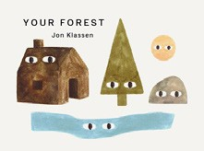
Adam Rubin, Daniel Salmieri (Illus.), Dial Books, $18.99
- Brown Bear, Brown Bear, What Do You See? Bill Martin, Jr., Eric Carle (Illus.), Henry Holt and Co. BYR, $8.99
- Good Night, Gorilla
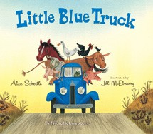

Peggy Rathmann, G.P. Putnam’s Sons Books for Young Readers, $8.99
- Knight Owl
Christopher Denise, Christy Ottaviano Books, $17.99
- Your Forest
Jon Klassen, Candlewick, $8.99
- Little Blue Truck
Alice Schertle, Jill McElmurry (Illus.), Clarion Books,
$10.99
  - Dog Man (hardcover)
Dav Pilkey, Graphix
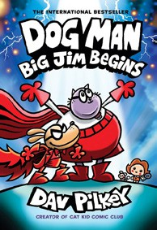

  - Wings of Fire
Tui T. Sutherland, Mike Holmes (Illus.), Scholastic
  - Diary of a Wimpy Kid (hardcover)
Jeff Kinney, Harry N. Abrams
  - InvestiGators (hardcover)
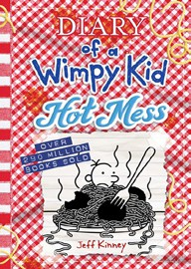

John Patrick Green, Christopher Hastings, Pat Lewis (Illus.), First Second
  - The Wild Robot
Peter Brown, Little, Brown Books for Young Readers
  - Elephant & Piggie (hardcover)
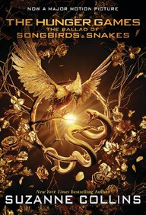

Mo Willems, Hyperion
  - The Hunger Games
Suzanne Collins, Scholastic
  - I Survived
Lauren Tarshis, Scholastic
  - Magic Tree House
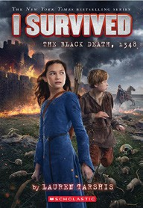

Mary Pope Osborne, Sal Murdocca (Illus.), Random House Books for Young Readers
  - Percy Jackson and the Olympians
Rick Riordan, Hyperion

All Fiction Series titles are hardcover and
paperback unless noted.
Debut


Indies Introduce

OTHER CHILDREN’S INDIE FAVORITES
AGES 4 TO 8
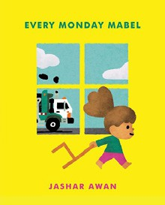

Every Monday Mabel
Jashar Awan, Simon & Schuster Books for Young Readers, $19.99 “Young children — and their parents — will surely relate to the absolute joy Mabel feels when it’s the day the garbage truck comes to her house. A delightful story beautifully illustrated.”
—Vicky Titcomb, Titcomb’s Bookshop, East Sandwich, MA

