RANK | FICTION
- Deep End
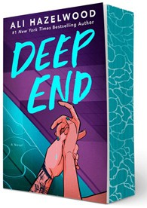



Ali Hazelwood, Berkley, $20
- Fourth Wing
Rebecca Yarros, Entangled: Red Tower Books, $20.99
- Martyr!
Kaveh Akbar, Vintage, $18
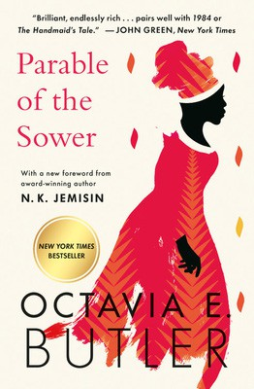
- The Frozen River
Ariel Lawhon, Vintage, $18
- Parable of the Sower
Octavia E. Butler, Grand Central, $19.99
- Demon Copperhead
Barbara Kingsolver, Harper Perennial, $21.99
- Orbital
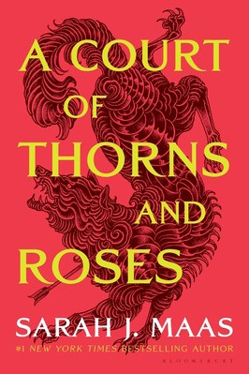

Samantha Harvey, Grove Press, $17
- North Woods
Daniel Mason, Random House Trade Paperbacks, $18
- The Crash
Freida McFadden, Poisoned Pen Press, $17.99
- A Court of Thorns and Roses
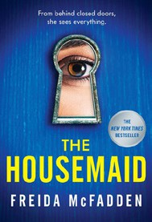

Sarah J. Maas, Bloomsbury Publishing, $19
- The Handmaid’s Tale
Margaret Atwood, Anchor, $18
- Yellowface
R. F. Kuang, William Morrow Paperbacks, $18.99
- The Housemaid


Freida McFadden, Grand Central, $12.99
- The Berry Pickers
Amanda Peters, Catapult, $17.95
- First Lie Wins
Ashley Elston, Penguin, $19
19 I Got Abducted by Aliens and Now I’m Trapped in a Rom-Com

Kimberly Lemming, Berkley, $19
February 26, 2025
For the week ending February 23, 2025 based on sales in hundreds of independent bookstores nationwide.
PAPERBACK

RANK | NONFICTION
- On Tyranny: Twenty Lessons from the Twentieth Century
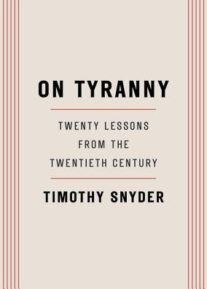

Timothy Snyder, Crown, $12
- Braiding Sweetgrass
Robin Wall Kimmerer, Milkweed Editions, $20
- The Backyard Bird Chronicles
Amy Tan, Knopf, $35
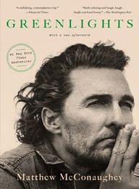

- All About Love: New Visions
bell hooks, Morrow, $16.99
- The Art Thief
Michael Finkel, Vintage, $18
- The Hundred Years’ War on Palestine
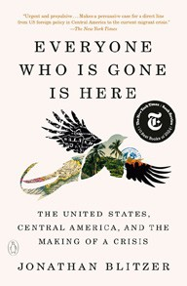
Rashid Khalidi, Metropolitan Books, $19.99
- The Body Keeps the Score
Bessel van der Kolk, M.D., Penguin, $19
- Democracy Awakening
Heather Cox Richardson, Penguin, $18
- Greenlights
Matthew McConaughey, Crown, $20
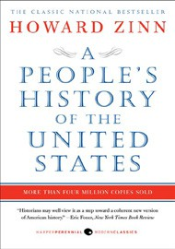

- All the Beauty in the World
Patrick Bringley, Simon & Schuster, $18.99
- Mutual Aid
Dean Spade, Verso, $15.95
- The Artist’s Way: 30th Anniversary Edition
Julia Cameron, TarcherPerigee, $20
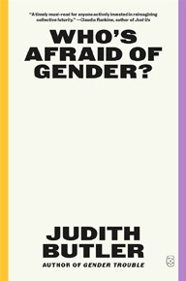

- Say Nothing
Patrick Radden Keefe, Vintage, $20
- Everyone Who Is Gone Is Here
Jonathan Blitzer, Penguin, $21
- A People’s History of the United States
Howard Zinn, Harper Perennial Modern Classics, $22.99
17 Who’s Afraid of Gender?

Judith Butler, Picador, $20

OTHER PAPERBACK INDIE FAVORITES
The Storm We Made: A Novel


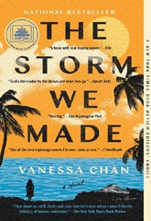

Vanessa Chan, S&S/Marysue Rucci Books, $18.99
“An incredible book from a strong new voice, focusing on the choices that a mother makes in the middle of colonial occupation during WWII. Vanessa Chan touches upon the murky grey areas of survival in a time of oppression and upheaval.”
—Jesse Hassinger, Odyssey Bookshop, South Hadley, MA
Debut
On the Rise

MASS MARKET Indies Introduce
- 1984 George Orwell, Signet, $10.99
- Animal Farm George Orwell, Signet, $9.99
- The Diary of a Young Girl Anne Frank, Bantam, $8.99
- The Way of Kings Brandon Sanderson, Tor, $12.99
- Mistborn: The Final Empire Brandon Sanderson, Tor, $10.99
- I Know Why the Caged Bird Sings Maya Angelou, Ballantine, $8.99
- Slaughterhouse-Five Kurt Vonnegut, Laurel Leaf, $9.99
- The Exchange John Grisham, Vintage, $10.99
- Resurrection Walk Michael Connelly, Little, Brown and Company, $10.99
- Reacher: Persuader Lee Child, Dell, $10.99

