RANK | HARDCOVER

- The Let Them Theory: A Life-Changing Tool That Millions of People Can’t Stop Talking About
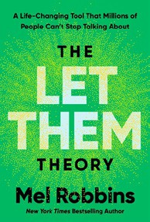



Mel Robbins, Hay House LLC, $29.99
- The Serviceberry
Robin Wall Kimmerer, John Burgoyne (Illus.), Scribner, $20
- How We Learn to Be Brave
Mariann Edgar Budde, Avery, $28


- Memorial Days: A Memoir
Geraldine Brooks, Viking, $28
- Atomic Habits
James Clear, Avery, $27
- The Creative Act: A Way of Being

Rick Rubin, Penguin Press, $32
- The Sirens’ Call
Chris Hayes, Penguin Press, $32
- Lorne: The Man Who Invented Saturday Night Live
Susan Morrison, Random House, $36
- On the Hippie Trail
Rick Steves, Rick Steves, $30


- The Message
Ta-Nehisi Coates, One World, $30
- Revenge of the Tipping Point
Malcolm Gladwell, Little, Brown and Company, $32
- The Harder I Fight the More I Love You
Neko Case, Grand Central Publishing, $30
- The Anxious Generation


Jonathan Haidt, Penguin Press, $30
- Be Ready When the Luck Happens: A Memoir
Ina Garten, Crown, $34
- Being Jewish After the Destruction of Gaza
Peter Beinart, Knopf, $26
- Jane Austen’s Bookshelf: A Rare Book Collector’s Quest to Find the

Women Writers Who Shaped a Legend
Rebecca Romney, S&S/Marysue Rucci Books, $29.99
February 26, 2025
For the week ending February 23, 2025 based on sales in hundreds of independent bookstores nationwide.
NONFICTION

RANK | PAPERBACK

  - On Tyranny: Twenty Lessons from the Twentieth Century
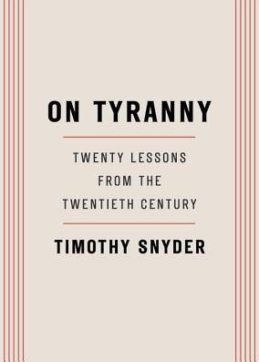

Timothy Snyder, Crown, $12
  - Braiding Sweetgrass
Robin Wall Kimmerer, Milkweed Editions, $20
  - The Backyard Bird Chronicles
Amy Tan, Knopf, $35


  - All About Love: New Visions
bell hooks, Morrow, $16.99
  - The Art Thief
Michael Finkel, Vintage, $18
  - The Hundred Years’ War on Palestine
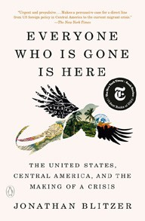
Rashid Khalidi, Metropolitan Books, $19.99
  - The Body Keeps the Score
Bessel van der Kolk, M.D., Penguin, $19
  - Democracy Awakening
Heather Cox Richardson, Penguin, $18
  - Greenlights
Matthew McConaughey, Crown, $20


  - All the Beauty in the World
Patrick Bringley, Simon & Schuster, $18.99
  - Mutual Aid
Dean Spade, Verso, $15.95
  - The Artist’s Way: 30th Anniversary Edition
Julia Cameron, TarcherPerigee, $20


  - Say Nothing
Patrick Radden Keefe, Vintage, $20
  - Everyone Who Is Gone Is Here
Jonathan Blitzer, Penguin, $21
  - A People’s History of the United States
Howard Zinn, Harper Perennial Modern Classics, $22.99
17 Who’s Afraid of Gender?

Judith Butler, Picador, $20

Debut
On the Rise Indies Introduce

