RANK | FICTION
- James




Percival Everett, Doubleday, $28
- Three Days in June
Anne Tyler, Knopf, $27
- The God of the Woods
Liz Moore, Riverhead Books, $30
- Iron Flame
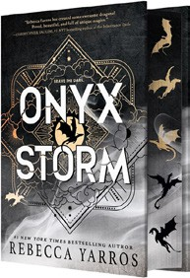

Rebecca Yarros, Entangled: Red Tower Books, $29.99
- Onyx Storm (Deluxe Limited Edition)
Rebecca Yarros, Entangled: Red Tower Books, $32.99
- Small Things Like These
Claire Keegan, Grove Press, $20
- The Wedding People
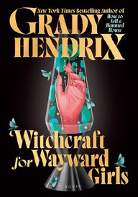

Alison Espach, Henry Holt and Co., $28.99
- Onyx Storm (Standard Edition)
Rebecca Yarros, Entangled: Red Tower Books, $29.99
- All Fours
Miranda July, Riverhead Books, $29
- Emily Wilde’s Compendium of Lost Tales
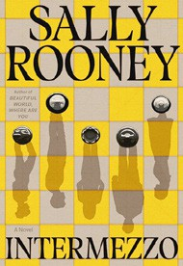

Heather Fawcett, Del Rey, $29
- The Women
Kristin Hannah, St. Martin’s Press, $30
- The Bones Beneath My Skin
TJ Klune, Tor Books, $29.99
- Witchcraft for Wayward Girls


Grady Hendrix, Berkley, $30
- Intermezzo
Sally Rooney, Farrar, Straus and Giroux, $29
- Isola
Allegra Goodman, The Dial Press, $28.99
17 Dream State

Eric Puchner, Doubleday, $28
February 26, 2025
For the week ending February 23, 2025 based on sales in hundreds of independent bookstores nationwide.
HARDCOVER

RANK | NONFICTION
- The Let Them Theory: A Life-Changing Tool That Millions of People Can’t Stop Talking About
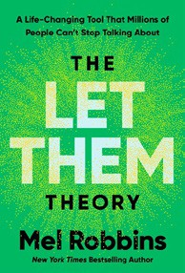

Mel Robbins, Hay House LLC, $29.99
- The Serviceberry
Robin Wall Kimmerer, John Burgoyne (Illus.), Scribner, $20
- How We Learn to Be Brave
Mariann Edgar Budde, Avery, $28
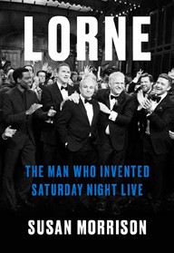

- Memorial Days: A Memoir
Geraldine Brooks, Viking, $28
- Atomic Habits
James Clear, Avery, $27
- The Creative Act: A Way of Being

Rick Rubin, Penguin Press, $32
- The Sirens’ Call
Chris Hayes, Penguin Press, $32
- Lorne: The Man Who Invented Saturday Night Live
Susan Morrison, Random House, $36
- On the Hippie Trail
Rick Steves, Rick Steves, $30


- The Message
Ta-Nehisi Coates, One World, $30
- Revenge of the Tipping Point
Malcolm Gladwell, Little, Brown and Company, $32
- The Harder I Fight the More I Love You
Neko Case, Grand Central Publishing, $30
- The Anxious Generation


Jonathan Haidt, Penguin Press, $30
- Be Ready When the Luck Happens: A Memoir
Ina Garten, Crown, $34
- Being Jewish After the Destruction of Gaza
Peter Beinart, Knopf, $26
- Jane Austen’s Bookshelf: A Rare Book Collector’s Quest to Find the

Women Writers Who Shaped a Legend
Rebecca Romney, S&S/Marysue Rucci Books, $29.99
Debut
On the Rise


OTHER HARDCOVER INDIE FAVORITES
Indies Introduce

Waiting for the Long Night Moon: Stories
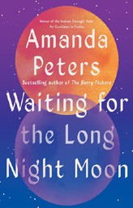

Amanda Peters, Catapult, $27
“This short story collection is filled with stunning prose, ranging chronologies, and characters that will stick with you after even the shortest vignette. A beautiful homage and moving contribution to the lineage of Indigenous storytelling.”
—Camille Thornton, The Bookshop, Nashville, TN
Beartooth
Callan Wink, Spiegel & Grau, $28
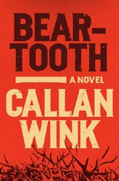

“Callan Wink has an ability to describe the look and smell of a setting like I’ve never experienced. This is the story of two brothers fighting to survive in a modern West by partaking in an illegal poaching trade. A suspenseful and timely family novel.”
—Josie Williams, Invitation Bookshop, Gig Harbor, WA

