RANK | HARDCOVER

- James




Percival Everett, Doubleday, $28
- Three Days in June
Anne Tyler, Knopf, $27
- The God of the Woods
Liz Moore, Riverhead Books, $30
- Iron Flame
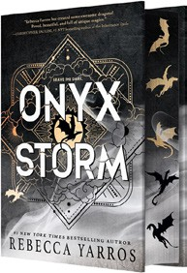

Rebecca Yarros, Entangled: Red Tower Books, $29.99
- Onyx Storm (Deluxe Limited Edition)
Rebecca Yarros, Entangled: Red Tower Books, $32.99
- Small Things Like These
Claire Keegan, Grove Press, $20
- The Wedding People


Alison Espach, Henry Holt and Co., $28.99
- Onyx Storm (Standard Edition)
Rebecca Yarros, Entangled: Red Tower Books, $29.99
- All Fours
Miranda July, Riverhead Books, $29
- Emily Wilde’s Compendium of Lost Tales
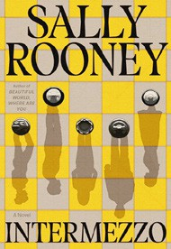

Heather Fawcett, Del Rey, $29
- The Women
Kristin Hannah, St. Martin’s Press, $30
- The Bones Beneath My Skin
TJ Klune, Tor Books, $29.99
- Witchcraft for Wayward Girls


Grady Hendrix, Berkley, $30
- Intermezzo
Sally Rooney, Farrar, Straus and Giroux, $29
- Isola
Allegra Goodman, The Dial Press, $28.99
17 Dream State

Eric Puchner, Doubleday, $28
February 26, 2025
For the week ending February 23, 2025 based on sales in hundreds of independent bookstores nationwide.
FICTION

RANK | PAPERBACK
- Deep End
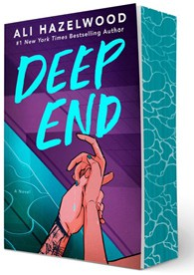

Ali Hazelwood, Berkley, $20
- Fourth Wing
Rebecca Yarros, Entangled: Red Tower Books, $20.99
- Martyr!
Kaveh Akbar, Vintage, $18
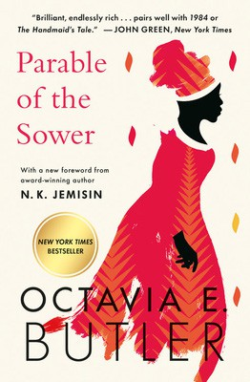
- The Frozen River
Ariel Lawhon, Vintage, $18
- Parable of the Sower
Octavia E. Butler, Grand Central, $19.99
- Demon Copperhead
Barbara Kingsolver, Harper Perennial, $21.99
- Orbital
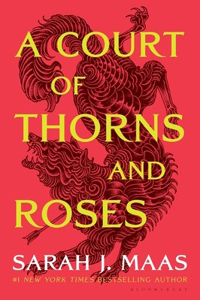

Samantha Harvey, Grove Press, $17
- North Woods
Daniel Mason, Random House Trade Paperbacks, $18
- The Crash
Freida McFadden, Poisoned Pen Press, $17.99
- A Court of Thorns and Roses
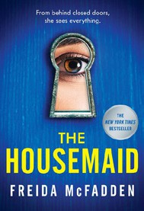

Sarah J. Maas, Bloomsbury Publishing, $19
- The Handmaid’s Tale
Margaret Atwood, Anchor, $18
- Yellowface
R. F. Kuang, William Morrow Paperbacks, $18.99
- The Housemaid


Freida McFadden, Grand Central, $12.99
- The Berry Pickers
Amanda Peters, Catapult, $17.95
- First Lie Wins
Ashley Elston, Penguin, $19
19 I Got Abducted by Aliens and Now I’m Trapped in a Rom-Com

Kimberly Lemming, Berkley, $19

Debut
On the Rise Indies Introduce

