February 26, 2025


For the week ending February 23, 2025 based on sales in hundreds of independent bookstores nationwide.
CHILDREN’S

RANK | SERIES

RANK | ILLUSTRATED

- Goodnight Moon
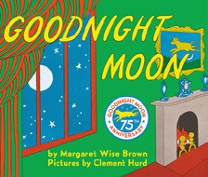

Margaret Wise Brown, Clement Hurd (Illus.), Harper,
$10.99
- The Very Hungry Caterpillar
Eric Carle, World of Eric Carle, $10.99
- Where the Wild Things Are
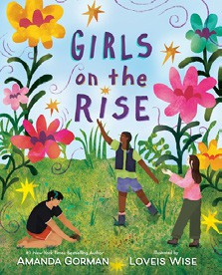

Maurice Sendak, Harper, $21.99
- I Am Elphaba (Little Golden Book)
Mary Man-Kong, Elsa Chang (Illus.), Golden Books,
$5.99
- Girls on the Rise
Amanda Gorman, Loveis Wise (Illus.), Viking Books for Young Readers, $19.99
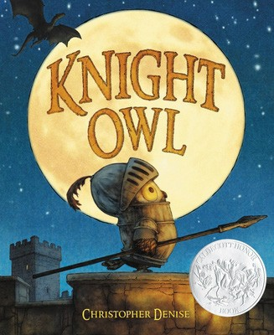

- The Bakery Dragon
Devin Elle Kurtz, Knopf Books for Young Readers,
$18.99
- I Am Glinda (Little Golden Book)
Mary Man-Kong, Elsa Chang (Illus.), Golden Books,
$5.99
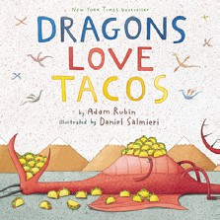

- The Snowy Day
Ezra Jack Keats, Viking Books for Young Readers,
$19.99
- Knight Owl and Early Bird
Christopher Denise, Christy Ottaviano Books, $18.99
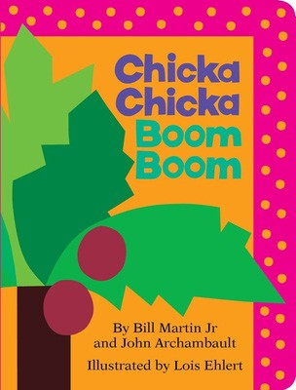

- Knight Owl
Christopher Denise, Christy Ottaviano Books, $17.99
- Brown Bear, Brown Bear, What Do You See? Bill Martin, Jr., Eric Carle (Illus.), Henry Holt and Co. BYR, $8.99
- Dragons Love Tacos
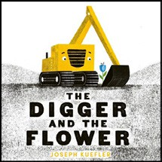

Adam Rubin, Daniel Salmieri (Illus.), Dial Books, $18.99
- Dragon’s First Taco
Adam Rubin, Daniel Salmieri (Illus.), Dial Books, $8.99
- Chicka Chicka Boom Boom
Bill Martin, Jr., John Archambault, Lois Ehlert (Illus.), Little Simon, $7.99
- The Digger and the Flower

Joseph Kuefler, HarperCollins, $10.99
  - Dog Man (hardcover)
Dav Pilkey, Graphix
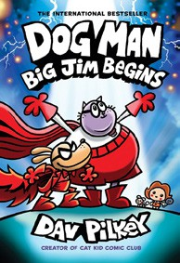

  - Diary of a Wimpy Kid (hardcover)
Jeff Kinney, Harry N. Abrams
  - InvestiGators (hardcover)
John Patrick Green, Christopher Hastings, Pat Lewis (Illus.), First Second
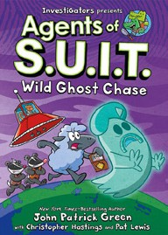

New in Series: Agents of S.U.I.T.: Wild Ghost Chase
  - Wings of Fire
Tui T. Sutherland, Mike Holmes (Illus.), Scholastic
  - The Wild Robot
Peter Brown, Little, Brown Books for Young Readers
  - Elephant & Piggie (hardcover)
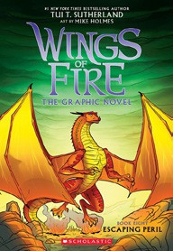

Mo Willems, Hyperion
  - The Hunger Games
Suzanne Collins, Scholastic
  - Percy Jackson and the Olympians
Rick Riordan, Hyperion
  - I Survived
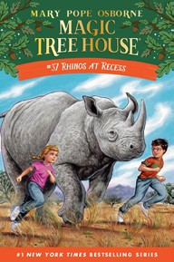

Lauren Tarshis, Scholastic
  - Magic Tree House
Mary Pope Osborne, Sal Murdocca (Illus.), Random House Books for Young Readers

All Fiction Series titles are hardcover and
paperback unless noted.
Debut


Indies Introduce

OTHER CHILDREN’S INDIE FAVORITES
AGES 4 TO 8
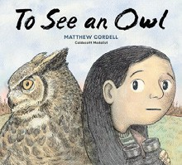

To See an Owl
Matthew Cordell, Random House Studio, $18.99
“Janie is a young birdwatcher who especially loves owls, but they’re very hard to spot. Fortunately, Janie has a lot of deter- mination and is not giving up! An inspiring story accompanied with gorgeous illustrations, perfect for the nature-lover.”
—Andrew King, Ridgecrest Books, Shoreline, WA

