RANK | FICTION
- Deep End




Ali Hazelwood, Berkley, $20
- Fourth Wing
Rebecca Yarros, Entangled: Red Tower Books, $20.99
- Martyr!
Kaveh Akbar, Vintage, $18
- The Frozen River
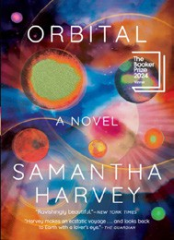

Ariel Lawhon, Vintage, $18
- Parable of the Sower
Octavia E. Butler, Grand Central, $19.99
- Demon Copperhead
Barbara Kingsolver, Harper Perennial, $21.99
- Orbital
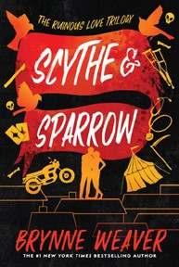

Samantha Harvey, Grove Press, $17
- The Crash
Freida McFadden, Poisoned Pen Press, $17.99
- North Woods
Daniel Mason, Random House Trade Paperbacks, $18
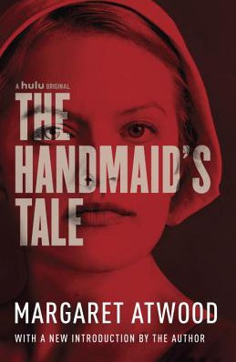
- Scythe & Sparrow
Brynne Weaver, Zando - Slowburn, $19
- A Court of Thorns and Roses
Sarah J. Maas, Bloomsbury Publishing, $19
- The Handmaid’s Tale
Margaret Atwood, Anchor, $18

- Yellowface
R. F. Kuang, William Morrow Paperbacks, $18.99
- First-Time Caller
B. K. Borison, Berkley, $19
- The Berry Pickers
Amanda Peters, Catapult, $17.95

OTHER PAPERBACK INDIE FAVORITES
Out of the Woods: A Novel


Hannah Bonam-Young, Dell, $18
“Out of the Woods is one of the best marriage-in-distress romances I have ever read. Not only do we get to see Sarah and Caleb work on things, but we also get to see where it all started. Have tissues handy — Bonam-Young’s writing is beautiful.”
—Preet Singh, Eagle Eye Book Shop, Decatur, GA
February 19, 2025
For the week ending February 16, 2025 based on sales in hundreds of independent bookstores nationwide.
PAPERBACK

RANK | NONFICTION
  - On Tyranny: Twenty Lessons from the Twentieth Century
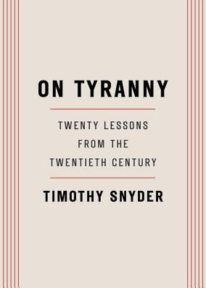

Timothy Snyder, Crown, $12
  - Braiding Sweetgrass
Robin Wall Kimmerer, Milkweed Editions, $20
  - The Backyard Bird Chronicles
Amy Tan, Knopf, $35
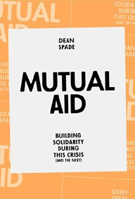

  - All About Love: New Visions
bell hooks, Morrow, $16.99
  - The Art Thief
Michael Finkel, Vintage, $18
  - The Body Keeps the Score
Bessel van der Kolk, M.D., Penguin, $19
  - Democracy Awakening
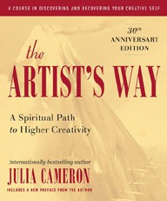

Heather Cox Richardson, Penguin, $18
  - Mutual Aid
Dean Spade, Verso, $15.95
  - The Hundred Years’ War on Palestine
Rashid Khalidi, Metropolitan Books, $19.99
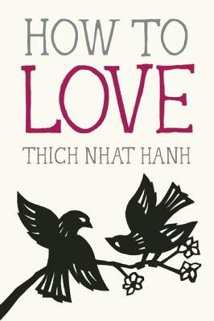
  - Say Nothing
Patrick Radden Keefe, Vintage, $20
  - Greenlights
Matthew McConaughey, Crown, $20
  - The Artist’s Way: 30th Anniversary Edition
Julia Cameron, TarcherPerigee, $20
  - All the Beauty in the World
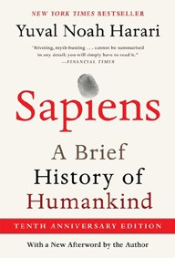
Patrick Bringley, Simon & Schuster, $18.99
  - Crying in H Mart: A Memoir
Michelle Zauner, Vintage, $17
  - How to Love (Mindfulness Essentials #3) Thich Nhat Hanh, Jason DeAntonis (Illus.), Parallax Press, $9.95
17 Sapiens (Tenth Anniversary Edition): A Brief History of Humankind

Yuval Noah Harari, Harper Perennial, $27.99
Debut
On the Rise

MASS MARKET Indies Introduce
- 1984 George Orwell, Signet, $10.99
- Animal Farm George Orwell, Signet, $9.99
- The Way of Kings Brandon Sanderson, Tor, $12.99
- Mistborn: The Final Empire Brandon Sanderson, Tor, $10.99
- The Diary of a Young Girl Anne Frank, Bantam, $8.99
- The Exchange John Grisham, Vintage, $10.99
- Reacher: Persuader Lee Child, Dell, $10.99
- Lord of the Flies William Golding, Penguin, $12
- Slaughterhouse-Five Kurt Vonnegut, Laurel Leaf, $9.99
- Resurrection Walk Michael Connelly, Little, Brown and Company, $10.99

