RANK | HARDCOVER

- The Let Them Theory: A Life-Changing Tool That Millions of People Can’t Stop Talking About
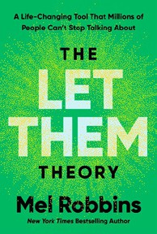



Mel Robbins, Hay House LLC, $29.99
- How We Learn to Be Brave
Mariann Edgar Budde, Avery, $28
- The Serviceberry
Robin Wall Kimmerer, John Burgoyne (Illus.), Scribner, $20


- Memorial Days: A Memoir
Geraldine Brooks, Viking, $28
- The Sirens’ Call
Chris Hayes, Penguin Press, $32
- The Message
Ta-Nehisi Coates, One World, $30
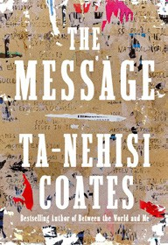

- On the Hippie Trail
Rick Steves, Rick Steves, $30
- Source Code: My Beginnings
Bill Gates, Knopf, $30
- The Harder I Fight the More I Love You
Neko Case, Grand Central Publishing, $30


- The Creative Act: A Way of Being
Rick Rubin, Penguin Press, $32
- Being Jewish After the Destruction of Gaza
Peter Beinart, Knopf, $26
- Revenge of the Tipping Point
Malcolm Gladwell, Little, Brown and Company, $32
- Atomic Habits
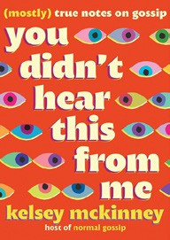

James Clear, Avery, $27
- The Anxious Generation
Jonathan Haidt, Penguin Press, $30
- Black in Blues
Imani Perry, Ecco, $28.99
17 You Didn’t Hear This From Me: (Mostly) True Notes on Gossip

Kelsey McKinney, Grand Central Publishing, $30
February 19, 2025
For the week ending February 16, 2025 based on sales in hundreds of independent bookstores nationwide.
NONFICTION

RANK | PAPERBACK

- On Tyranny: Twenty Lessons from the Twentieth Century
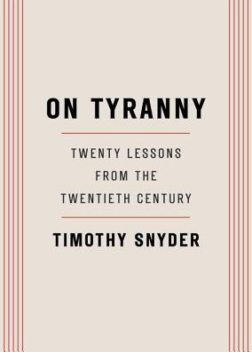

Timothy Snyder, Crown, $12
- Braiding Sweetgrass
Robin Wall Kimmerer, Milkweed Editions, $20
- The Backyard Bird Chronicles
Amy Tan, Knopf, $35


- All About Love: New Visions
bell hooks, Morrow, $16.99
- The Art Thief
Michael Finkel, Vintage, $18
- The Body Keeps the Score
Bessel van der Kolk, M.D., Penguin, $19
- Democracy Awakening


Heather Cox Richardson, Penguin, $18
- Mutual Aid
Dean Spade, Verso, $15.95
- The Hundred Years’ War on Palestine
Rashid Khalidi, Metropolitan Books, $19.99

- Say Nothing
Patrick Radden Keefe, Vintage, $20
- Greenlights
Matthew McConaughey, Crown, $20
- The Artist’s Way: 30th Anniversary Edition
Julia Cameron, TarcherPerigee, $20
- All the Beauty in the World

Patrick Bringley, Simon & Schuster, $18.99
- Crying in H Mart: A Memoir
Michelle Zauner, Vintage, $17
- How to Love (Mindfulness Essentials #3) Thich Nhat Hanh, Jason DeAntonis (Illus.), Parallax Press, $9.95
17 Sapiens (Tenth Anniversary Edition): A Brief History of Humankind

Yuval Noah Harari, Harper Perennial, $27.99

Debut
On the Rise Indies Introduce

