RANK | EARLY & MIDDLE GRADE
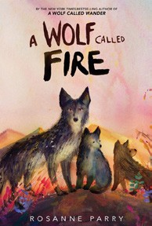


- A Wolf Called Fire
Rosanne Parry, Mónica Armiño (Illus.), Greenwillow Books, $18.99
- Impossible Creatures
Katherine Rundell, Ashley Mackenzie (Illus.), Knopf Books for Young Readers, $19.99
- Away
Megan E. Freeman, Aladdin, $18.99
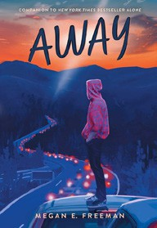

- The Squad: A Graphic Novel
Christina Soontornvat, Joanna Cacao (Illus.), Graphix, $12.99
- Warriors Graphic Novel #1
Erin Hunter, Natalie Riess (Illus.), Sara Goetter (Illus.), HarperAlley, $15.99
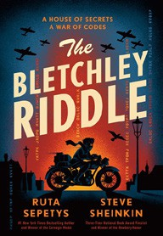

- Super Duper Extra Deluxe Essential Handbook (Pokémon)
Scholastic, $16.99
- The New Girl: A Graphic Novel
Cassandra Calin, Graphix, $12.99
- The One and Only Bob
Katherine Applegate, Patricia Castelao (Illus.), Harper, $10.99
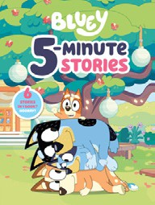

- The Bletchley Riddle
Ruta Sepetys, Steve Sheinkin, Viking Books for Young Readers, $18.99
- Bluey 5-Minute Stories
Penguin Young Readers, $14.99
- A Wrinkle in Time
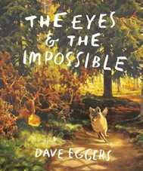

Madeleine L’Engle, Square Fish, $8.99
- Drama: A Graphic Novel
Raina Telgemeier, Graphix, $12.99
- Hatchet
Gary Paulsen, Simon & Schuster Books for Young Readers, $9.99
- The Eyes and the Impossible
Dave Eggers, Shawn Harris (Illus.), Knopf Books for Young Readers, $19.99
- Mixed-Up
Kami Garcia, Brittney Williams (Illus.), First Second, $14.99
February 19, 2025
For the week ending February 16, 2025 based on sales in hundreds of independent bookstores nationwide.
CHILDREN’S

RANK | YOUNG ADULT
  - Better Than the Movies
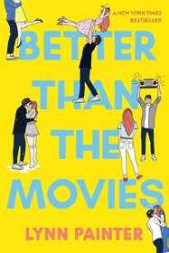

Lynn Painter, Simon & Schuster Books for Young Readers, $12.99
  - Heavenly Tyrant
Xiran Jay Zhao, Tundra Books, $20.99
  - Powerless
Lauren Roberts, Simon & Schuster Books for Young Readers, $19.99
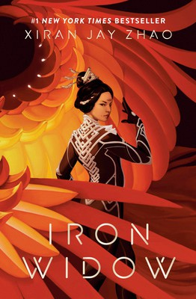

  - All Better Now
Neal Shusterman, Simon & Schuster Books for Young Readers, $21.99
  - Under the Same Stars
Libba Bray, Farrar, Straus and Giroux BYR, $24.99
  - Wings of Starlight
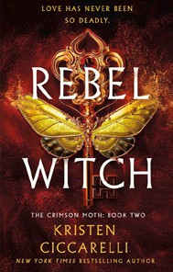

Allison Saft, Disney Press, $18.99
  - If He Had Been with Me
Laura Nowlin, Sourcebooks Fire, $10.99
  - Nothing Like the Movies
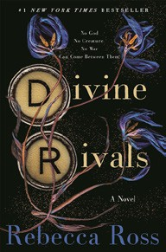

Lynn Painter, Simon & Schuster Books for Young Readers, $19.99
  - Iron Widow
Xiran Jay Zhao, Tundra Books, $11.99
  - The Perks of Being a Wallflower
Stephen Chbosky, MTV Books, $15.99
  - Legendborn
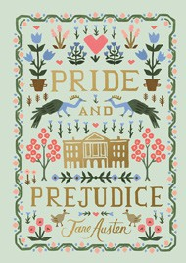
Tracy Deonn, Margaret K. McElderry Books, $13.99
  - The Giver
Lois Lowry, Clarion Books, $11.99
  - Rebel Witch: The Crimson Moth: Book 2
Kristen Ciccarelli, Wednesday Books, $20
  - Divine Rivals
Rebecca Ross, Wednesday Books, $18.99
  - Pride and Prejudice
Jane Austen, Anna Bond (Illus.), Puffin Books, $17

Debut


OTHER CHILDREN’S INDIE FAVORITES ^{Indies} ^{Introduce}
AGES 8 TO 12 TEEN READERS
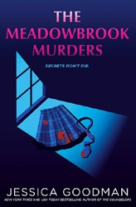

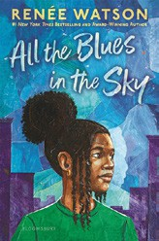

All the Blues in the Sky
Renée Watson, Bloomsbury Children’s Books, $17.99
“The story of a young girl haunted by the grief of losing her best friend. Sage navigates daily life without her friend and the guilt she feels for her part in her friend’s death. A beautiful novel in verse showing us it is ok to be sad on the long journey to hope and healing.”
—Rayna Nielsen, Blue Cypress Books, New Orleans, LA
The Meadowbrook Murders
Jessica Goodman, G.P. Putnam’s Sons Books for Young Readers, $19.99
“This twisty private school mystery centers on a young couple found murdered in a dorm room. We follow a student reporter and the victim’s roommate as they try to put the pieces together and solve the crime. Excellent!”
—Suzanna Hermans, Oblong Books, Millerton, NY

