RANK | FICTION
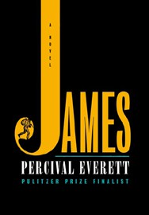


- James
Percival Everett, Doubleday, $28
- Emily Wilde’s Compendium of Lost Tales
Heather Fawcett, Del Rey, $29
- Three Days in June
Anne Tyler, Knopf, $27
- Onyx Storm (Deluxe Limited Edition)
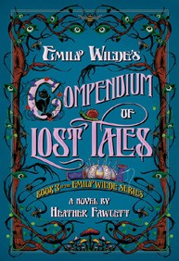

Rebecca Yarros, Entangled: Red Tower Books, $32.99
- The God of the Woods
Liz Moore, Riverhead Books, $30
- The Wedding People
Alison Espach, Henry Holt and Co., $28.99
- Onyx Storm (Standard Edition)
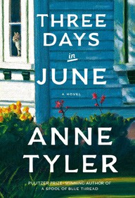

Rebecca Yarros, Entangled: Red Tower Books, $29.99
- The Bones Beneath My Skin
TJ Klune, Tor Books, $29.99
- Iron Flame
Rebecca Yarros, Entangled: Red Tower Books, $29.99
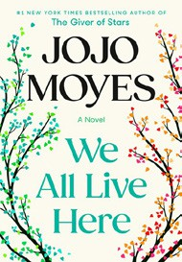
- Small Things Like These
Claire Keegan, Grove Press, $20
- All Fours
Miranda July, Riverhead Books, $29
- Witchcraft for Wayward Girls
Grady Hendrix, Berkley, $30

- We All Live Here
Jojo Moyes, Pamela Dorman Books, $30
- The Women
Kristin Hannah, St. Martin’s Press, $30
- Isola
Allegra Goodman, The Dial Press, $28.99
17 Victorian Psycho

Virginia Feito, Liveright, $24.99
February 19, 2025
For the week ending February 16, 2025 based on sales in hundreds of independent bookstores nationwide.
HARDCOVER

RANK | NONFICTION
- The Let Them Theory: A Life-Changing Tool That Millions of People Can’t Stop Talking About
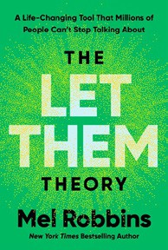

Mel Robbins, Hay House LLC, $29.99
- How We Learn to Be Brave
Mariann Edgar Budde, Avery, $28
- The Serviceberry
Robin Wall Kimmerer, John Burgoyne (Illus.), Scribner, $20
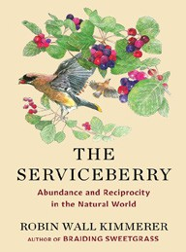

- Memorial Days: A Memoir
Geraldine Brooks, Viking, $28
- The Sirens’ Call
Chris Hayes, Penguin Press, $32
- The Message
Ta-Nehisi Coates, One World, $30
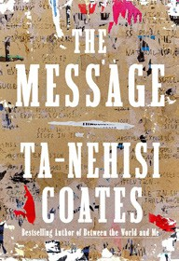

- On the Hippie Trail
Rick Steves, Rick Steves, $30
- Source Code: My Beginnings
Bill Gates, Knopf, $30
- The Harder I Fight the More I Love You
Neko Case, Grand Central Publishing, $30


- The Creative Act: A Way of Being
Rick Rubin, Penguin Press, $32
- Being Jewish After the Destruction of Gaza
Peter Beinart, Knopf, $26
- Revenge of the Tipping Point
Malcolm Gladwell, Little, Brown and Company, $32
- Atomic Habits
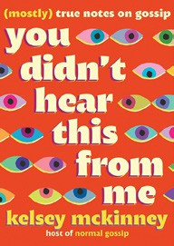

James Clear, Avery, $27
- The Anxious Generation
Jonathan Haidt, Penguin Press, $30
- Black in Blues
Imani Perry, Ecco, $28.99
17 You Didn’t Hear This From Me: (Mostly) True Notes on Gossip

Kelsey McKinney, Grand Central Publishing, $30
Debut
On the Rise

OTHER HARDCOVER INDIE FAVORITES
Indies Introduce

A Forty Year Kiss: A Novel


Nickolas Butler, Sourcebooks Landmark, $27.99
“Can a love be rekindled after forty years? Charlie has been living with regrets since the ending of his first marriage to Vivian. He arranges a meeting to find out if she’s still the one. A Forty Year Kiss is a tale of love, hope, and change.”
—Mary McBride, Monstera’s Books, Overland Park, KS
The Lamb: A Novel
Lucy Rose, Harper, $27.99
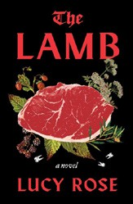

“A coming-of-age story meets the cabin-in-the-woods cannibalism trope. The senses are engaged for a moody, atmospheric ride spattered in blood and rot as Margot makes sense in a world of neglectful trauma and relative isolation.”
—Danielle Smith, Auntie’s Bookstore, Spokane, WA

