RANK | HARDCOVER




- James
Percival Everett, Doubleday, $28
- Emily Wilde’s Compendium of Lost Tales
Heather Fawcett, Del Rey, $29
- Three Days in June
Anne Tyler, Knopf, $27
- Onyx Storm (Deluxe Limited Edition)
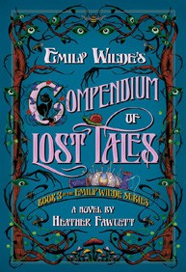

Rebecca Yarros, Entangled: Red Tower Books, $32.99
- The God of the Woods
Liz Moore, Riverhead Books, $30
- The Wedding People
Alison Espach, Henry Holt and Co., $28.99
- Onyx Storm (Standard Edition)
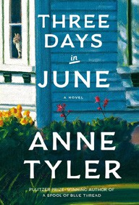

Rebecca Yarros, Entangled: Red Tower Books, $29.99
- The Bones Beneath My Skin
TJ Klune, Tor Books, $29.99
- Iron Flame
Rebecca Yarros, Entangled: Red Tower Books, $29.99
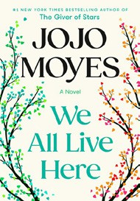
- Small Things Like These
Claire Keegan, Grove Press, $20
- All Fours
Miranda July, Riverhead Books, $29
- Witchcraft for Wayward Girls
Grady Hendrix, Berkley, $30

- We All Live Here
Jojo Moyes, Pamela Dorman Books, $30
- The Women
Kristin Hannah, St. Martin’s Press, $30
- Isola
Allegra Goodman, The Dial Press, $28.99
17 Victorian Psycho

Virginia Feito, Liveright, $24.99
February 19, 2025
For the week ending February 16, 2025 based on sales in hundreds of independent bookstores nationwide.
FICTION

RANK | PAPERBACK
- Deep End
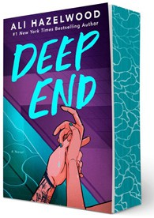

Ali Hazelwood, Berkley, $20
- Fourth Wing
Rebecca Yarros, Entangled: Red Tower Books, $20.99
- Martyr!
Kaveh Akbar, Vintage, $18
- The Frozen River
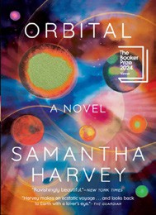

Ariel Lawhon, Vintage, $18
- Parable of the Sower
Octavia E. Butler, Grand Central, $19.99
- Demon Copperhead
Barbara Kingsolver, Harper Perennial, $21.99
- Orbital
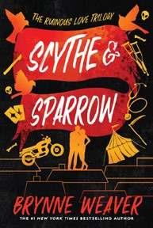

Samantha Harvey, Grove Press, $17
- The Crash
Freida McFadden, Poisoned Pen Press, $17.99
- North Woods
Daniel Mason, Random House Trade Paperbacks, $18
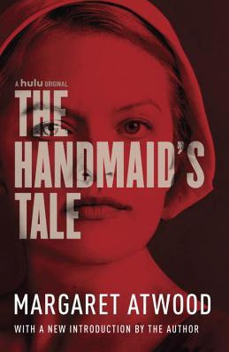
- Scythe & Sparrow
Brynne Weaver, Zando - Slowburn, $19
- A Court of Thorns and Roses
Sarah J. Maas, Bloomsbury Publishing, $19
- The Handmaid’s Tale
Margaret Atwood, Anchor, $18

- Yellowface
R. F. Kuang, William Morrow Paperbacks, $18.99
- First-Time Caller
B. K. Borison, Berkley, $19
- The Berry Pickers
Amanda Peters, Catapult, $17.95

Debut
On the Rise Indies Introduce

