February 19, 2025


For the week ending February 16, 2025 based on sales in hundreds of independent bookstores nationwide.
CHILDREN’S

RANK | SERIES

RANK | ILLUSTRATED

- Goodnight Moon
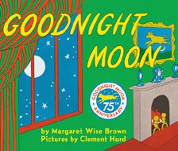

Margaret Wise Brown, Clement Hurd (Illus.), Harper,
$10.99
- Little Blue Truck’s Valentine
Alice Schertle, Jill McElmurry (Illus.), Clarion Books,
$13.99
- The Very Hungry Caterpillar
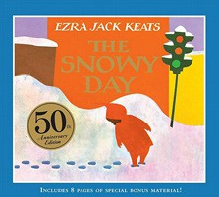

Eric Carle, World of Eric Carle, $10.99
- Girls on the Rise
Amanda Gorman, Loveis Wise (Illus.), Viking Books for Young Readers, $19.99
- The Snowy Day
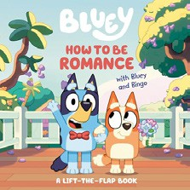

Ezra Jack Keats, Viking Books for Young Readers,
$19.99
- How to Be Romance with Bluey and Bingo
Penguin Young Readers, $9.99
- The Bakery Dragon
Devin Elle Kurtz, Knopf Books for Young Readers,
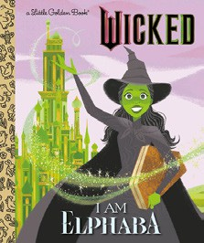

$18.99
- I Am Elphaba (Little Golden Book)
Mary Man-Kong, Elsa Chang (Illus.), Golden Books,
$5.99
- Where the Wild Things Are
Maurice Sendak, Harper, $21.99
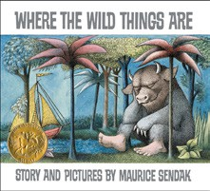
- I Am Glinda (Little Golden Book)
Mary Man-Kong, Elsa Chang (Illus.), Golden Books,
$5.99
- Knight Owl and Early Bird
Christopher Denise, Christy Ottaviano Books, $18.99
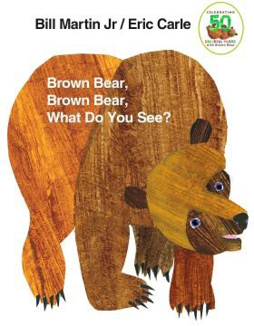
- Little Love Songs
Sandra Boynton, Boynton Bookworks, $14.99
- I Spy Love
Walter Wick (Illus.), Dan Marzollo, Dave Marzollo, Cartwheel Books, $14.99
- The Very Hungry Caterpillar’s Peekaboo Valentine
Eric Carle, World of Eric Carle, $9.99
- Brown Bear, Brown Bear, What Do You See? Bill Martin, Jr., Eric Carle (Illus.), Henry Holt and Co. BYR, $8.99
  - Dog Man (hardcover)
Dav Pilkey, Graphix
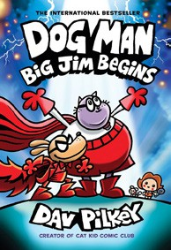

  - Diary of a Wimpy Kid (hardcover)
Jeff Kinney, Harry N. Abrams
  - Wings of Fire
Tui T. Sutherland, Mike Holmes (Illus.), Scholastic
  - The Wild Robot
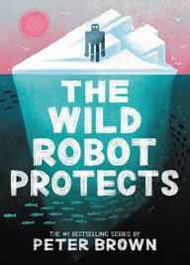

Peter Brown, Little, Brown Books for Young Readers
  - Elephant & Piggie (hardcover)
Mo Willems, Hyperion
  - InvestiGators (hardcover)
John Patrick Green, First Second
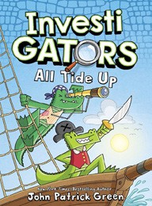

  - The Hunger Games
Suzanne Collins, Scholastic
  - I Survived
Lauren Tarshis, Scholastic
  - Percy Jackson and the Olympians
Rick Riordan, Hyperion
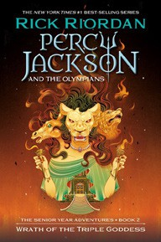

  - Magic Tree House
Mary Pope Osborne, Sal Murdocca (Illus.), Random House Books for Young Readers

All Fiction Series titles are hardcover and
paperback unless noted.
Debut


Indies Introduce

OTHER CHILDREN’S INDIE FAVORITES
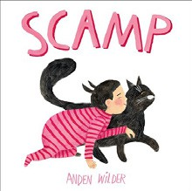
AGES 4 TO 8
Scamp
Anden Wilder, Little, Brown Books for Young Readers, $18.99 “A delight from first page to last. This joyous, beautifully illustrated cat tale jumps off the page with true-to-life emotions. A new side of the story lends freshness to this simple tale told oh-so well! Meow!”
—Maureen Palacios, Once Upon a Time, Montrose, CA

