RANK | FICTION



- Deep End
Ali Hazelwood, Berkley, $20
- Fourth Wing
Rebecca Yarros, Entangled: Red Tower Books, $20.99
- Martyr!
Kaveh Akbar, Vintage, $18
- The Frozen River
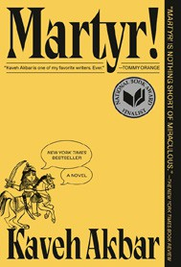

Ariel Lawhon, Vintage, $18
- Parable of the Sower
Octavia E. Butler, Grand Central, $19.99
- Orbital
Samantha Harvey, Grove Press, $17
- Demon Copperhead


Barbara Kingsolver, Harper Perennial, $21.99
- The Crash
Freida McFadden, Poisoned Pen Press, $17.99
- Yellowface
R. F. Kuang, William Morrow Paperbacks, $18.99
- A Court of Thorns and Roses


Sarah J. Maas, Bloomsbury Publishing, $19
- The Handmaid’s Tale
Margaret Atwood, Anchor, $18
- The Housemaid
Freida McFadden, Grand Central, $12.99

- North Woods
Daniel Mason, Random House Trade Paperbacks, $18
- The Berry Pickers
Amanda Peters, Catapult, $17.95
- First Lie Wins
Ashley Elston, Penguin, $19

OTHER PAPERBACK INDIE FAVORITES
elseship: an unrequited affair


Tree Abraham, Soft Skull, $19.95
“Tree Abraham’s elseship recounts a tale of unrequited love between her and her housemate via striking prose and mixed media visuals. This book serves as both an emotional autopsy of the heart and a case study of true unconditional love.”
—Emma Fong, Books Inc., San Francisco, CA
February 12, 2025
For the week ending February 9, 2025 based on sales in hundreds of independent bookstores nationwide.
PAPERBACK

RANK | NONFICTION
  - On Tyranny: Twenty Lessons from the Twentieth Century
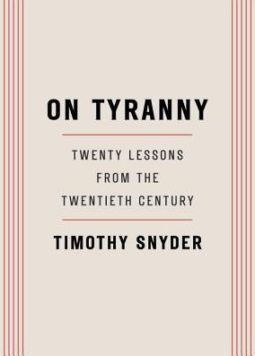

Timothy Snyder, Crown, $12
  - Braiding Sweetgrass
Robin Wall Kimmerer, Milkweed Editions, $20
  - The Backyard Bird Chronicles
Amy Tan, Knopf, $35


  - All About Love: New Visions
bell hooks, Morrow, $16.99
  - The Art Thief
Michael Finkel, Vintage, $18
  - The Hundred Years’ War on Palestine: A History of Settler Colonialism and Resistance, 1917—2017
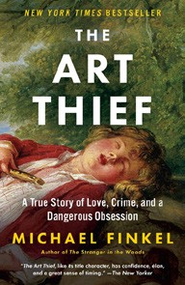

Rashid Khalidi, Metropolitan Books, $19.99
  - The Body Keeps the Score
Bessel van der Kolk, M.D., Penguin, $19
  - Say Nothing
Patrick Radden Keefe, Vintage, $20
  - Democracy Awakening


Heather Cox Richardson, Penguin, $18
  - Everyone Who Is Gone Is Here
Jonathan Blitzer, Penguin, $21
  - Mutual Aid: Building Solidarity During This Crisis (and the Next)
Dean Spade, Verso, $15.95


  - Love in a F*cked-Up World
Dean Spade, Algonquin Books, $19.99
  - Greenlights
Matthew McConaughey, Crown, $20
  - All the Beauty in the World
Patrick Bringley, Simon & Schuster, $18.99
  - Crying in H Mart: A Memoir
Michelle Zauner, Vintage, $17 Debut
On the Rise

MASS MARKET Indies Introduce
- 1984 George Orwell, Signet, $10.99
- Animal Farm George Orwell, Signet, $9.99
- The Diary of a Young Girl Anne Frank, Bantam, $8.99
- Mistborn: The Final Empire Brandon Sanderson, Tor, $10.99
- Reacher: Persuader Lee Child, Dell, $10.99

- The Way of Kings Brandon Sanderson, Tor, $12.99
- The Exchange John Grisham, Vintage, $10.99
- Lord of the Flies William Golding, Penguin, $12
- Slaughterhouse-Five Kurt Vonnegut, Laurel Leaf, $9.99
- Simply Lies David Baldacci, Grand Central, $10.99

