RANK | HARDCOVER

- The Let Them Theory: A Life-Changing Tool That Millions of People Can’t Stop Talking About
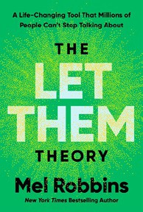



Mel Robbins, Hay House LLC, $29.99
- The Serviceberry
Robin Wall Kimmerer, John Burgoyne (Illus.), Scribner, $20
- Memorial Days: A Memoir

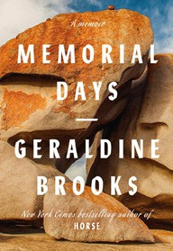
Geraldine Brooks, Viking, $28
- The Sirens’ Call
Chris Hayes, Penguin Press, $32
- Source Code: My Beginnings
Bill Gates, Knopf, $30
- The Harder I Fight the More I Love You
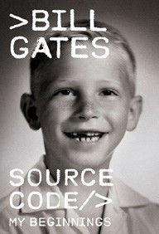
Neko Case, Grand Central Publishing, $30
- On the Hippie Trail: Istanbul to Kathmandu and the Making of a Travel Writer
Rick Steves, Rick Steves, $30
- The Message
Ta-Nehisi Coates, One World, $30
- The Creative Act: A Way of Being
Rick Rubin, Penguin Press, $32


- Being Jewish After the Destruction of Gaza: A Reckoning
Peter Beinart, Knopf, $26
- Atomic Habits
James Clear, Avery, $27
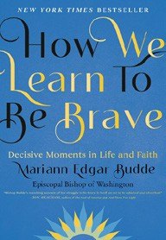
- How We Learn to Be Brave: Decisive Moments in Life and Faith
Mariann Edgar Budde, Avery, $28
- Revenge of the Tipping Point
Malcolm Gladwell, Little, Brown and Company, $32
- The Anxious Generation
Jonathan Haidt, Penguin Press, $30
- Black in Blues
Imani Perry, Ecco, $28.99
February 12, 2025
For the week ending February 9, 2025 based on sales in hundreds of independent bookstores nationwide.
NONFICTION

RANK | PAPERBACK

  - On Tyranny: Twenty Lessons from the Twentieth Century
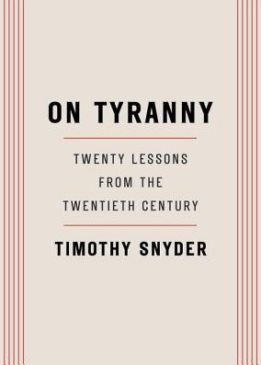

Timothy Snyder, Crown, $12
  - Braiding Sweetgrass
Robin Wall Kimmerer, Milkweed Editions, $20
  - The Backyard Bird Chronicles
Amy Tan, Knopf, $35


  - All About Love: New Visions
bell hooks, Morrow, $16.99
  - The Art Thief
Michael Finkel, Vintage, $18
  - The Hundred Years’ War on Palestine: A History of Settler Colonialism and Resistance, 1917—2017
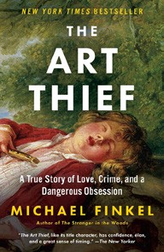

Rashid Khalidi, Metropolitan Books, $19.99
  - The Body Keeps the Score
Bessel van der Kolk, M.D., Penguin, $19
  - Say Nothing
Patrick Radden Keefe, Vintage, $20
  - Democracy Awakening


Heather Cox Richardson, Penguin, $18
  - Everyone Who Is Gone Is Here
Jonathan Blitzer, Penguin, $21
  - Mutual Aid: Building Solidarity During This Crisis (and the Next)
Dean Spade, Verso, $15.95


  - Love in a F*cked-Up World
Dean Spade, Algonquin Books, $19.99
  - Greenlights
Matthew McConaughey, Crown, $20
  - All the Beauty in the World
Patrick Bringley, Simon & Schuster, $18.99
  - Crying in H Mart: A Memoir
Michelle Zauner, Vintage, $17

Debut
On the Rise Indies Introduce

