RANK | EARLY & MIDDLE GRADE
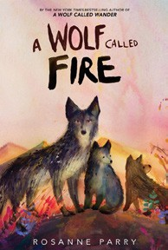


- A Wolf Called Fire
Rosanne Parry, Mónica Armiño (Illus.), Greenwillow Books, $18.99
- Impossible Creatures
Katherine Rundell, Ashley Mackenzie (Illus.), Knopf Books for Young Readers, $19.99
- The Squad: A Graphic Novel
Christina Soontornvat, Joanna Cacao (Illus.), Graphix, $12.99
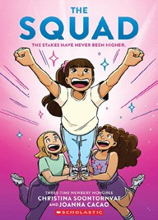

- The New Girl: A Graphic Novel
Cassandra Calin, Graphix, $12.99
- Warriors Graphic Novel #1
Erin Hunter, Natalie Riess (Illus.), Sara Goetter (Illus.), HarperAlley, $15.99
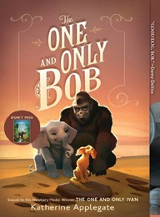

- Super Duper Extra Deluxe Essential Handbook (Pokémon)
Scholastic, $16.99
- The Bletchley Riddle
Ruta Sepetys, Steve Sheinkin, Viking Books for Young Readers, $18.99
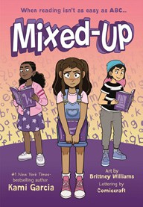
- The One and Only Bob
Katherine Applegate, Patricia Castelao (Illus.), Harper, $10.99
- Mixed-Up
Kami Garcia, Brittney Williams (Illus.), First Second, $14.99
- Hatchet
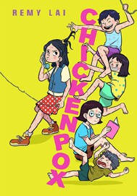
Gary Paulsen, Simon & Schuster Books for Young Readers, $9.99
- Chickenpox
Remy Lai, Henry Holt and Co. BYR Paperbacks, $14.99
- The First State of Being
Erin Entrada Kelly, Greenwillow Books, $19.99
- Bluey 5-Minute Stories
Penguin Young Readers, $14.99
- Smile: A Graphic Novel
Raina Telgemeier, Graphix, $12.99
- Charlotte’s Web

E. B. White, HarperCollins, $10.99
Debut
Indies Introduce
February 12, 2025
For the week ending February 9, 2025 based on sales in hundreds of independent bookstores nationwide.
CHILDREN’S

RANK | YOUNG ADULT
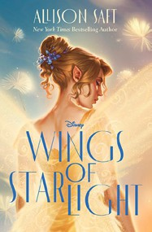
  - Wings of Starlight
Allison Saft, Disney Press, $18.99
  - Under the Same Stars
Libba Bray, Farrar, Straus and Giroux BYR, $24.99
  - Heavenly Tyrant
Xiran Jay Zhao, Tundra Books, $20.99
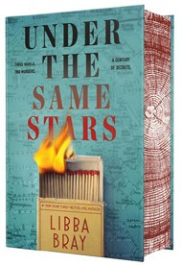
  - Powerless
Lauren Roberts, Simon & Schuster Books for Young Readers, $19.99
  - All Better Now
Neal Shusterman, Simon & Schuster Books for Young Readers, $21.99
  - Pride and Prejudice
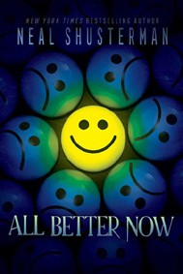

Jane Austen, Anna Bond (Illus.), Puffin Books, $17
  - If He Had Been with Me
Laura Nowlin, Sourcebooks Fire, $10.99
  - The Perks of Being a Wallflower
Stephen Chbosky, MTV Books, $15.99
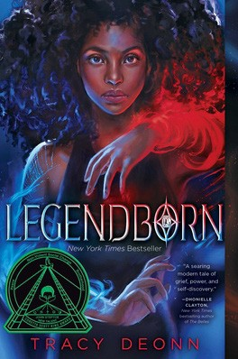

  - The Giver
Lois Lowry, Clarion Books, $11.99
  - Better Than the Movies
Lynn Painter, Simon & Schuster Books for Young Readers, $12.99
  - Legendborn
Tracy Deonn, Margaret K. McElderry Books, $13.99
  - Iron Widow
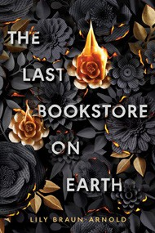

Xiran Jay Zhao, Tundra Books, $11.99
  - Divine Rivals
Rebecca Ross, Wednesday Books, $18.99
  - The Last Bookstore on Earth
Lily Braun-Arnold, Delacorte Press, $19.99
  - The Outsiders
S. E. Hinton, Viking Books for Young Readers, $14.99

OTHER CHILDREN’S INDIE FAVORITES
AGES 8 TO 12 TEEN READERS
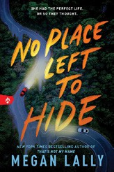

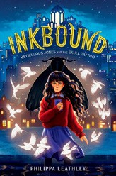

Inkbound: Meticulous Jones and the Skull Tattoo
Philippa Leathley, HarperCollins, $19.99
“The start of a great new fantasy series! I can’t wait for the sequel!”
—Chris Abouzeid, Belmont Books, Belmont, MA
No Place Left to Hide
Megan Lally, Sourcebooks Fire, $12.99
“Buckle up! You’re in for a wild ride. No Place Left to Hide is a gripping thriller full of twists and turns, both figuratively and literally.”
—Alyssa Leibow, Beach Books, Seaside, OR

