RANK | FICTION



- James
Percival Everett, Doubleday, $28
- Onyx Storm (Deluxe Limited Edition)
Rebecca Yarros, Entangled: Red Tower Books, $32.99
- The Bones Beneath My Skin
TJ Klune, Tor Books, $29.99
4. Onyx Storm (Standard Edition)


Rebecca Yarros, Entangled: Red Tower Books, $29.99
- The God of the Woods
Liz Moore, Riverhead Books, $30
- Small Things Like These
Claire Keegan, Grove Press, $20
- Iron Flame
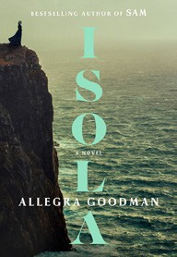

Rebecca Yarros, Entangled: Red Tower Books, $29.99
- The Wedding People
Alison Espach, Henry Holt and Co., $28.99
- Witchcraft for Wayward Girls
Grady Hendrix, Berkley, $30
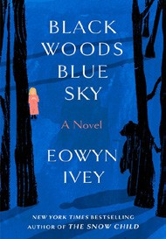
- All Fours
Miranda July, Riverhead Books, $29
- Isola
Allegra Goodman, The Dial Press, $28.99
- The Women
Kristin Hannah, St. Martin’s Press, $30

- Intermezzo
Sally Rooney, Farrar, Straus and Giroux, $29
- Black Woods, Blue Sky
Eowyn Ivey, Random House, $29
- We Do Not Part
Han Kang, e. yaewon (Transl.),
Paige Aniyah Morris (Transl.), Hogarth, $28
17 Last Twilight in Paris

Pam Jenoff, Park Row, $28.99
February 12, 2025
For the week ending February 9, 2025 based on sales in hundreds of independent bookstores nationwide.
HARDCOVER

RANK | NONFICTION
- The Let Them Theory: A Life-Changing Tool That Millions of People Can’t Stop Talking About
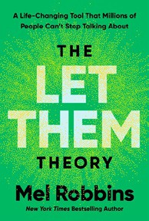

Mel Robbins, Hay House LLC, $29.99
- The Serviceberry
Robin Wall Kimmerer, John Burgoyne (Illus.), Scribner, $20
- Memorial Days: A Memoir

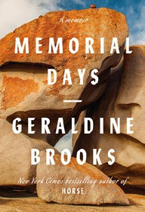
Geraldine Brooks, Viking, $28
- The Sirens’ Call
Chris Hayes, Penguin Press, $32
- Source Code: My Beginnings
Bill Gates, Knopf, $30
- The Harder I Fight the More I Love You
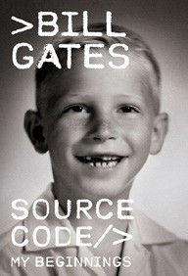
Neko Case, Grand Central Publishing, $30
- On the Hippie Trail: Istanbul to Kathmandu and the Making of a Travel Writer
Rick Steves, Rick Steves, $30
- The Message
Ta-Nehisi Coates, One World, $30
- The Creative Act: A Way of Being
Rick Rubin, Penguin Press, $32


- Being Jewish After the Destruction of Gaza: A Reckoning
Peter Beinart, Knopf, $26
- Atomic Habits
James Clear, Avery, $27
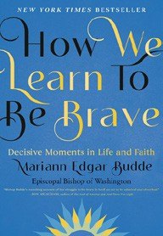
- How We Learn to Be Brave: Decisive Moments in Life and Faith
Mariann Edgar Budde, Avery, $28
- Revenge of the Tipping Point
Malcolm Gladwell, Little, Brown and Company, $32
- The Anxious Generation
Jonathan Haidt, Penguin Press, $30
- Black in Blues
Imani Perry, Ecco, $28.99

OTHER HARDCOVER INDIE FAVORITES
Debut
On the Rise

Indies Introduce

We Could Be Rats: A Novel
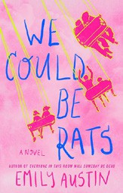

Emily Austin, Atria Books, $27.99
“In her latest novel, Austin captures the bittersweet heart of growing up and growing apart. Told over the course of Sigrid’s attempts at a suicide note, Austin guides the reader though Sigrid’s disenchantment with equal humor and heartbreak.”
—Alea Lopes, The Oxford Exchange, Tampa, FL
Penitence: A Novel
Kristin Koval, Celadon Books, $28.99
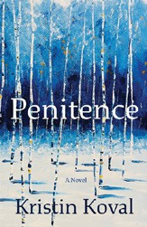

“Penitence tells the story of a small town Colorado murder, woven with the guilt and anger of another loss from many years ago.
Touching on youth incarceration, families, love, and trust, this debut makes me want to see what Kristin Koval will bring next.”
—Gail Dickson, The Bookstore of Glen Ellyn, Glen Ellyn, IL

