RANK | HARDCOVER




- James
Percival Everett, Doubleday, $28
- Onyx Storm (Deluxe Limited Edition)
Rebecca Yarros, Entangled: Red Tower Books, $32.99
- The Bones Beneath My Skin
TJ Klune, Tor Books, $29.99
4. Onyx Storm (Standard Edition)
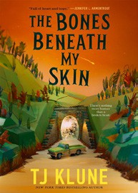

Rebecca Yarros, Entangled: Red Tower Books, $29.99
- The God of the Woods
Liz Moore, Riverhead Books, $30
- Small Things Like These
Claire Keegan, Grove Press, $20
- Iron Flame
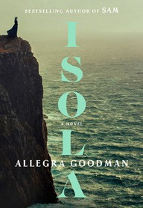

Rebecca Yarros, Entangled: Red Tower Books, $29.99
- The Wedding People
Alison Espach, Henry Holt and Co., $28.99
- Witchcraft for Wayward Girls
Grady Hendrix, Berkley, $30
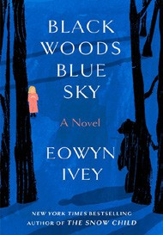
- All Fours
Miranda July, Riverhead Books, $29
- Isola
Allegra Goodman, The Dial Press, $28.99
- The Women
Kristin Hannah, St. Martin’s Press, $30

- Intermezzo
Sally Rooney, Farrar, Straus and Giroux, $29
- Black Woods, Blue Sky
Eowyn Ivey, Random House, $29
- We Do Not Part
Han Kang, e. yaewon (Transl.),
Paige Aniyah Morris (Transl.), Hogarth, $28
17 Last Twilight in Paris

Pam Jenoff, Park Row, $28.99
February 12, 2025
For the week ending February 9, 2025 based on sales in hundreds of independent bookstores nationwide.
FICTION

RANK | PAPERBACK
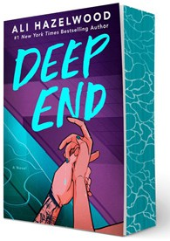
- Deep End
Ali Hazelwood, Berkley, $20
- Fourth Wing
Rebecca Yarros, Entangled: Red Tower Books, $20.99
- Martyr!
Kaveh Akbar, Vintage, $18
- The Frozen River


Ariel Lawhon, Vintage, $18
- Parable of the Sower
Octavia E. Butler, Grand Central, $19.99
- Orbital
Samantha Harvey, Grove Press, $17
- Demon Copperhead
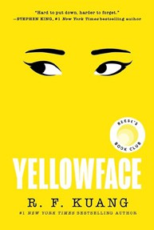

Barbara Kingsolver, Harper Perennial, $21.99
- The Crash
Freida McFadden, Poisoned Pen Press, $17.99
- Yellowface
R. F. Kuang, William Morrow Paperbacks, $18.99
- A Court of Thorns and Roses


Sarah J. Maas, Bloomsbury Publishing, $19
- The Handmaid’s Tale
Margaret Atwood, Anchor, $18
- The Housemaid
Freida McFadden, Grand Central, $12.99
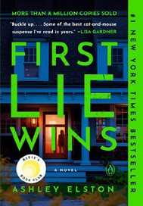
- North Woods
Daniel Mason, Random House Trade Paperbacks, $18
- The Berry Pickers
Amanda Peters, Catapult, $17.95
- First Lie Wins
Ashley Elston, Penguin, $19

Debut
On the Rise Indies Introduce

