RANK | ILLUSTRATED
- Little Blue Truck’s Valentine
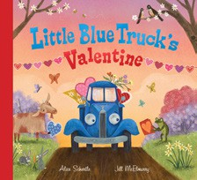



Alice Schertle, Jill McElmurry (Illus.), Clarion Books,
$13.99
- Goodnight Moon
Margaret Wise Brown, Clement Hurd (Illus.), Harper,
$10.99
- The Very Hungry Caterpillar
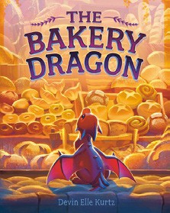

Eric Carle, World of Eric Carle, $10.99
- The Snowy Day
Ezra Jack Keats, Viking Books for Young Readers,
$19.99
- Girls on the Rise
Amanda Gorman, Loveis Wise (Illus.), Viking Books for Young Readers, $19.99
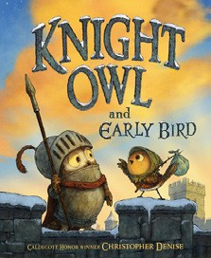

- The Very Hungry Caterpillar’s Peekaboo Valentine
Eric Carle, World of Eric Carle, $9.99
- Where the Wild Things Are
Maurice Sendak, Harper, $21.99

- The Bakery Dragon
Devin Elle Kurtz, Knopf Books for Young Readers,
$18.99
- Knight Owl and Early Bird
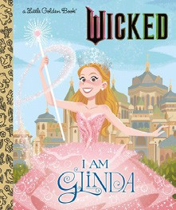
Christopher Denise, Christy Ottaviano Books, $18.99
- Your Forest
Jon Klassen, Candlewick, $8.99
- How to Be Romance with Bluey and Bingo
Penguin Young Readers, $9.99
- I Am Glinda (Little Golden Book)
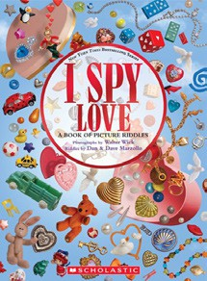
Mary Man-Kong, Elsa Chang (Illus.), Golden Books,
$5.99
- Dragons Love Tacos
Adam Rubin, Daniel Salmieri (Illus.), Dial Books, $18.99
- I Spy Love
Dan Marzollo, Dave Marzollo, Walter Wick (Illus.), Cartwheel Books, $14.99
- Happy Valentine’s Day, Curious George!
H. A. Rey, Clarion Books, $10.99
February 12, 2025
For the week ending February 9, 2025 based on sales in hundreds of independent bookstores nationwide.
CHILDREN’S

RANK | SERIES
  - Dog Man (hardcover)
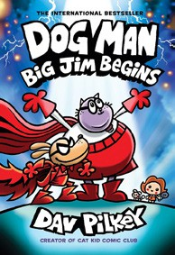

Dav Pilkey, Graphix
  - Diary of a Wimpy Kid (hardcover)
Jeff Kinney, Harry N. Abrams
  - Wings of Fire
Tui T. Sutherland, Mike Holmes (Illus.), Scholastic
  - The Wild Robot
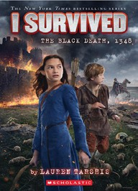

Peter Brown, Little, Brown Books for Young Readers
  - Elephant & Piggie (hardcover)
Mo Willems, Hyperion
  - I Survived
Lauren Tarshis, Scholastic
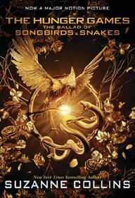

  - InvestiGators (hardcover)
John Patrick Green, First Second
  - The Hunger Games
Suzanne Collins, Scholastic
  - Percy Jackson and the Olympians
Rick Riordan, Hyperion
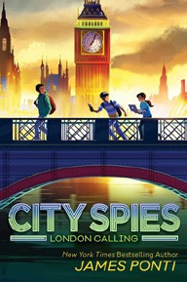

  - City Spies
James Ponti, Aladdin
New in Series: London Calling

All Fiction Series titles are hardcover and
paperback unless noted.
Debut


Indies Introduce

OTHER CHILDREN’S INDIE FAVORITES
AGES 4 TO 8
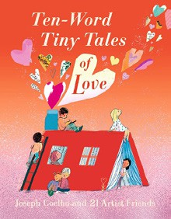

Ten-Word Tiny Tales of Love
Joseph Coelho, Various Illustrators, Candlewick, $18.99 “What if you had to condense your adoration into just ten words? I absolutely love this coffee table worthy picture book with ten-word expressions of love. Stunningly illustrated by some of the best, it’s a perfect gift for anyone who makes your heart sing.”
—Angie Tally, The Country Bookshop, Southern Pines, NC

