RANK | FICTION
- Fourth Wing
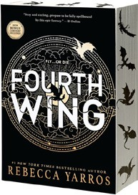



Rebecca Yarros, Entangled: Red Tower Books, $20.99
- Martyr!
Kaveh Akbar, Vintage, $18
- The Frozen River
Ariel Lawhon, Vintage, $18
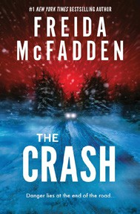
- The Crash
Freida McFadden, Poisoned Pen Press, $17.99
- Parable of the Sower
Octavia E. Butler, Grand Central, $19.99
- Orbital
Samantha Harvey, Grove Press, $17
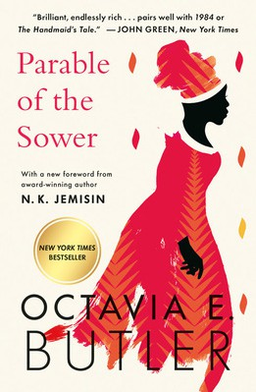
- Demon Copperhead
Barbara Kingsolver, Harper Perennial, $21.99
- The Handmaid’s Tale
Margaret Atwood, Anchor, $18
- Yellowface
R. F. Kuang, William Morrow Paperbacks, $18.99
- A Court of Thorns and Roses
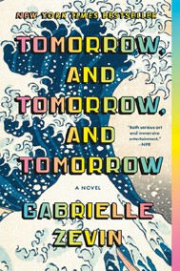

Sarah J. Maas, Bloomsbury Publishing, $19
- The Berry Pickers
Amanda Peters, Catapult, $17.95
- North Woods
Daniel Mason, Random House Trade Paperbacks, $18
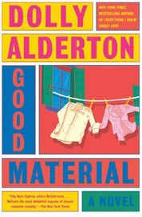
- Fahrenheit 451
Ray Bradbury, Simon & Schuster, $17
- The Housemaid
Freida McFadden, Grand Central, $12.99
- Tomorrow, and Tomorrow, and Tomorrow
Gabrielle Zevin, Vintage, $19
- Good Material

Dolly Alderton, Vintage, $18

OTHER PAPERBACK INDIE FAVORITES
Death in the Downline: A Multi-Level Marketing Murder Mystery


Maria Abrams, Quirk Books, $18.99
“I absolutely loved this twisty thriller! Centered in the world of a women’s beauty brand multi-level marketing company, this book had me guessing from the get-go and made me laugh out loud more times than I can count. An incredibly strong debut!”
—Val Partenheimer, Books Are Awesome!, Parker, CO
February 5, 2025
For the week ending February 2, 2025 based on sales in hundreds of independent bookstores nationwide.
PAPERBACK

RANK | NONFICTION
  - On Tyranny: Twenty Lessons from the Twentieth Century
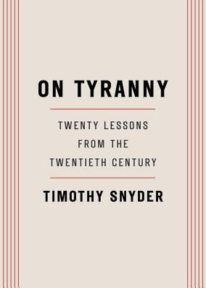

Timothy Snyder, Crown, $12
  - Braiding Sweetgrass
Robin Wall Kimmerer, Milkweed Editions, $20
  - The Backyard Bird Chronicles
Amy Tan, Knopf, $35
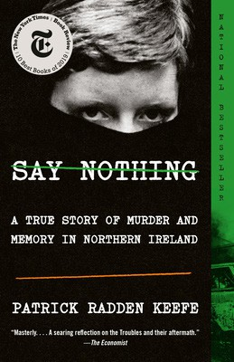

  - All About Love: New Visions
bell hooks, Morrow, $16.99
  - The Art Thief
Michael Finkel, Vintage, $18
  - The Body Keeps the Score
Bessel van der Kolk, M.D., Penguin, $19
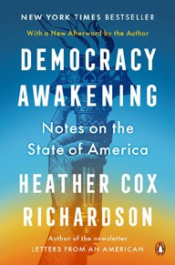

  - The Hundred Years’ War on Palestine: A History of Settler Colonialism and Resistance, 1917—2017
Rashid Khalidi, Metropolitan Books, $19.99
  - Say Nothing
Patrick Radden Keefe, Vintage, $20


  - Everyone Who Is Gone Is Here
Jonathan Blitzer, Penguin, $21
  - Democracy Awakening
Heather Cox Richardson, Penguin, $18
  - Greenlights
Matthew McConaughey, Crown, $20
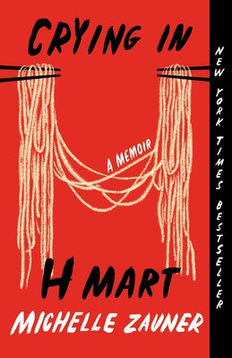

  - All the Beauty in the World
Patrick Bringley, Simon & Schuster, $18.99
  - A People’s History of the United States
Howard Zinn, Harper Perennial Modern Classics, $22.99
  - Crying in H Mart: A Memoir
Michelle Zauner, Vintage, $17
  - Mutual Aid: Building Solidarity During This Crisis (and the Next)
Dean Spade, Verso, $15.95 Debut
On the Rise

MASS MARKET Indies Introduce
- 1984 George Orwell, Signet, $10.99
- Animal Farm George Orwell, Signet, $9.99
- The Diary of a Young Girl Anne Frank, Bantam, $8.99
- Mistborn: The Final Empire Brandon Sanderson, Tor, $10.99
- Lord of the Flies William Golding, Penguin, $12
- The Way of Kings Brandon Sanderson, Tor, $12.99
- I Know Why the Caged Bird Sings Maya Angelou, Ballantine, $8.99
- The Exchange John Grisham, Vintage, $10.99
- Slaughterhouse-Five Kurt Vonnegut, Laurel Leaf, $9.99
- Dune Frank Herbert, Ace, $10.99

