RANK | EARLY & MIDDLE GRADE
- Impossible Creatures
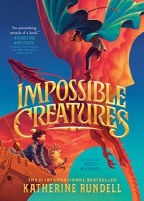



Katherine Rundell, Ashley Mackenzie (Illus.), Knopf Books for Young Readers, $19.99
- The First State of Being
Erin Entrada Kelly, Greenwillow Books, $19.99
- Warriors Graphic Novel: The Prophecies Begin #1
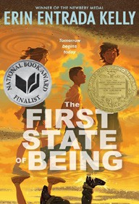

Erin Hunter, Natalie Riess (Illus.), Sara Goetter (Illus.), HarperAlley, $15.99
- The Squad: A Graphic Novel
Christina Soontornvat, Joanna Cacao (Illus.), Graphix, $12.99
- The Bletchley Riddle
Ruta Sepetys, Steve Sheinkin, Viking Books for Young Readers, $18.99
- The New Girl: A Graphic Novel
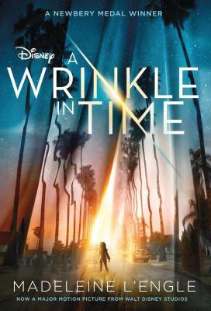

Cassandra Calin, Graphix, $12.99
- Super Duper Extra Deluxe Essential Handbook (Pokémon)
Scholastic, $16.99
- The One and Only Bob
Katherine Applegate, Patricia Castelao (Illus.), Harper,
$10.99
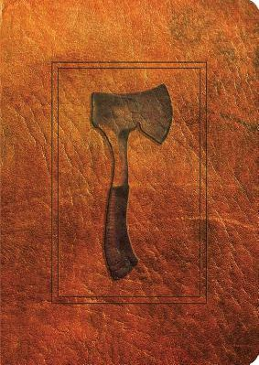

- Bluey 5-Minute Stories
Penguin Young Readers, $14.99
- A Wrinkle in Time
Madeleine L’Engle, Square Fish, $8.99
- Drama: A Graphic Novel
Raina Telgemeier, Graphix, $12.99
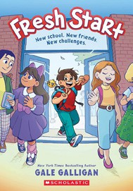

- The Eyes and the Impossible
Dave Eggers, Shawn Harris (Illus.), Knopf Books for Young Readers, $19.99
- Hatchet
Gary Paulsen, Simon & Schuster Books for Young Readers, $9.99
- Fresh Start: A Graphic Novel
Gale Galligan, Graphix, $14.99
- The Millicent Quibb School of Etiquette for Young Ladies of Mad Science
Kate McKinnon, Little, Brown Books for Young
February 5, 2025
For the week ending February 2, 2025 based on sales in hundreds of independent bookstores nationwide.
CHILDREN’S

RANK | YOUNG ADULT
  - Heavenly Tyrant
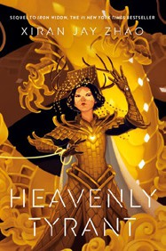

Xiran Jay Zhao, Tundra Books, $20.99
  - Powerless
Lauren Roberts, Simon & Schuster Books for Young Readers, $19.99
  - The Giver
Lois Lowry, Clarion Books, $11.99
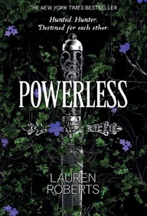

  - If He Had Been with Me
Laura Nowlin, Sourcebooks Fire, $10.99
  - The Perks of Being a Wallflower
Stephen Chbosky, MTV Books, $15.99
  - Better Than the Movies
Lynn Painter, Simon & Schuster Books for Young Readers, $12.99
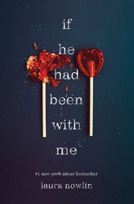

  - The Last Bookstore on Earth
Lily Braun-Arnold, Delacorte Press, $19.99
  - The Book Thief
Markus Zusak, Knopf Books for Young Readers, $14.99
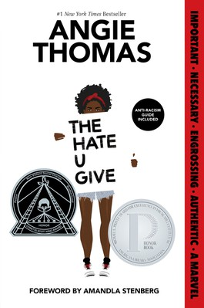

  - The Hate U Give
Angie Thomas, Balzer + Bray, $16.99
  - Legendborn
Tracy Deonn, Margaret K. McElderry Books, $13.99
  - Iron Widow
Xiran Jay Zhao, Tundra Books, $11.99
  - Divine Rivals
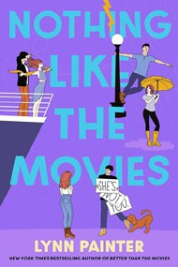

Rebecca Ross, Wednesday Books, $18.99
  - The Outsiders
S. E. Hinton, Viking Books for Young Readers, $14.99
  - If Only I Had Told Her
Laura Nowlin, Sourcebooks Fire, $12.99
  - Nothing Like the Movies
Lynn Painter, Simon & Schuster Books for Young Readers, $19.99
Debut


^{Readers,} ^{$17.99} OTHER CHILDREN’S INDIE FAVORITES ^{Indies} ^{Introduce}
AGES 8 TO 12 TEEN READERS
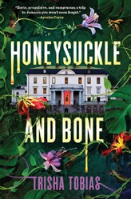

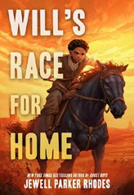

Will’s Race for Home
Jewell Parker Rhodes, Little, Brown Books for Young Readers, $17.99 “This was so enjoyable! This book highlights a part of history you don’t see very often from a child’s perspective. I loved reading about the Land Rush and the free Black people who participated in it. Lots of action and suspense and honest emotion.”
—Izzy Stringham, White River Books, Carbondale, CO
Honeysuckle and Bone
Trisha Tobias, Zando – Sweet July Books, $19.99
“Don’t let the duppy get you! Honeysuckle and Bone transports you to the canicular heat of Jamaica as the secrets heat up with each turning page. Evocative horror that pays homage to the rich oral history that is Caribbean folklore.”
—Morgan Haywood-Joy, Greenlight Bookstore, Brooklyn, NY

