RANK | FICTION
- Onyx Storm (Deluxe Limited Edition)
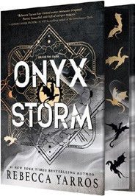



Rebecca Yarros, Entangled: Red Tower Books, $32.99
- James
Percival Everett, Doubleday, $28
- Onyx Storm (Standard Edition)
Rebecca Yarros, Entangled: Red Tower Books, $29.99
- Witchcraft for Wayward Girls


Grady Hendrix, Berkley, $30
- Iron Flame
Rebecca Yarros, Entangled: Red Tower Books, $29.99
- The God of the Woods
Liz Moore, Riverhead Books, $30
- Small Things Like These


Claire Keegan, Grove Press, $20
- The Wedding People
Alison Espach, Henry Holt and Co., $28.99
- All Fours
Miranda July, Riverhead Books, $29
- The Women


Kristin Hannah, St. Martin’s Press, $30
- Intermezzo
Sally Rooney, Farrar, Straus and Giroux, $29
- We Do Not Part
Han Kang, e. yaewon (Transl.),

Paige Aniyah Morris (Transl.), Hogarth, $28
- Water Moon
Samantha Sotto Yambao, Del Rey, $28.99
- All the Colors of the Dark
Chris Whitaker, Crown, $30
- Good Dirt
Charmaine Wilkerson, Ballantine Books, $30
February 5, 2025
For the week ending February 2, 2025 based on sales in hundreds of independent bookstores nationwide.
HARDCOVER

RANK | NONFICTION
  - The Let Them Theory: A Life-Changing Tool That Millions of People Can’t Stop Talking About
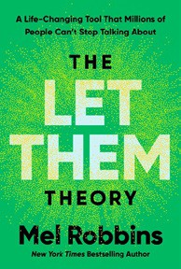

Mel Robbins, Hay House LLC, $29.99
  - The Serviceberry: Abundance and Reciprocity in the Natural World
Robin Wall Kimmerer, John Burgoyne (Illus.), Scribner, $20

  - The Sirens’ Call: How Attention Became the World’s Most Endangered Resource Chris Hayes, Penguin Press, $32
  - The Harder I Fight the More I Love You: A Memoir
Neko Case, Grand Central Publishing, $30
  - The Message
Ta-Nehisi Coates, One World, $30


  - Atomic Habits
James Clear, Avery, $27
  - The Creative Act: A Way of Being
Rick Rubin, Penguin Press, $32
  - Be Ready When the Luck Happens: A Memoir
Ina Garten, Crown, $34

  - Black in Blues: How a Color Tells the Story of My People
Imani Perry, Ecco, $28.99
  - Revenge of the Tipping Point
Malcolm Gladwell, Little, Brown and Company, $32
  - The Anxious Generation
Jonathan Haidt, Penguin Press, $30

  - Being Jewish After the Destruction of Gaza: A Reckoning
Peter Beinart, Knopf, $26
  - The Wide Wide Sea
Hampton Sides, Doubleday, $35
  - Meditations for Mortals
Oliver Burkeman, Farrar, Straus and Giroux, $27
  - The Demon of Unrest
Erik Larson, Crown, $35

OTHER HARDCOVER INDIE FAVORITES
Debut
On the Rise

Indies Introduce

The Business Trip: A Novel
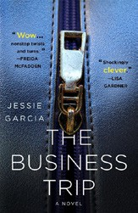

Jessie Garcia, St. Martin’s Press, $29
“This story of two strangers meeting on a plane is full of sus- pense from start to finish. I read a lot of thrillers and I could not put this one down!”
—Marilyn Negip, R.J. Julia Booksellers, Madison, CT
The Note: A Novel
Alafair Burke, Knopf, $29


“A long overdue girl’s weekend is upended when a seemingly random stranger goes missing. Old rivalries, distant connections, and very real deaths seem unrelated…at first. In this very well-crafted novel, Alafair Burke is at the top of her game.”
—Sarah Bagby, Watermark Books & Café, Wichita, KS

