RANK | HARDCOVER

- Onyx Storm (Deluxe Limited Edition)
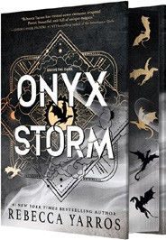



Rebecca Yarros, Entangled: Red Tower Books, $32.99
- James
Percival Everett, Doubleday, $28
- Onyx Storm (Standard Edition)
Rebecca Yarros, Entangled: Red Tower Books, $29.99
- Witchcraft for Wayward Girls


Grady Hendrix, Berkley, $30
- Iron Flame
Rebecca Yarros, Entangled: Red Tower Books, $29.99
- The God of the Woods
Liz Moore, Riverhead Books, $30
- Small Things Like These
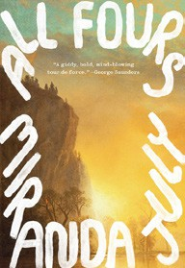

Claire Keegan, Grove Press, $20
- The Wedding People
Alison Espach, Henry Holt and Co., $28.99
- All Fours
Miranda July, Riverhead Books, $29
- The Women
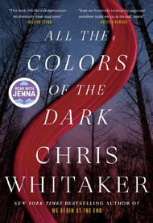

Kristin Hannah, St. Martin’s Press, $30
- Intermezzo
Sally Rooney, Farrar, Straus and Giroux, $29
- We Do Not Part
Han Kang, e. yaewon (Transl.),
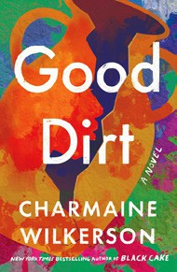
Paige Aniyah Morris (Transl.), Hogarth, $28
- Water Moon
Samantha Sotto Yambao, Del Rey, $28.99
- All the Colors of the Dark
Chris Whitaker, Crown, $30
- Good Dirt
Charmaine Wilkerson, Ballantine Books, $30
February 5, 2025
For the week ending February 2, 2025 based on sales in hundreds of independent bookstores nationwide.
FICTION

RANK | PAPERBACK
  - Fourth Wing
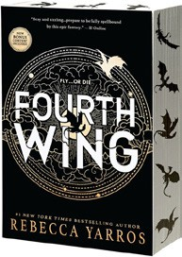

Rebecca Yarros, Entangled: Red Tower Books, $20.99
  - Martyr!
Kaveh Akbar, Vintage, $18
  - The Frozen River
Ariel Lawhon, Vintage, $18

  - The Crash
Freida McFadden, Poisoned Pen Press, $17.99
  - Parable of the Sower
Octavia E. Butler, Grand Central, $19.99
  - Orbital
Samantha Harvey, Grove Press, $17
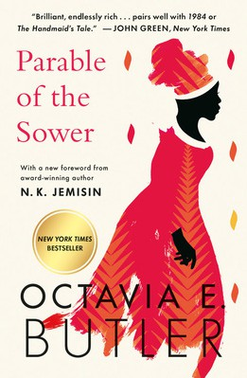
  - Demon Copperhead
Barbara Kingsolver, Harper Perennial, $21.99
  - The Handmaid’s Tale
Margaret Atwood, Anchor, $18
  - Yellowface
R. F. Kuang, William Morrow Paperbacks, $18.99
  - A Court of Thorns and Roses
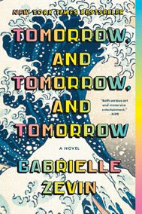

Sarah J. Maas, Bloomsbury Publishing, $19
  - The Berry Pickers
Amanda Peters, Catapult, $17.95
  - North Woods
Daniel Mason, Random House Trade Paperbacks, $18
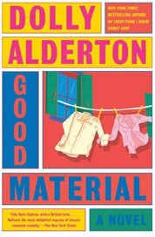
  - Fahrenheit 451
Ray Bradbury, Simon & Schuster, $17
  - The Housemaid
Freida McFadden, Grand Central, $12.99
  - Tomorrow, and Tomorrow, and Tomorrow
Gabrielle Zevin, Vintage, $19
  - Good Material

Dolly Alderton, Vintage, $18

Debut
On the Rise Indies Introduce

