RANK | ILLUSTRATED
- Goodnight Moon
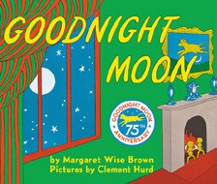



Margaret Wise Brown, Clement Hurd (Illus.), Harper,
$10.99
- The Very Hungry Caterpillar
Eric Carle, World of Eric Carle, $10.99
- Little Blue Truck’s Valentine
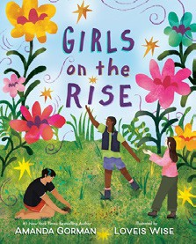

Alice Schertle, Jill McElmurry (Illus.), Clarion Books,
$13.99
- The Snowy Day
Ezra Jack Keats, Viking Books for Young Readers,
$19.99
- Where the Wild Things Are


Maurice Sendak, Harper, $21.99
- Girls on the Rise
Amanda Gorman, Loveis Wise (Illus.), Viking Books for Young Readers, $19.99
- I Am Glinda (Little Golden Book)
Mary Man-Kong, Elsa Chang (Illus.), Golden Books,
$5.99


- Knight Owl and Early Bird
Christopher Denise, Christy Ottaviano Books, $18.99
- The Bakery Dragon
Devin Elle Kurtz, Knopf Books for Young Readers,
$18.99
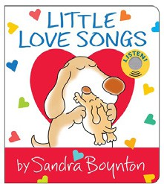
- I Am Elphaba (Little Golden Book)
Mary Man-Kong, Elsa Chang (Illus.), Golden Books,
$5.99
- The Very Hungry Caterpillar’s Peekaboo Valentine
Eric Carle, World of Eric Carle, $9.99
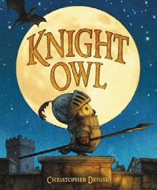
- Happy Valentine’s Day, Curious George!
H. A. Rey, Clarion Books, $10.99
- Little Love Songs
Sandra Boynton, Boynton Bookworks, $14.99
- Dragons Love Tacos
Adam Rubin, Daniel Salmieri (Illus.), Dial Books, $18.99
- Knight Owl
Christopher Denise, Christy Ottaviano Books, $17.99
February 5, 2025
For the week ending February 2, 2025 based on sales in hundreds of independent bookstores nationwide.
CHILDREN’S

RANK | SERIES
  - Dog Man (hardcover)
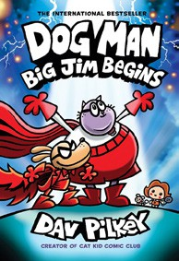

Dav Pilkey, Graphix
  - Diary of a Wimpy Kid (hardcover)
Jeff Kinney, Harry N. Abrams
  - Wings of Fire
Tui T. Sutherland, Mike Holmes (Illus.), Scholastic
  - The Wild Robot
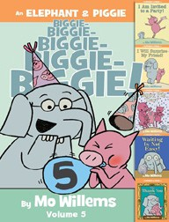

Peter Brown, Little, Brown Books for Young Readers
  - Elephant & Piggie (hardcover)
Mo Willems, Hyperion
  - I Survived
Lauren Tarshis, Scholastic
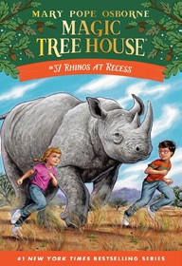

  - Percy Jackson and the Olympians
Rick Riordan, Hyperion
  - InvestiGators (hardcover)
John Patrick Green, First Second
  - Magic Tree House
Mary Pope Osborne, Sal Murdocca (Illus.), Random House Books for Young Readers
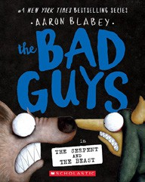

  - The Bad Guys (paperback)
Aaron Blabey, Scholastic

All Fiction Series titles are hardcover and
paperback unless noted.
Debut


Indies Introduce

OTHER CHILDREN’S INDIE FAVORITES
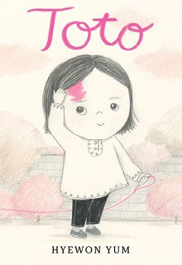
AGES 4 TO 8
Toto
Hyewon Yum, Neal Porter Books, $18.99
“I adore Toto — the book as well as the birthmark who bears the name! A lovely story that focuses on learning to embrace what makes you different. Yum’s evocative, warm illustrations and gentle prose deserve a place on your shelf.”
—Janet Geddis, Avid Bookshop, Athens, GA

