RANK | FICTION
- Fourth Wing
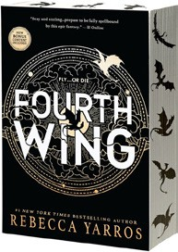



Rebecca Yarros, Entangled: Red Tower Books, $20.99
- Martyr!
Kaveh Akbar, Vintage, $18
- The Frozen River
Ariel Lawhon, Vintage, $18
- Orbital
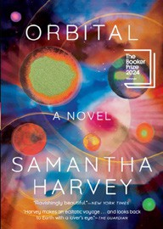

Samantha Harvey, Grove Press, $17
- Demon Copperhead
Barbara Kingsolver, Harper Perennial, $21.99
- Parable of the Sower
Octavia E. Butler, Grand Central, $19.99
- Yellowface
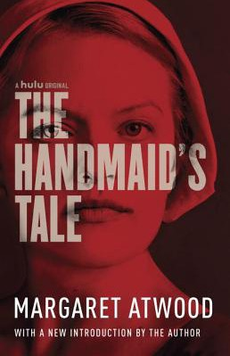

R. F. Kuang, William Morrow Paperbacks, $18.99
- The Handmaid’s Tale
Margaret Atwood, Anchor, $18
- A Court of Thorns and Roses
Sarah J. Maas, Bloomsbury Publishing, $19
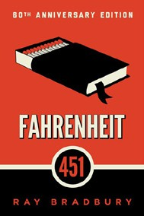
- North Woods
Daniel Mason, Random House Trade Paperbacks,
$18
- The Berry Pickers
Amanda Peters, Catapult, $17.95
- Fahrenheit 451
Ray Bradbury, Simon & Schuster, $17


- The Housemaid
Freida McFadden, Grand Central, $12.99
- Tomorrow, and Tomorrow, and Tomorrow
Gabrielle Zevin, Vintage, $19
- The Vegetarian
Han Kang, Hogarth, $17

OTHER PAPERBACK INDIE FAVORITES
The Perfect Home: A Novel


Daniel Kenitz, Scribner, $17.99
“The Perfect Home delivers two characters with seemingly perfect lives, then upends the story in the most diabolical fashion. If you are looking for an addictive novel, you have found the perfect prescription for a thriller that delivers!”
—Pamela Klinger-Horn, Valley Bookseller, Stillwater, MN
January 29, 2025
For the week ending January 26, 2025 based on sales in hundreds of independent bookstores nationwide.
PAPERBACK

RANK | NONFICTION
  - On Tyranny: Twenty Lessons from the Twentieth Century
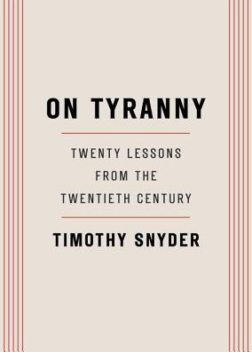

Timothy Snyder, Crown, $12
  - The Backyard Bird Chronicles
Amy Tan, Knopf, $35
  - Braiding Sweetgrass
Robin Wall Kimmerer, Milkweed Editions, $20
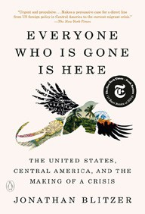

  - The Art Thief
Michael Finkel, Vintage, $18
  - All About Love: New Visions
bell hooks, Morrow, $16.99
  - Say Nothing
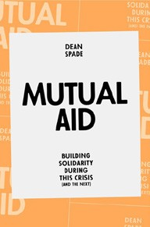
Patrick Radden Keefe, Vintage, $20
  - Everyone Who Is Gone Is Here: The United States, Central America, and the Making of a Crisis
Jonathan Blitzer, Penguin Books, $21
  - Greenlights
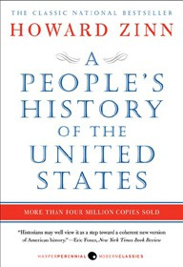
Matthew McConaughey, Crown, $20
  - The Hundred Years’ War on Palestine
Rashid Khalidi, Metropolitan Books, $19.99
  - The Body Keeps the Score
Bessel van der Kolk, M.D., Penguin, $19
  - Democracy Awakening
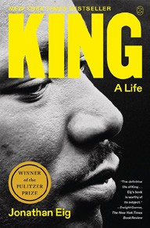
Heather Cox Richardson, Penguin, $18
  - All the Beauty in the World
Patrick Bringley, Simon & Schuster, $18.99
  - Mutual Aid: Building Solidarity During This Crisis (and the Next)
Dean Spade, Verso, $15.95
  - A People’s History of the United States
Howard Zinn, Harper Perennial Modern Classics, $22.99
  - King: A Life

Jonathan Eig, Picador, $23 Debut
On the Rise

MASS MARKET Indies Introduce
- 1984 George Orwell, Signet, $10.99
- Animal Farm George Orwell, Signet, $9.99
- The Diary of a Young Girl Anne Frank, Bantam, $8.99
- The Way of Kings Brandon Sanderson, Tor, $12.99
- Mistborn: The Final Empire Brandon Sanderson, Tor, $10.99
- Slaughterhouse-Five Kurt Vonnegut, Laurel Leaf, $9.99
- Lord of the Flies William Golding, Penguin, $12
- The Catcher in the Rye J.D. Salinger, Little, Brown, $9.99
- The Exchange John Grisham, Vintage, $10.99
- Dune Frank Herbert, Ace, $10.99

