RANK | FICTION
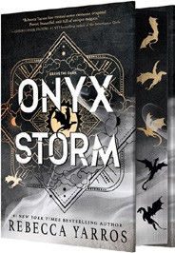


- Onyx Storm (Deluxe Limited Edition)
Rebecca Yarros, Entangled: Red Tower Books, $32.99
- Onyx Storm (Standard Edition)
Rebecca Yarros, Entangled: Red Tower Books, $29.99
- James
Percival Everett, Doubleday, $28
- Witchcraft for Wayward Girls
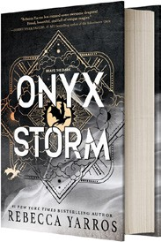

Grady Hendrix, Berkley, $30
- Iron Flame
Rebecca Yarros, Entangled: Red Tower Books, $29.99
- The God of the Woods
Liz Moore, Riverhead Books, $30
- Small Things Like These
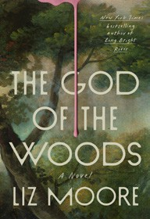

Claire Keegan, Grove Press, $20
- The Wedding People
Alison Espach, Henry Holt and Co., $28.99
- Intermezzo
Sally Rooney, Farrar, Straus and Giroux, $29

- The Women
Kristin Hannah, St. Martin’s Press, $30
- All Fours
Miranda July, Riverhead Books, $29
- We Do Not Part
Han Kang, e. yaewon (Transl.),
Paige Aniyah Morris (Transl.), Hogarth, $28
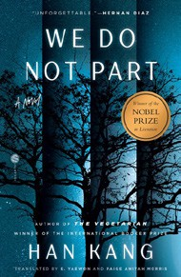

- Water Moon
Samantha Sotto Yambao, Del Rey, $28.99
- All the Colors of the Dark
Chris Whitaker, Crown, $30
- Tell Me Everything
Elizabeth Strout, Random House, $30
January 29, 2025
For the week ending January 26, 2025 based on sales in hundreds of independent bookstores nationwide.
HARDCOVER

RANK | NONFICTION
  - The Serviceberry: Abundance and Reciprocity in the Natural World


Robin Wall Kimmerer, John Burgoyne (Illus.), Scribner, $20
  - The Let Them Theory
Mel Robbins, Hay House LLC, $29.99
  - The Message
Ta-Nehisi Coates, One World, $30


  - The Creative Act: A Way of Being
Rick Rubin, Penguin Press, $32
  - Be Ready When the Luck Happens: A Memoir
Ina Garten, Crown, $34
  - Revenge of the Tipping Point
Malcolm Gladwell, Little, Brown and Company, $32
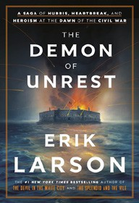

  - The Anxious Generation
Jonathan Haidt, Penguin Press, $30
  - Atomic Habits
James Clear, Avery, $27
  - Meditations for Mortals
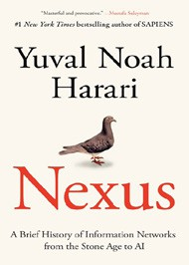
Oliver Burkeman, Farrar, Straus and Giroux, $27
  - The Demon of Unrest
Erik Larson, Crown, $35
  - The Wide Wide Sea
Hampton Sides, Doubleday, $35
  - Nexus: A Brief History of Information Networks from the Stone Age to AI Yuval Noah Harari, Random House, $35
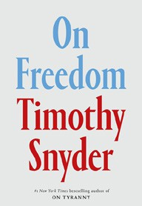

  - The Little Frog’s Guide to Self-Care
Maybell Eequay, Summersdale, $11.99
  - On Freedom
Timothy Snyder, Crown, $32
  - Aflame: Learning from Silence
Pico Iyer, Riverhead Books, $30

OTHER HARDCOVER INDIE FAVORITES
Debut
On the Rise

Indies Introduce

The Naming of the Birds: A Novel
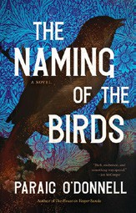

Paraic O’Donnell, Tin House Books, $28.95
“Soulfully Sherlockian, with skillfully delineated characters, The Naming of the Birds susurrates easefully into deeper mystery like an enchanted spool of thread through a darkling wood. This is mesmerizing, transporting historical fiction.”
—Amanda Qassar, Warwick’s, La Jolla, CA
Hello Stranger: Musings on Modern Intimacies
Manuel Betancourt, Catapult, $27
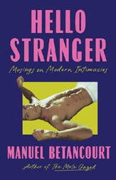

“This examination of belonging, vulnerability, privacy, and modern courtship puts into words those feelings that can be too painful to voice. Betancourt’s expansive definition of friendship and intimacy is salient in this time of division and loss.”
—Viktor Hughes, Loudmouth Books, Indianapolis, IN

