RANK | HARDCOVER

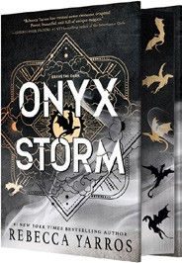


- Onyx Storm (Deluxe Limited Edition)
Rebecca Yarros, Entangled: Red Tower Books, $32.99
- Onyx Storm (Standard Edition)
Rebecca Yarros, Entangled: Red Tower Books, $29.99
- James
Percival Everett, Doubleday, $28
- Witchcraft for Wayward Girls
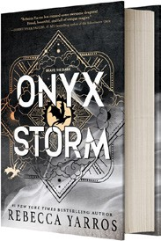

Grady Hendrix, Berkley, $30
- Iron Flame
Rebecca Yarros, Entangled: Red Tower Books, $29.99
- The God of the Woods
Liz Moore, Riverhead Books, $30
- Small Things Like These
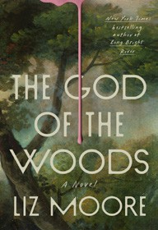

Claire Keegan, Grove Press, $20
- The Wedding People
Alison Espach, Henry Holt and Co., $28.99
- Intermezzo
Sally Rooney, Farrar, Straus and Giroux, $29
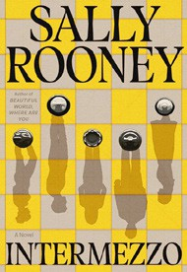
- The Women
Kristin Hannah, St. Martin’s Press, $30
- All Fours
Miranda July, Riverhead Books, $29
- We Do Not Part
Han Kang, e. yaewon (Transl.),
Paige Aniyah Morris (Transl.), Hogarth, $28
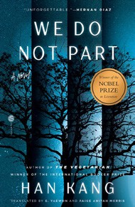

- Water Moon
Samantha Sotto Yambao, Del Rey, $28.99
- All the Colors of the Dark
Chris Whitaker, Crown, $30
- Tell Me Everything
Elizabeth Strout, Random House, $30
January 29, 2025
For the week ending January 26, 2025 based on sales in hundreds of independent bookstores nationwide.
FICTION

RANK | PAPERBACK
  - Fourth Wing
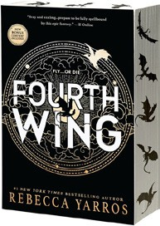

Rebecca Yarros, Entangled: Red Tower Books, $20.99
  - Martyr!
Kaveh Akbar, Vintage, $18
  - The Frozen River
Ariel Lawhon, Vintage, $18
  - Orbital


Samantha Harvey, Grove Press, $17
  - Demon Copperhead
Barbara Kingsolver, Harper Perennial, $21.99
  - Parable of the Sower
Octavia E. Butler, Grand Central, $19.99
  - Yellowface
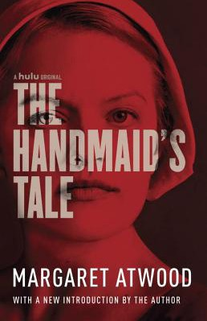

R. F. Kuang, William Morrow Paperbacks, $18.99
  - The Handmaid’s Tale
Margaret Atwood, Anchor, $18
  - A Court of Thorns and Roses
Sarah J. Maas, Bloomsbury Publishing, $19
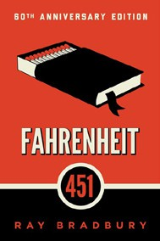
  - North Woods
Daniel Mason, Random House Trade Paperbacks,
$18
  - The Berry Pickers
Amanda Peters, Catapult, $17.95
  - Fahrenheit 451
Ray Bradbury, Simon & Schuster, $17


  - The Housemaid
Freida McFadden, Grand Central, $12.99
  - Tomorrow, and Tomorrow, and Tomorrow
Gabrielle Zevin, Vintage, $19
  - The Vegetarian
Han Kang, Hogarth, $17

Debut
On the Rise Indies Introduce

