January 29, 2025


For the week ending January 26, 2025 based on sales in hundreds of independent bookstores nationwide.
CHILDREN’S

RANK | SERIES

RANK | ILLUSTRATED

- Goodnight Moon
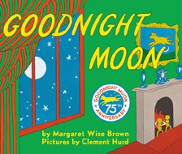

Margaret Wise Brown, Clement Hurd (Illus.), Harper,
$10.99
- The Very Hungry Caterpillar
Eric Carle, World of Eric Carle, $10.99
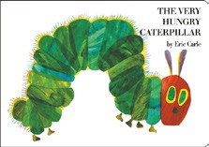
- Girls on the Rise
Amanda Gorman, Loveis Wise (Illus.), Viking Books for Young Readers, $19.99
- Little Blue Truck’s Valentine
Alice Schertle, Jill McElmurry (Illus.), Clarion Books,
$13.99
- I Am Glinda (Little Golden Book)
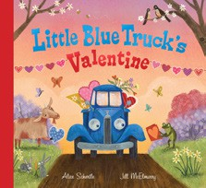

Mary Man-Kong, Elsa Chang (Illus.), Golden Books,
$5.99
- The Snowy Day
Ezra Jack Keats, Viking Books for Young Readers,
$19.99
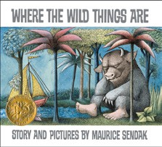
- I Am Elphaba (Little Golden Book)
Mary Man-Kong, Elsa Chang (Illus.), Golden Books,
$5.99
- The Bakery Dragon
Devin Elle Kurtz, Knopf Books for Young Readers,
$18.99
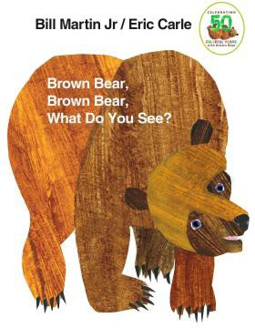
- Knight Owl and Early Bird
Christopher Denise, Christy Ottaviano Books, $18.99
- Good Night, Gorilla
Peggy Rathmann, G.P. Putnam’s Sons Books for Young Readers, $8.99
- Knight Owl
Christopher Denise, Christy Ottaviano Books, $17.99
- Where the Wild Things Are
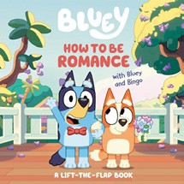

Maurice Sendak, Harper, $21.99
- Brown Bear, Brown Bear, What Do You See? Bill Martin, Jr., Eric Carle (Illus.), Henry Holt and Co. BYR, $8.99
- How to Be Romance with Bluey and Bingo

Penguin Young Readers, $9.99
- Dragons Love Tacos
Adam Rubin, Daniel Salmieri (Illus.), Dial Books, $18.99
  - Dog Man (hardcover)
Dav Pilkey, Graphix
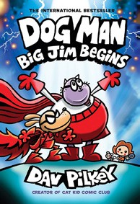

  - Wings of Fire
Tui T. Sutherland, Mike Holmes (Illus.), Scholastic
  - Diary of a Wimpy Kid (hardcover)
Jeff Kinney, Harry N. Abrams
  - The Wild Robot
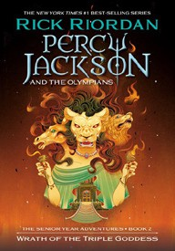

Peter Brown, Little, Brown Books for Young Readers
  - Elephant & Piggie (hardcover)
Mo Willems, Hyperion
  - Percy Jackson and the Olympians
Rick Riordan, Hyperion
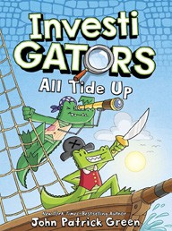

  - InvestiGators (hardcover)
John Patrick Green, First Second
  - I Survived
Lauren Tarshis, Scholastic
  - Magic Tree House
Mary Pope Osborne, Sal Murdocca (Illus.), Random House Books for Young Readers
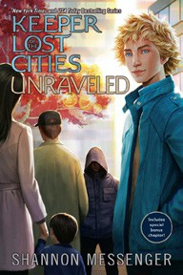

  - Keeper of the Lost Cities
Shannon Messenger, Aladdin

All Fiction Series titles are hardcover and
paperback unless noted.
Debut


Indies Introduce

OTHER CHILDREN’S INDIE FAVORITES
AGES 4 TO 8
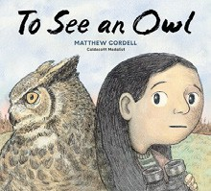

To See an Owl
Matthew Cordell, Random House Studio, $18.99
“Janie is a young birdwatcher who especially loves owls, but they’re very hard to spot. Fortunately, Janie has a lot of deter- mination and is not giving up! An inspiring story accompanied with gorgeous illustrations, perfect for the nature-lover.”
—Andrew King, Ridgecrest Books, Shoreline, WA

