RANK | FICTION
- Martyr!
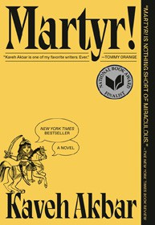



Kaveh Akbar, Vintage, $18
- Orbital
Samantha Harvey, Grove Press, $17
- Fourth Wing
Rebecca Yarros, Entangled: Red Tower Books, $20.99
- The Frozen River


Ariel Lawhon, Vintage, $18
- Demon Copperhead
Barbara Kingsolver, Harper Perennial, $21.99
- Parable of the Sower
Octavia E. Butler, Grand Central, $19.99
- Yellowface


R. F. Kuang, William Morrow Paperbacks, $18.99
- North Woods
Daniel Mason, Random House Trade Paperbacks, $18
- A Court of Thorns and Roses
Sarah J. Maas, Bloomsbury Publishing, $19
- The Berry Pickers
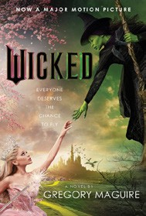

Amanda Peters, Catapult, $17.95
- The Housemaid
Freida McFadden, Grand Central, $12.99
- Tomorrow, and Tomorrow, and Tomorrow
Gabrielle Zevin, Vintage, $19
- None of This Is True
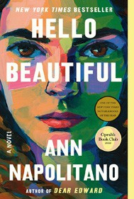

Lisa Jewell, Atria Books, $18.99
- Wicked
Gregory Maguire, William Morrow Paperbacks, $19.99
- Hello Beautiful
Ann Napolitano, Dial Press Trade Paperback, $18.99

OTHER PAPERBACK INDIE FAVORITES
The Fetishist: A Novel
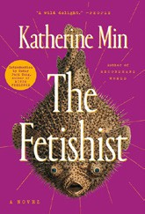

Katherine Min, G.P. Putnam’s Sons, $19
“The Fetishist is an exploration of serious emotions, accompanied by a degree of absurdity and humor. Min expertly highlights the female Asian American experience of being fetishized with unforgiving, razor-sharp prose.”
—Stuart McCommon, Interabang Books, Dallas, TX
January 22, 2025
For the week ending January 19, 2025 based on sales in hundreds of independent bookstores nationwide.
PAPERBACK

RANK | NONFICTION
  - On Tyranny: Twenty Lessons from the Twentieth Century
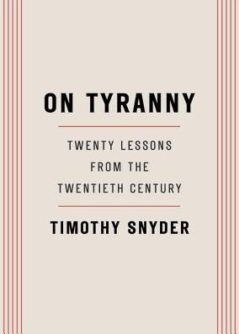

Timothy Snyder, Crown, $12
  - The Backyard Bird Chronicles
Amy Tan, Knopf, $35
  - Braiding Sweetgrass
Robin Wall Kimmerer, Milkweed Editions, $20
  - The Art Thief


Michael Finkel, Vintage, $18
  - All About Love: New Visions
bell hooks, Morrow, $16.99
  - Greenlights
Matthew McConaughey, Crown, $20
  - The Body Keeps the Score
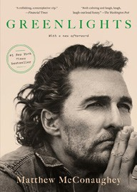

Bessel van der Kolk, M.D., Penguin, $19
  - Say Nothing
Patrick Radden Keefe, Vintage, $20
  - The Hundred Years’ War on Palestine
Rashid Khalidi, Metropolitan Books, $19.99
  - All the Beauty in the World
Patrick Bringley, Simon & Schuster, $18.99
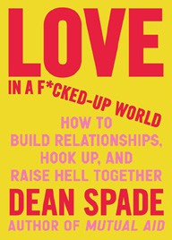

  - A New Earth
Eckhart Tolle, Penguin Life, $18
  - Four Thousand Weeks
Oliver Burkeman, Picador, $19
  - The Artist’s Way: 30th Anniversary Edition
Julia Cameron, TarcherPerigee, $20

  - Crying in H Mart: A Memoir
Michelle Zauner, Vintage, $17
  - Love in a F*cked-Up World: How to Build Relationships, Hook Up, and Raise
Hell Together
Dean Spade, Algonquin Books, $19.99
  - The Secret History of the Rape Kit: A True Crime Story
Pagan Kennedy, Vintage, $19
Debut
On the Rise

MASS MARKET Indies Introduce
- 1984 George Orwell, Signet, $10.99
- Animal Farm George Orwell, Signet, $9.99
- The Way of Kings Brandon Sanderson, Tor, $12.99
- The Exchange John Grisham, Vintage, $10.99
- Mistborn: The Final Empire Brandon Sanderson, Tor, $10.99
- Dune Frank Herbert, Ace, $10.99
- Simply Lies David Baldacci, Grand Central, $10.99
- Clive Cussler The Corsican Shadow Dirk Cussler, G.P. Putnam’s Sons, $10.99

- The Diary of a Young Girl Anne Frank, Bantam, $8.99
- The Left Hand of Darkness Ursula K. Le Guin, Ace, $10.99

