RANK | FICTION



- James
Percival Everett, Doubleday, $28
- Witchcraft for Wayward Girls
Grady Hendrix, Berkley, $30
- The God of the Woods
Liz Moore, Riverhead Books, $30
- Small Things Like These
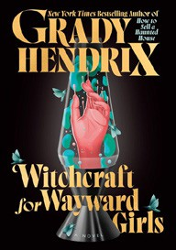

Claire Keegan, Grove Press, $20
- All Fours
Miranda July, Riverhead Books, $29
- The Wedding People
Alison Espach, Henry Holt and Co., $28.99
- Intermezzo


Sally Rooney, Farrar, Straus and Giroux, $29
- The Women
Kristin Hannah, St. Martin’s Press, $30
- Iron Flame
Rebecca Yarros, Entangled: Red Tower Books, $29.99
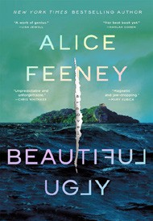
- Water Moon
Samantha Sotto Yambao, Del Rey, $28.99
- Beautiful Ugly
Alice Feeney, Flatiron Books, $28.99
- Death of the Author (Deluxe Limited Edition)
Nnedi Okorafor, William Morrow, $30
- Playground


Richard Powers, W. W. Norton & Company, $29.99
- All the Colors of the Dark
Chris Whitaker, Crown, $30
- Remarkably Bright Creatures
Shelby Van Pelt, Ecco, $29.99
January 22, 2025
For the week ending January 19, 2025 based on sales in hundreds of independent bookstores nationwide.
HARDCOVER

RANK | NONFICTION
  - The Serviceberry: Abundance and Reciprocity in the Natural World


Robin Wall Kimmerer, John Burgoyne (Illus.), Scribner, $20
  - The Let Them Theory
Mel Robbins, Hay House LLC, $29.99
  - The Message
Ta-Nehisi Coates, One World, $30
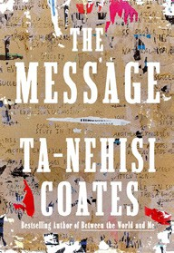

  - Revenge of the Tipping Point
Malcolm Gladwell, Little, Brown and Company, $32
  - Be Ready When the Luck Happens: A Memoir
Ina Garten, Crown, $34
  - The Creative Act: A Way of Being
Rick Rubin, Penguin Press, $32
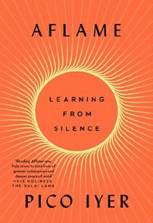
  - The Anxious Generation
Jonathan Haidt, Penguin Press, $30
  - Atomic Habits
James Clear, Avery, $27
  - Aflame: Learning from Silence
Pico Iyer, Riverhead Books, $30
  - Meditations for Mortals


Oliver Burkeman, Farrar, Straus and Giroux, $27
  - The Wide Wide Sea
Hampton Sides, Doubleday, $35
  - The Demon of Unrest
Erik Larson, Crown, $35
  - Nexus
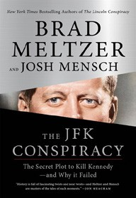

Yuval Noah Harari, Random House, $35
  - The Little Frog’s Guide to Self-Care
Maybell Eequay, Summersdale, $11.99
  - Wintering: The Power of Rest and Retreat
in Difficult Times
Katherine May, Riverhead Books, $25
17 The JFK Conspiracy: The Secret Plot to Kill Kennedy—and Why It Failed

Brad Meltzer, Josh Mensch, Flatiron Books, $29.99
Debut
On the Rise

OTHER HARDCOVER INDIE FAVORITES
Indies Introduce

The Lotus Shoes: A Novel


Jane Yang, Park Row, $28.99
“A suspenseful novel, The Lotus Shoes follows Linjing and her maidservant Little Flower in 19th-century China. As the two strug- gle to define their own relationship, they are caught between old traditions and their desire for freedom. Completely absorbing!”
—Janet Hutchison, The Open Door Bookstore, Schenectady, NY
Sweet Fury: A Novel
Sash Bischoff, Simon & Schuster, $27.99
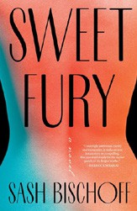

“Sweet Fury is sure to please readers who want a solid, twisty, character-driven thriller with a film industry background. Obsessive love, misogyny, deceit, revenge — this carefully crafted, well-written debut has it all. Dig in.”
—Kathy Mailloux, East City Bookshop, Washington, DC

