RANK | HARDCOVER




- James
Percival Everett, Doubleday, $28
- Witchcraft for Wayward Girls
Grady Hendrix, Berkley, $30
- The God of the Woods
Liz Moore, Riverhead Books, $30
- Small Things Like These
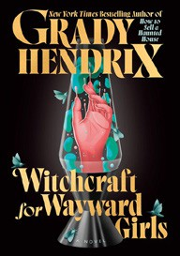

Claire Keegan, Grove Press, $20
- All Fours
Miranda July, Riverhead Books, $29
- The Wedding People
Alison Espach, Henry Holt and Co., $28.99
- Intermezzo
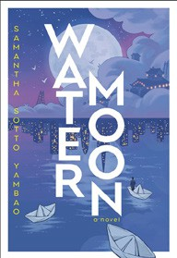

Sally Rooney, Farrar, Straus and Giroux, $29
- The Women
Kristin Hannah, St. Martin’s Press, $30
- Iron Flame
Rebecca Yarros, Entangled: Red Tower Books, $29.99
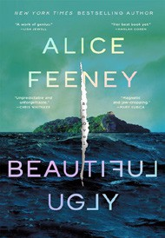
- Water Moon
Samantha Sotto Yambao, Del Rey, $28.99
- Beautiful Ugly
Alice Feeney, Flatiron Books, $28.99
- Death of the Author (Deluxe Limited Edition)
Nnedi Okorafor, William Morrow, $30
- Playground
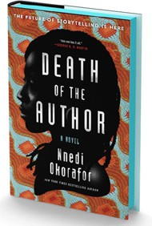

Richard Powers, W. W. Norton & Company, $29.99
- All the Colors of the Dark
Chris Whitaker, Crown, $30
- Remarkably Bright Creatures
Shelby Van Pelt, Ecco, $29.99
January 22, 2025
For the week ending January 19, 2025 based on sales in hundreds of independent bookstores nationwide.
FICTION

RANK | PAPERBACK
  - Martyr!
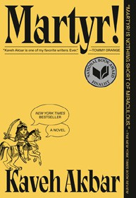

Kaveh Akbar, Vintage, $18
  - Orbital
Samantha Harvey, Grove Press, $17
  - Fourth Wing
Rebecca Yarros, Entangled: Red Tower Books, $20.99
  - The Frozen River


Ariel Lawhon, Vintage, $18
  - Demon Copperhead
Barbara Kingsolver, Harper Perennial, $21.99
  - Parable of the Sower
Octavia E. Butler, Grand Central, $19.99
  - Yellowface


R. F. Kuang, William Morrow Paperbacks, $18.99
  - North Woods
Daniel Mason, Random House Trade Paperbacks, $18
  - A Court of Thorns and Roses
Sarah J. Maas, Bloomsbury Publishing, $19
  - The Berry Pickers
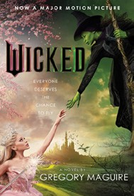

Amanda Peters, Catapult, $17.95
  - The Housemaid
Freida McFadden, Grand Central, $12.99
  - Tomorrow, and Tomorrow, and Tomorrow
Gabrielle Zevin, Vintage, $19
  - None of This Is True
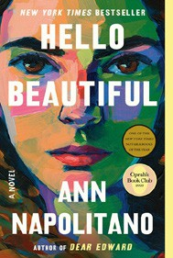

Lisa Jewell, Atria Books, $18.99
  - Wicked
Gregory Maguire, William Morrow Paperbacks, $19.99
  - Hello Beautiful
Ann Napolitano, Dial Press Trade Paperback, $18.99

Debut
On the Rise Indies Introduce

