January 22, 2025


For the week ending January 19, 2025 based on sales in hundreds of independent bookstores nationwide.
CHILDREN’S

RANK | SERIES

RANK | ILLUSTRATED

- Goodnight Moon
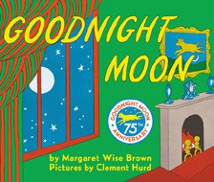

Margaret Wise Brown, Clement Hurd (Illus.), Harper,
$10.99
- Girls on the Rise
Amanda Gorman, Loveis Wise (Illus.), Viking Books for Young Readers, $19.99
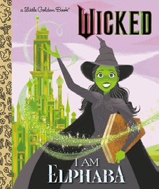

- The Very Hungry Caterpillar
Eric Carle, World of Eric Carle, $10.99
- I Am Elphaba (Little Golden Book)
Mary Man-Kong, Elsa Chang (Illus.), Golden Books,
$5.99
- Where the Wild Things Are
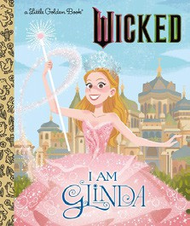

Maurice Sendak, Harper, $21.99
- The Snowy Day
Ezra Jack Keats, Viking Books for Young Readers,
$19.99
- I Am Glinda (Little Golden Book)
Mary Man-Kong, Elsa Chang (Illus.), Golden Books,
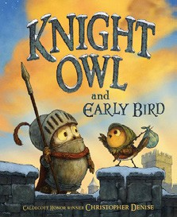

$5.99
- Knight Owl and Early Bird
Christopher Denise, Christy Ottaviano Books, $18.99
- The Bakery Dragon
Devin Elle Kurtz, Knopf Books for Young Readers,
$18.99
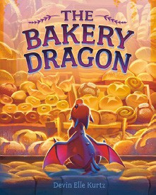

- Knight Owl
Christopher Denise, Christy Ottaviano Books, $17.99
- Brown Bear, Brown Bear, What Do You See? Bill Martin, Jr., Eric Carle (Illus.), Henry Holt and Co. BYR, $8.99
- The Mitten
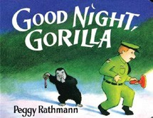

Jan Brett, G.P. Putnam’s Sons Books for Young Readers, $9.99
- Dragons Love Tacos
Adam Rubin, Daniel Salmieri (Illus.), Dial Books, $18.99
- Good Night, Gorilla
Peggy Rathmann, G.P. Putnam’s Sons Books for Young Readers, $8.99
- Dragon’s First Taco
Adam Rubin, Daniel Salmieri (Illus.), Dial Books, $8.99
  - Dog Man (hardcover)
Dav Pilkey, Graphix
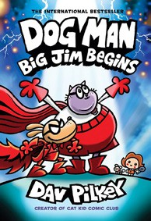

  - Wings of Fire
Tui T. Sutherland, Mike Holmes (Illus.), Scholastic
  - Diary of a Wimpy Kid (hardcover)
Jeff Kinney, Harry N. Abrams
  - The Wild Robot
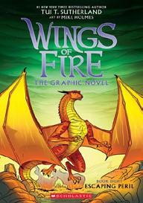

Peter Brown, Little, Brown Books for Young Readers
  - Elephant & Piggie (hardcover)
Mo Willems, Hyperion
  - Percy Jackson and the Olympians
Rick Riordan, Hyperion
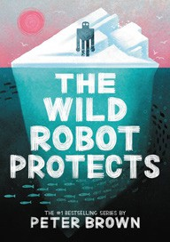

  - Magic Tree House
Mary Pope Osborne, Sal Murdocca (Illus.), Random House Books for Young Readers
  - The Bad Guys (paperback)
Aaron Blabey, Scholastic
  - I Survived
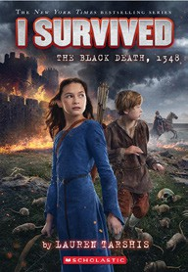

Lauren Tarshis, Dave Shephard (Illus.), Scholastic
  - InvestiGators (hardcover)
John Patrick Green, First Second

All Fiction Series titles are hardcover and
paperback unless noted.
Debut


Indies Introduce

OTHER CHILDREN’S INDIE FAVORITES
AGES 4 TO 8
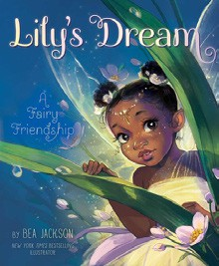

Lily’s Dream: A Fairy Friendship
Bea Jackson, Aladdin, $18.99
“Stunning! A truly beautiful book, full of messages about perseverance, friendship, and appreciating what makes each of us unique. This story will also leave readers itching to build fairy houses of their own.”
—Amanda Zarni, Book Ends Winchester, Winchester, MA

