RANK | FICTION
- Martyr!
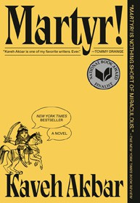



Kaveh Akbar, Vintage, $18
- Orbital
Samantha Harvey, Grove Press, $17
- Demon Copperhead
Barbara Kingsolver, Harper Perennial, $21.99
- The Frozen River
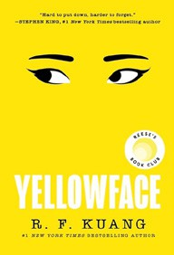

Ariel Lawhon, Vintage, $18
- Fourth Wing
Rebecca Yarros, Entangled: Red Tower Books, $20.99
- A Court of Thorns and Roses
Sarah J. Maas, Bloomsbury Publishing, $19
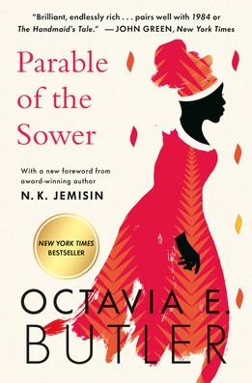
- North Woods
Daniel Mason, Random House Trade Paperbacks,
$18
- Yellowface
R. F. Kuang, William Morrow Paperbacks, $18.99
- The Berry Pickers
Amanda Peters, Catapult, $17.95
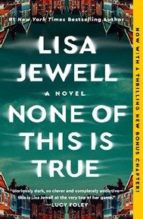

- The Housemaid
Freida McFadden, Grand Central, $12.99
- Wicked
Gregory Maguire, William Morrow Paperbacks, $19.99
- Parable of the Sower

Octavia E. Butler, Grand Central, $19.99
- Tomorrow, and Tomorrow, and Tomorrow
Gabrielle Zevin, Vintage, $19
- None of This Is True
Lisa Jewell, Atria Books, $18.99
- Beg, Borrow, or Steal
Sarah Adams, Dell, $18

OTHER PAPERBACK INDIE FAVORITES
The Mystery Guest: A Maid Novel
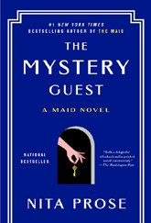

Nita Prose, Ballantine Books, $18
“Molly is back with another entertaining mystery to solve at the Regency Grand Hotel. This time, a famous author is under scru- tiny, featuring a pack of rabid fans and a peek into Molly’s past. Pour a nice cup of tea and enjoy Molly’s next case!”
—Jenny Stroyeck, The Homer Bookstore, Homer, AK
January 15, 2025
For the week ending January 12, 2025 based on sales in hundreds of independent bookstores nationwide.
PAPERBACK

RANK | NONFICTION
  - Braiding Sweetgrass: Indigenous Wisdom, Scientific Knowledge, and the Teachings of Plants


Robin Wall Kimmerer, Milkweed Editions, $20
  - The Backyard Bird Chronicles
Amy Tan, Knopf, $35
  - On Tyranny
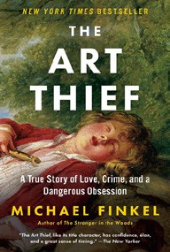

Timothy Snyder, Crown, $12
  - The Art Thief
Michael Finkel, Vintage, $18
  - All About Love: New Visions
bell hooks, Morrow, $16.99
  - Greenlights


Matthew McConaughey, Crown, $20
  - The Hundred Years’ War on Palestine
Rashid Khalidi, Metropolitan Books, $19.99
  - The Artist’s Way: 30th Anniversary Edition
Julia Cameron, TarcherPerigee, $20
  - Say Nothing
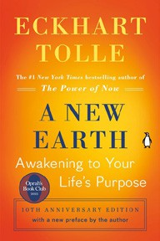

Patrick Radden Keefe, Vintage, $20
  - A New Earth: Awakening to Your Life’s Purpose
Eckhart Tolle, Penguin Life, $18
  - The Four Agreements
Don Miguel Ruiz, Amber-Allen, $12.95
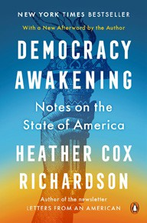

  - The Body Keeps the Score
Bessel van der Kolk, M.D., Penguin, $19
  - Crying in H Mart: A Memoir
Michelle Zauner, Vintage, $17
  - All the Beauty in the World
Patrick Bringley, Simon & Schuster, $18.99
  - Democracy Awakening
Heather Cox Richardson, Penguin, $18
Debut
On the Rise

MASS MARKET Indies Introduce
- 1984 George Orwell, Signet, $10.99
- Mistborn: The Final Empire Brandon Sanderson, Tor, $10.99
- Animal Farm George Orwell, Signet, $9.99
- The Way of Kings Brandon Sanderson, Tor, $12.99
- Dune Frank Herbert, Ace, $10.99
- The Exchange John Grisham, Vintage, $10.99

- Simply Lies David Baldacci, Grand Central, $10.99
- Rhythm of War Brandon Sanderson, Tor, $12.99
- Shattered James Patterson, James O. Born, Grand Central, $10.99
- Warbreaker Brandon Sanderson, Tor, $11.99

