RANK | HARDCOVER

- The Serviceberry: Abundance and Reciprocity in the Natural World




Robin Wall Kimmerer, John Burgoyne (Illus.), Scribner, $20
- The Message
Ta-Nehisi Coates, One World, $30
- Be Ready When the Luck Happens: A Memoir
Ina Garten, Crown, $34
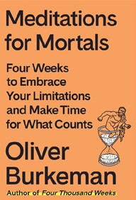

- Atomic Habits
James Clear, Avery, $27
- The Creative Act: A Way of Being
Rick Rubin, Penguin Press, $32
- Revenge of the Tipping Point
Malcolm Gladwell, Little, Brown and Company, $32
- The Anxious Generation


Jonathan Haidt, Penguin Press, $30
- Meditations for Mortals
Oliver Burkeman, Farrar, Straus and Giroux, $27
- The Wide Wide Sea
Hampton Sides, Doubleday, $35
- The Let Them Theory

Mel Robbins, Hay House LLC, $29.99
- Nexus
Yuval Noah Harari, Random House, $35
- Beyond Anxiety: Curiosity, Creativity, and Finding Your Life’s Purpose
Martha Beck, The Open Field, $30

- The Demon of Unrest
Erik Larson, Crown, $35
- The Little Frog’s Guide to Self-Care
Maybell Eequay, Summersdale, $11.99
- The Dog Who Followed the Moon
James Norbury, William Morrow, $25
- The House of My Mother: A Daughter’s Quest for Freedom

Shari Franke, Gallery Books, $29.99
January 15, 2025
For the week ending January 12, 2025 based on sales in hundreds of independent bookstores nationwide.
NONFICTION

RANK | PAPERBACK

  - Braiding Sweetgrass: Indigenous Wisdom, Scientific Knowledge, and the Teachings of Plants


Robin Wall Kimmerer, Milkweed Editions, $20
  - The Backyard Bird Chronicles
Amy Tan, Knopf, $35
  - On Tyranny
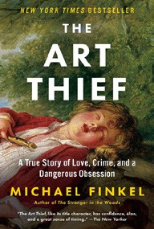

Timothy Snyder, Crown, $12
  - The Art Thief
Michael Finkel, Vintage, $18
  - All About Love: New Visions
bell hooks, Morrow, $16.99
  - Greenlights


Matthew McConaughey, Crown, $20
  - The Hundred Years’ War on Palestine
Rashid Khalidi, Metropolitan Books, $19.99
  - The Artist’s Way: 30th Anniversary Edition
Julia Cameron, TarcherPerigee, $20
  - Say Nothing


Patrick Radden Keefe, Vintage, $20
  - A New Earth: Awakening to Your Life’s Purpose
Eckhart Tolle, Penguin Life, $18
  - The Four Agreements
Don Miguel Ruiz, Amber-Allen, $12.95
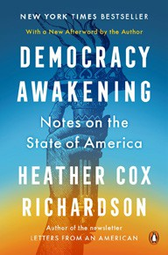

  - The Body Keeps the Score
Bessel van der Kolk, M.D., Penguin, $19
  - Crying in H Mart: A Memoir
Michelle Zauner, Vintage, $17
  - All the Beauty in the World
Patrick Bringley, Simon & Schuster, $18.99
  - Democracy Awakening
Heather Cox Richardson, Penguin, $18

Debut
On the Rise Indies Introduce

