RANK | EARLY & MIDDLE GRADE
- Impossible Creatures
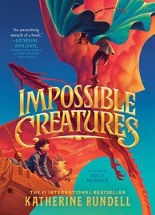



Katherine Rundell, Ashley Mackenzie (Illus.), Knopf Books for Young Readers, $19.99
- The Bletchley Riddle
Ruta Sepetys, Steve Sheinkin, Viking Books for Young Readers, $18.99
- The Squad: A Graphic Novel
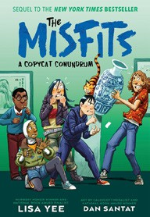
Christina Soontornvat, Joanna Cacao (Illus.) Graphix, $12.99
- Warriors Graphic Novel: The Prophecies Begin #1 Erin Hunter, Natalie Riess (Illus.), Sara Goetter (Illus.), HarperAlley, $15.99
- A Copycat Conundrum (The Misfits)
Lisa Yee, Dan Santat (Illus.), Random House Books for Young Readers, $14.99
- The Millicent Quibb School of Etiquette for Young Ladies of Mad Science
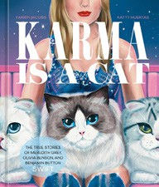

Kate McKinnon, Little, Brown Books for Young Readers, $17.99
- Super Duper Extra Deluxe Essential
Handbook (Pokémon)
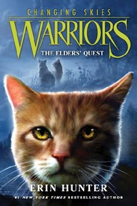
Scholastic, $16.99
- Karma Is a Cat: The True Stories of Meredith Grey, Olivia Benson, and Benjamin Button Swift Farrin Jacobs, Katty Huertas (Illus.), Ten Speed Press, $12.99
- The One and Only Bob
Katherine Applegate, Patricia Castelao (Illus.), HarperCollins, $10.99
- The New Girl: A Graphic Novel
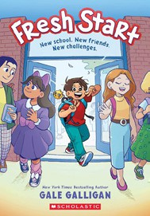
Cassandra Calin, Graphix, $12.99
- Warriors: Changing Skies #1: The Elders’ Quest
Erin Hunter, HarperCollins, $19.99
- The Eyes and the Impossible
Dave Eggers, Shawn Harris (Illus.), Knopf Books for Young Readers, $19.99
- Fresh Start: A Graphic Novel
Gale Galligan, Graphix, $14.99
- The Last Dragon on Mars
Scott Reintgen, Aladdin, $18.99
- Drama: A Graphic Novel
Raina Telgemeier, Graphix, $12.99
January 15, 2025
For the week ending January 12, 2025 based on sales in hundreds of independent bookstores nationwide.
CHILDREN’S

RANK | YOUNG ADULT
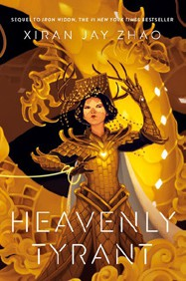
  - Heavenly Tyrant
Xiran Jay Zhao, Tundra Books, $20.99
  - Powerless
Lauren Roberts, Simon & Schuster Books for Young Readers, $19.99
  - The Last Bookstore on Earth
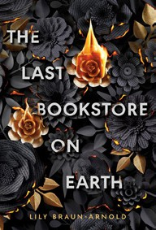
Lily Braun-Arnold, Delacorte Press, $19.99
  - Iron Widow
Xiran Jay Zhao, Tundra Books, $11.99
  - Breath of the Dragon: Breathmarked
Fonda Lee, Shannon Lee, Wednesday Books, $21
  - If He Had Been with Me
Laura Nowlin, Sourcebooks Fire, $10.99
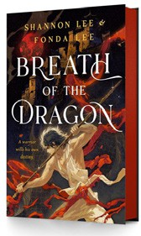

  - Pride and Prejudice
Jane Austen, Anna Bond (Illus.), Puffin Books, $17
  - Better Than the Movies
Lynn Painter, Simon & Schuster Books for Young Readers, $12.99
  - The Outsiders
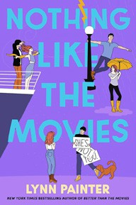

S. E. Hinton, Viking Books for Young Readers, $14.99
  - Nothing Like the Movies
Lynn Painter, Simon & Schuster Books for Young Readers, $19.99
  - The Perks of Being a Wallflower
Stephen Chbosky, MTV Books, $15.99
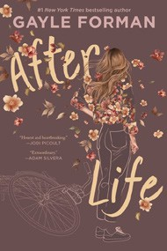
  - Divine Rivals
Rebecca Ross, Wednesday Books, $18.99
  - Reckless
Lauren Roberts, Simon & Schuster Books for Young Readers, $21.99
  - After Life
Gayle Forman, Quill Tree Books, $19.99
  - Heir
Sabaa Tahir, G.P. Putnam’s Sons Books for Young Readers, $21.99
Debut


OTHER CHILDREN’S INDIE FAVORITES
Indies Introduce

AGES 8 TO 12 TEEN READERS
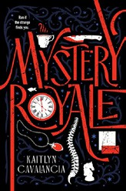

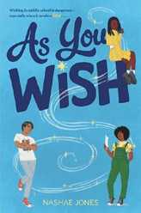

As You Wish
Nashae Jones, Aladdin, $17.99
“Birdie’s plans to get a boyfriend as an eighth grader go awry when a mythological West African god Anansi appears and grants a series of wishes. A sweet middle grade romance with a fun twist!”
—Beth Seufer Buss, Bookmarks, Winston-Salem, NC
Mystery Royale
Kaitlyn Cavalancia, Disney Hyperion, $18.99

“This novel reads like a complex puzzle game with a touch of romance and lots of family drama! Readers will be swept up in this magical illusionary world.”
—Kristine Jelstrom-Hamill, Buttonwood Books and Toys, Cohasset, MA

