RANK | HARDCOVER

- James




Percival Everett, Doubleday, $28
- The God of the Woods
Liz Moore, Riverhead Books, $30
- Small Things Like These
Claire Keegan, Grove Press, $20
- Intermezzo
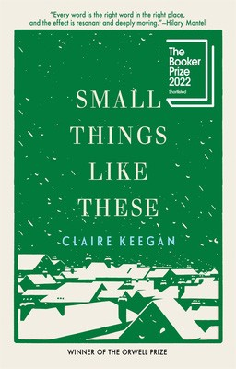

Sally Rooney, Farrar, Straus and Giroux, $29
- All Fours
Miranda July, Riverhead Books, $29
- The Women
Kristin Hannah, St. Martin’s Press, $30
- The Wedding People
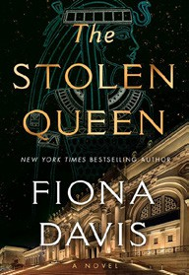

Alison Espach, Henry Holt and Co., $28.99
- Iron Flame
Rebecca Yarros, Entangled: Red Tower Books, $29.99
- Playground
Richard Powers, W. W. Norton & Company, $29.99

- Tell Me Everything
Elizabeth Strout, Random House, $30
- All the Colors of the Dark
Chris Whitaker, Crown, $30
- The Stolen Queen
Fiona Davis, Dutton, $29
- Wind and Truth


Brandon Sanderson, Tor Books, $39.99
- Remarkably Bright Creatures
Shelby Van Pelt, Ecco, $29.99
- The City and Its Uncertain Walls
Haruki Murakami, Knopf, $35
17 The Life Cycle of the Common Octopus

Emma Knight, Pamela Dorman Books, $29
January 15, 2025
For the week ending January 12, 2025 based on sales in hundreds of independent bookstores nationwide.
FICTION

RANK | PAPERBACK
- Martyr!


Kaveh Akbar, Vintage, $18
- Orbital
Samantha Harvey, Grove Press, $17
- Demon Copperhead
Barbara Kingsolver, Harper Perennial, $21.99
- The Frozen River


Ariel Lawhon, Vintage, $18
- Fourth Wing
Rebecca Yarros, Entangled: Red Tower Books, $20.99
- A Court of Thorns and Roses
Sarah J. Maas, Bloomsbury Publishing, $19
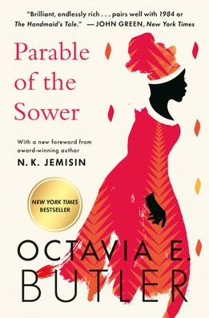
- North Woods
Daniel Mason, Random House Trade Paperbacks,
$18
- Yellowface
R. F. Kuang, William Morrow Paperbacks, $18.99
- The Berry Pickers
Amanda Peters, Catapult, $17.95
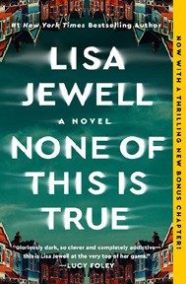

- The Housemaid
Freida McFadden, Grand Central, $12.99
- Wicked
Gregory Maguire, William Morrow Paperbacks, $19.99
- Parable of the Sower

Octavia E. Butler, Grand Central, $19.99
- Tomorrow, and Tomorrow, and Tomorrow
Gabrielle Zevin, Vintage, $19
- None of This Is True
Lisa Jewell, Atria Books, $18.99
- Beg, Borrow, or Steal
Sarah Adams, Dell, $18

Debut
On the Rise Indies Introduce

