January 15, 2025


For the week ending January 12, 2025 based on sales in hundreds of independent bookstores nationwide.
CHILDREN’S

RANK | SERIES

RANK | ILLUSTRATED

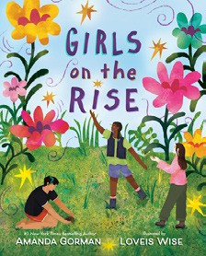
- Girls on the Rise
Amanda Gorman, Loveis Wise (Illus.), Viking Books for Young Readers, $19.99
- Goodnight Moon
Margaret Wise Brown, Clement Hurd (Illus.), Harper,
$10.99
- The Very Hungry Caterpillar
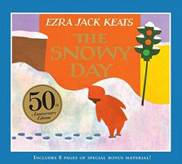

Eric Carle, World of Eric Carle, $10.99
- The Snowy Day
Ezra Jack Keats, Viking Books for Young Readers,
$19.99
- The Bakery Dragon
Devin Elle Kurtz, Knopf Books for Young Readers,
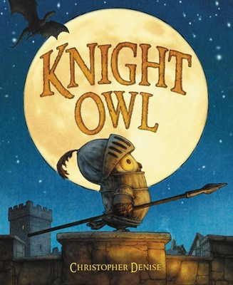

$18.99
- I Am Elphaba (Little Golden Book)
Mary Man-Kong, Elsa Chang (Illus.), Golden Books,
$5.99
- Knight Owl and Early Bird
Christopher Denise, Christy Ottaviano Books, $18.99
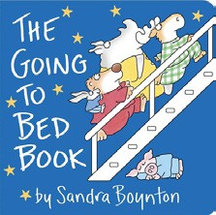

- Where the Wild Things Are
Maurice Sendak, Harper, $21.99
- I Am Glinda (Little Golden Book)
Mary Man-Kong, Elsa Chang (Illus.), Golden Books,
$5.99
- Brown Bear, Brown Bear, What Do You See? Bill Martin, Jr., Eric Carle (Illus.), Henry Holt and Co. BYR, $8.99
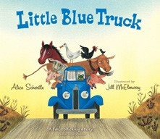

- Knight Owl
Christopher Denise, Christy Ottaviano Books,
$17.99
- The Going to Bed Book
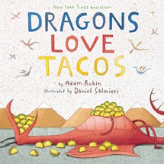

Sandra Boynton, Boynton Bookworks, $6.99
- The Mitten
Jan Brett, G.P. Putnam’s Sons Books for Young Readers, $9.99
- Little Blue Truck
Alice Schertle, Jill McElmurry (Illus.), Clarion Books,
$10.99
- Dragons Love Tacos
Adam Rubin, Daniel Salmieri (Illus.), Dial Books,
$18.99
  - Dog Man (hardcover)
Dav Pilkey, Graphix
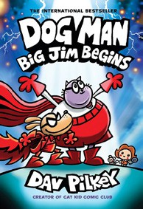

  - Wings of Fire
Tui T. Sutherland, Mike Holmes (Illus.), Scholastic
  - Diary of a Wimpy Kid (hardcover)
Jeff Kinney, Harry N. Abrams
  - The Wild Robot
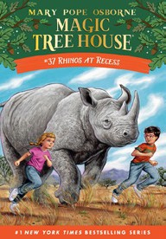

Peter Brown, Little, Brown Books for Young Readers
  - Elephant & Piggie (hardcover)
Mo Willems, Hyperion
  - Percy Jackson and the Olympians
Rick Riordan, Hyperion
  - Magic Tree House
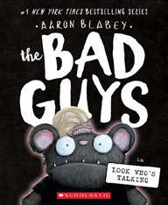

Mary Pope Osborne, Sal Murdocca (Illus.), Random House Books for Young Readers
  - The Bad Guys (paperback)
Aaron Blabey, Scholastic
  - Keeper of the Lost Cities
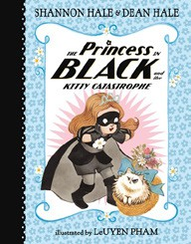

Shannon Messenger, Aladdin
  - The Princess in Black
Shannon Hale, Dean Hale, LeUyen Pham (Illus.), Candlewick

All Fiction Series titles are hardcover and
paperback unless noted.
Debut


Indies Introduce

OTHER CHILDREN’S INDIE FAVORITES
AGES 4 TO 8
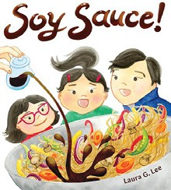

Soy Sauce!
Laura G. Lee, Algonquin Young Readers, $18.99
“Where would we be without the humble, versatile, workhorse of flavor: soy sauce? This picture book is a joyful ode to this
essential element of East Asian food, and provides a fascinating look at how different cultures make soy sauce.”
—Audrey Mueller, Linden Tree Children’s Books, Los Altos, CA

