RANK | FICTION
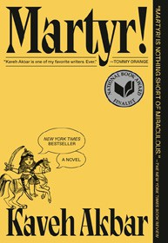


- Martyr!
Kaveh Akbar, Vintage, $18
- Orbital
Samantha Harvey, Grove Press, $17
- Demon Copperhead
Barbara Kingsolver, Harper Perennial, $21.99
- Fourth Wing


Rebecca Yarros, Entangled: Red Tower Books, $20.99
- The Frozen River
Ariel Lawhon, Vintage, $18
- The Berry Pickers
Amanda Peters, Catapult, $17.95
- A Court of Thorns and Roses
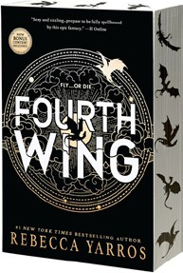

Sarah J. Maas, Bloomsbury Publishing, $19
- North Woods
Daniel Mason, Random House Trade Paperbacks,
$18
- Wicked
Gregory Maguire, William Morrow Paperbacks,
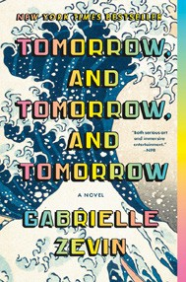

$19.99
- Tomorrow, and Tomorrow, and Tomorrow
Gabrielle Zevin, Vintage, $19
- Hello Beautiful
Ann Napolitano, Dial Press Trade Paperback, $18.99
- The Housemaid
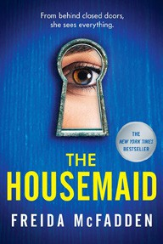

Freida McFadden, Grand Central, $12.99
- The Thursday Murder Club
Richard Osman, Penguin, $18
- The Hunter
Tana French, Penguin, $19
- The Midnight Library
Matt Haig, Penguin, $18

OTHER PAPERBACK INDIE FAVORITES
Alice Sadie Celine: A Novel
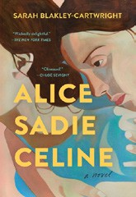

Sarah Blakley-Cartwright, Simon & Schuster, $17.99
“Written in gorgeous prose that dives deeply into each of the three women’s characters and backstories, with a level of sus- pense that kept me wondering how things would turn out in the end. This novel is unique and surprising. A great read.”
—Christine Bell, Roundabout Books, Bend, OR
January 8, 2025
For the week ending January 5, 2025 based on sales in hundreds of independent bookstores nationwide.
PAPERBACK

RANK | NONFICTION
  - On Tyranny: Twenty Lessons from the Twentieth Century
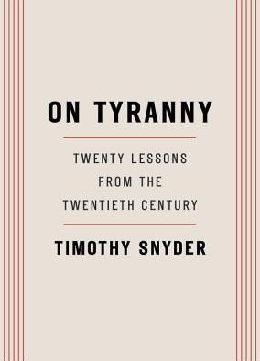

Timothy Snyder, Crown, $12
  - The Backyard Bird Chronicles
Amy Tan, Knopf, $35
  - Braiding Sweetgrass
Robin Wall Kimmerer, Milkweed Editions, $20
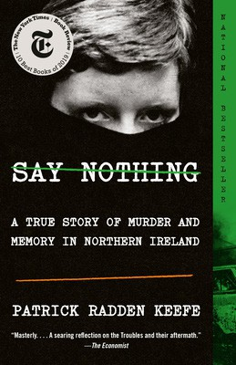

  - The Art Thief
Michael Finkel, Vintage, $18
  - All About Love: New Visions
bell hooks, Morrow, $16.99
  - Greenlights
Matthew McConaughey, Crown, $20
  - Say Nothing


Patrick Radden Keefe, Vintage, $20
  - The Hundred Years’ War on Palestine
Rashid Khalidi, Metropolitan Books, $19.99
  - The Body Keeps the Score
Bessel van der Kolk, M.D., Penguin, $19
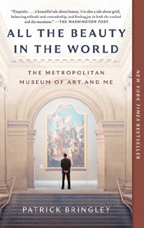

  - The Artist’s Way: 30th Anniversary Edition
Julia Cameron, TarcherPerigee, $20
  - Democracy Awakening
Heather Cox Richardson, Penguin, $18
  - All the Beauty in the World
Patrick Bringley, Simon & Schuster, $18.99
  - The Four Agreements


Don Miguel Ruiz, Amber-Allen, $12.95
  - Four Thousand Weeks
Oliver Burkeman, Picador, $19
  - Crying in H Mart: A Memoir
Michelle Zauner, Vintage, $17
  - Your Brain on Art: How the Arts Transform Us Susan Magsamen, Ivy Ross, Random House Trade Paperbacks, $20

Debut
On the Rise

MASS MARKET Indies Introduce
- 1984 George Orwell, Signet, $10.99
- The Way of Kings Brandon Sanderson, Tor, $12.99
- Mistborn: The Final Empire Brandon Sanderson, Tor, $10.99
- The Exchange John Grisham, Vintage, $10.99
- Dune Frank Herbert, Ace, $10.99
- Animal Farm George Orwell, Signet, $9.99

- After That Night Karin Slaughter, William Morrow Paperbacks, $10.99
- Dune Messiah Frank Herbert, Ace, $9.99

- Upside Down Danielle Steel, Dell, $9.99
- The Left Hand of Darkness Ursula K. Le Guin, Ace, $10.99

