RANK | HARDCOVER

- The Serviceberry: Abundance and Reciprocity in the Natural World




Robin Wall Kimmerer, John Burgoyne (Illus.), Scribner, $20
- The Message
Ta-Nehisi Coates, One World, $30
- Be Ready When the Luck Happens: A Memoir

Ina Garten, Crown, $34
- Revenge of the Tipping Point
Malcolm Gladwell, Little, Brown and Company, $32
- The Creative Act: A Way of Being
Rick Rubin, Penguin Press, $32
- Atomic Habits
James Clear, Avery, $27
- The Anxious Generation


Jonathan Haidt, Penguin Press, $30
- The Demon of Unrest
Erik Larson, Crown, $35
- The Wide Wide Sea
Hampton Sides, Doubleday, $35


- Nexus: A Brief History of Information Networks from the Stone Age to AI Yuval Noah Harari, Random House, $35
- The Let Them Theory: A Life-Changing Tool That Millions of People Can’t Stop Talking About

Mel Robbins, Hay House LLC, $29.99
- Meditations for Mortals
Oliver Burkeman, Farrar, Straus and Giroux, $27
- The Dog Who Followed the Moon
James Norbury, William Morrow, $25
- What I Ate in One Year
Stanley Tucci, Gallery Books, $35
- Patriot: A Memoir
Alexei Navalny, Knopf, $35
January 8, 2025
For the week ending January 5, 2025 based on sales in hundreds of independent bookstores nationwide.
NONFICTION

RANK | PAPERBACK

  - On Tyranny: Twenty Lessons from the Twentieth Century


Timothy Snyder, Crown, $12
  - The Backyard Bird Chronicles
Amy Tan, Knopf, $35
  - Braiding Sweetgrass
Robin Wall Kimmerer, Milkweed Editions, $20
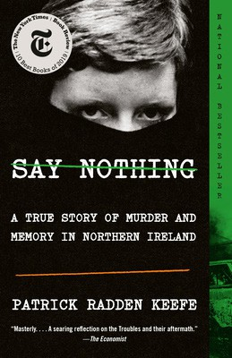

  - The Art Thief
Michael Finkel, Vintage, $18
  - All About Love: New Visions
bell hooks, Morrow, $16.99
  - Greenlights
Matthew McConaughey, Crown, $20
  - Say Nothing


Patrick Radden Keefe, Vintage, $20
  - The Hundred Years’ War on Palestine
Rashid Khalidi, Metropolitan Books, $19.99
  - The Body Keeps the Score
Bessel van der Kolk, M.D., Penguin, $19


  - The Artist’s Way: 30th Anniversary Edition
Julia Cameron, TarcherPerigee, $20
  - Democracy Awakening
Heather Cox Richardson, Penguin, $18
  - All the Beauty in the World
Patrick Bringley, Simon & Schuster, $18.99
  - The Four Agreements
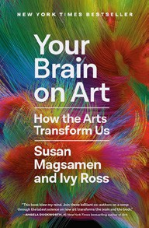

Don Miguel Ruiz, Amber-Allen, $12.95
  - Four Thousand Weeks
Oliver Burkeman, Picador, $19
  - Crying in H Mart: A Memoir
Michelle Zauner, Vintage, $17
  - Your Brain on Art: How the Arts Transform Us Susan Magsamen, Ivy Ross, Random House Trade Paperbacks, $20

Debut
On the Rise Indies Introduce

