RANK | EARLY & MIDDLE GRADE
- Impossible Creatures
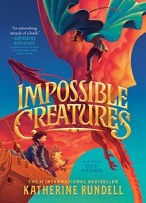



Katherine Rundell, Ashley Mackenzie (Illus.), Knopf Books for Young Readers, $19.99
- The Squad: A Graphic Novel
Christina Soontornvat, Joanna Cacao (Illus.), Graphix, $12.99
- The Bletchley Riddle
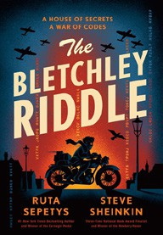

Ruta Sepetys, Steve Sheinkin, Viking Books for Young Readers, $18.99
- The New Girl: A Graphic Novel
Cassandra Calin, Graphix, $12.99
- Warriors Graphic Novel: The Prophecies Begin #1
Erin Hunter, Natalie Riess (Illus.), Sara Goetter (Illus.), HarperAlley, $15.99
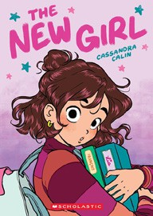

- Super Duper Extra Deluxe Essential Handbook (Pokémon)
Scholastic, $16.99
- The Sherlock Society
James Ponti, Aladdin, $18.99
- The Eyes and the Impossible
Dave Eggers, Shawn Harris (Illus.), Knopf Books for Young Readers, $19.99
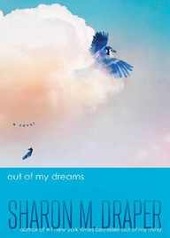

- Scholastic Year in Sports 2025
James Buckley, Scholastic, $14.99
- Guts: A Graphic Novel
Raina Telgemeier, Graphix, $12.99
- The Millicent Quibb School of Etiquette for Young Ladies of Mad Science
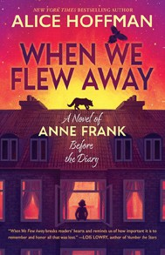

Kate McKinnon, Little, Brown Books for Young Readers, $17.99
- Out of My Dreams
Sharon M. Draper, Atheneum/Caitlyn Dlouhy Books, $18.99
- Smile: A Graphic Novel
Raina Telgemeier, Graphix, $12.99
- Drama: A Graphic Novel
Raina Telgemeier, Graphix, $12.99
- When We Flew Away: A Novel of Anne Frank Before the Diary

Alice Hoffman, Scholastic Press, $19.99
Debut
Indies Introduce
January 8, 2025
For the week ending January 5, 2025 based on sales in hundreds of independent bookstores nationwide.
CHILDREN’S

RANK | YOUNG ADULT
  - Heavenly Tyrant
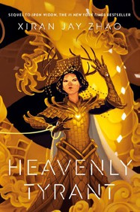

Xiran Jay Zhao, Tundra Books, $20.99
  - Nothing Like the Movies
Lynn Painter, Simon & Schuster Books for Young Readers, $19.99
  - Powerless
Lauren Roberts, Simon & Schuster Books for Young Readers, $19.99
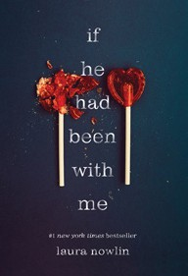

  - If He Had Been with Me
Laura Nowlin, Sourcebooks Fire, $10.99
  - Better Than the Movies
Lynn Painter, Simon & Schuster Books for Young Readers, $12.99
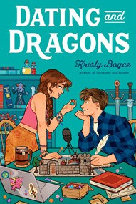
  - Dating and Dragons
Kristy Boyce, Delacorte Romance, $12.99
  - If Only I Had Told Her
Laura Nowlin, Sourcebooks Fire, $12.99
  - The Reappearance of Rachel Price
Holly Jackson, Delacorte Press, $20.99
  - Pride and Prejudice
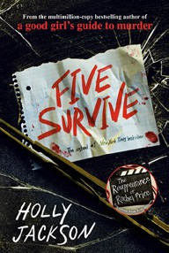

Jane Austen, Anna Bond (Illus.), Puffin Books, $17
  - Reckless
Lauren Roberts, Simon & Schuster Books for Young Readers, $21.99
  - Iron Widow
Xiran Jay Zhao, Tundra Books, $11.99
  - Betting on You
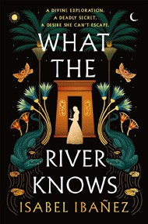

Lynn Painter, Simon & Schuster Books for Young Readers, $12.99
  - Heir
Sabaa Tahir, G.P. Putnam’s Sons Books for Young Readers, $21.99
  - Five Survive
Holly Jackson, Ember, $14.99
  - What the River Knows
Isabel Ibañez, Wednesday Books, $20

OTHER CHILDREN’S INDIE FAVORITES
AGES 8 TO 12 TEEN READERS
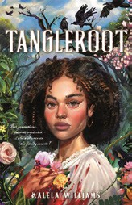

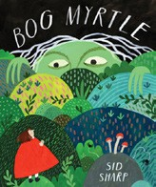

Bog Myrtle
Sid Sharp, Annick Press, $19.99
“I LOVE THIS GRAPHIC NOVEL! Fantastic illustrations perfectly depict the story’s changing moods. Problems are solved righteously with humor. And I love that spiders are depicted as the intelligent, valuable creatures they are.”
—Kay Wosewick, Boswell Book Company, Milwaukee, WI
Tangleroot
Kalela Williams, Feiwel & Friends, $19.99

“Sometimes your family history is as tangled as the vines on the ground. When Noni is forced to make a new home in the ‘Big House’ built by an enslaved ancestor, she may discover truths about herself and her family that none could have imagined.”
—Sally Sue Lavigne, The Storybook Shoppe, Bluffton, SC

