RANK | FICTION
- James
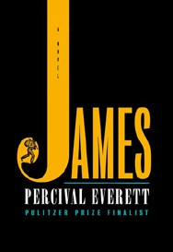



Percival Everett, Doubleday, $28
- Intermezzo
Sally Rooney, Farrar, Straus and Giroux, $29
- All Fours
Miranda July, Riverhead Books, $29
- Small Things Like These


Claire Keegan, Grove Press, $20
- The God of the Woods
Liz Moore, Riverhead Books, $30
- The Women
Kristin Hannah, St. Martin’s Press, $30
- The Wedding People
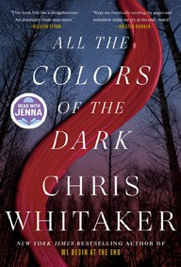

Alison Espach, Henry Holt and Co., $28.99
- Wind and Truth
Brandon Sanderson, Tor Books, $39.99
- Playground
Richard Powers, W. W. Norton & Company, $29.99
- Iron Flame
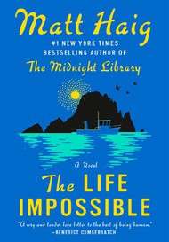

Rebecca Yarros, Entangled: Red Tower Books, $29.99
- Tell Me Everything
Elizabeth Strout, Random House, $30
- All the Colors of the Dark
Chris Whitaker, Crown, $30
- The City and Its Uncertain Walls
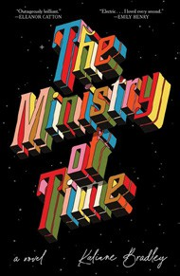

Haruki Murakami, Knopf, $35
- The Life Impossible
Matt Haig, Viking, $30
- The Ministry of Time
Kaliane Bradley, Avid Reader Press/Simon & Schuster,
$28.99
January 8, 2025
For the week ending January 5, 2025 based on sales in hundreds of independent bookstores nationwide.
HARDCOVER

RANK | NONFICTION
  - The Serviceberry: Abundance and Reciprocity in the Natural World
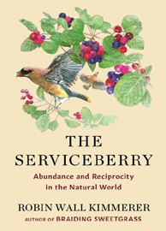

Robin Wall Kimmerer, John Burgoyne (Illus.), Scribner, $20
  - The Message
Ta-Nehisi Coates, One World, $30
  - Be Ready When the Luck Happens: A Memoir
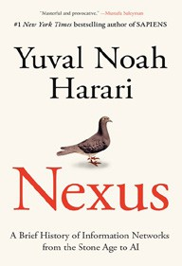
Ina Garten, Crown, $34
  - Revenge of the Tipping Point
Malcolm Gladwell, Little, Brown and Company, $32
  - The Creative Act: A Way of Being
Rick Rubin, Penguin Press, $32
  - Atomic Habits
James Clear, Avery, $27
  - The Anxious Generation
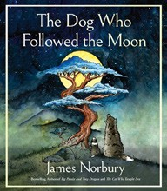

Jonathan Haidt, Penguin Press, $30
  - The Demon of Unrest
Erik Larson, Crown, $35
  - The Wide Wide Sea
Hampton Sides, Doubleday, $35


  - Nexus: A Brief History of Information Networks from the Stone Age to AI Yuval Noah Harari, Random House, $35
  - The Let Them Theory: A Life-Changing Tool That Millions of People Can’t Stop Talking About

Mel Robbins, Hay House LLC, $29.99
  - Meditations for Mortals
Oliver Burkeman, Farrar, Straus and Giroux, $27
  - The Dog Who Followed the Moon
James Norbury, William Morrow, $25
  - What I Ate in One Year
Stanley Tucci, Gallery Books, $35
  - Patriot: A Memoir
Alexei Navalny, Knopf, $35

OTHER HARDCOVER INDIE FAVORITES
Debut
On the Rise

Indies Introduce

The Champagne Letters: A Novel
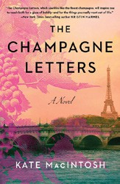

Kate MacIntosh, Gallery Books, $28.99
“This novel is an exciting glass of history and present day that celebrates a strong woman, pouring in journal entries from an 18th-century connoisseur of early champagne with a modern tale of deception, love, and revenge. Well worth the time and read!”
—R. Aimee Chipman, The Bluestocking Bookshop, Holland, MI
A Monsoon Rising: A Novel
Thea Guanzon, Harper Voyager, $32
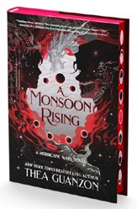

“Talasyn and Alaric must prepare for the Moonless Dark and the eruption of the Voidfell. This book is equally funny and heartbreaking as we find out more about their pasts, the present, and how it affects their actions. A stellar Hurricane Wars installment.”
—Lisa Kroger, Village Books, The Woodlands, TX

