January 8, 2025


For the week ending January 5, 2025 based on sales in hundreds of independent bookstores nationwide.
CHILDREN’S

RANK | SERIES

RANK | ILLUSTRATED

- Goodnight Moon
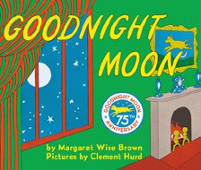

Margaret Wise Brown, Clement Hurd (Illus.), Harper,
$10.99
- The Snowy Day
Ezra Jack Keats, Viking Books for Young Readers,
$19.99
- Knight Owl and Early Bird
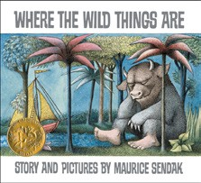

Christopher Denise, Christy Ottaviano Books, $18.99
- The Very Hungry Caterpillar
Eric Carle, World of Eric Carle, $10.99
- The Bakery Dragon
Devin Elle Kurtz, Knopf Books for Young Readers,
$18.99
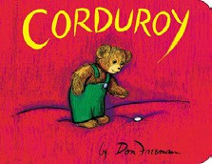

- I Am Glinda (Little Golden Book)
Mary Man-Kong, Elsa Chang (Illus.), Golden Books,
$5.99
- I Am Elphaba (Little Golden Book)
Mary Man-Kong, Elsa Chang (Illus.), Golden Books,
$5.99
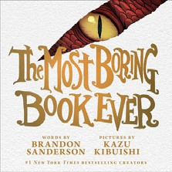

- Alice in a Winter Wonderland
Jan Brett, G.P. Putnam’s Sons Books for Young Readers, $19.99
- Knight Owl
Christopher Denise, Christy Ottaviano Books, $17.99
- Where the Wild Things Are
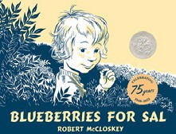

Maurice Sendak, Harper, $21.99
- Corduroy
Don Freeman, Viking Children’s Books, $7.99
- The Most Boring Book Ever Brandon Sanderson, Kazu Kibuishi (Illus.), Roaring Brook Press, $19.99
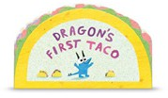

- Blueberries for Sal
Robert McCloskey, Puffin, $9.99
- Dragon’s First Taco
Adam Rubin, Daniel Salmieri (Illus.), Dial Books, $8.99
- The Mitten
Jan Brett, G.P. Putnam’s Sons Books for Young Readers, $9.99
  - Dog Man (hardcover)
Dav Pilkey, Graphix
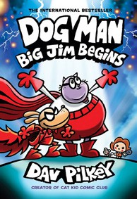

  - Diary of a Wimpy Kid (hardcover)
Jeff Kinney, Harry N. Abrams
  - Wings of Fire
Tui T. Sutherland, Mike Holmes (Illus.), Scholastic
  - The Wild Robot
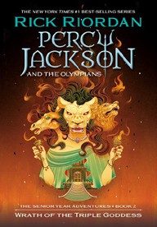

Peter Brown, Little, Brown Books for Young Readers
  - Percy Jackson and the Olympians
Rick Riordan, Hyperion
  - Elephant & Piggie (hardcover)
Mo Willems, Hyperion
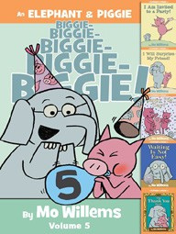

  - Keeper of the Lost Cities
Shannon Messenger, Aladdin
  - InvestiGators (hardcover)
John Patrick Green, First Second
  - The Bad Guys (paperback)
Aaron Blabey, Scholastic
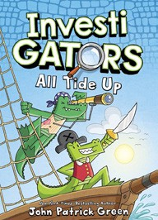

  - I Survived
Lauren Tarshis, Dave Shephard (Illus.), Scholastic

All Fiction Series titles are hardcover and
paperback unless noted.
Debut


Indies Introduce

OTHER CHILDREN’S INDIE FAVORITES
AGES 4 TO 8
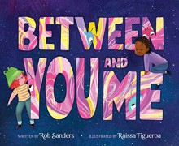

Between You and Me
Rob Sanders, Raissa Figueroa (Illus.), Clarion Books, $19.99 “Moving to a new place can be hard and frightening, but it can also be wondrous and fun like this uplifting picture book about new places, new friends, and new adventures.”
—Stephanie Staton, CoffeeTree Books, Morehead, KY

