RANK | FICTION
- Demon Copperhead
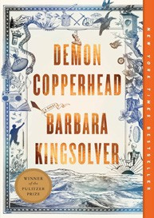



Barbara Kingsolver, Harper Perennial, $21.99
- Orbital
Samantha Harvey, Grove Press, $17
- The Frozen River
Ariel Lawhon, Vintage, $18
- Fourth Wing
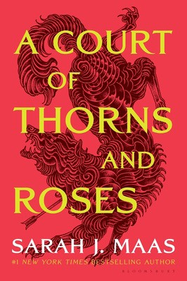

Rebecca Yarros, Entangled: Red Tower Books, $20.99
- A Court of Thorns and Roses
Sarah J. Maas, Bloomsbury Publishing, $19
- North Woods
Daniel Mason, Random House Trade Paperbacks, $18
- Tomorrow, and Tomorrow, and Tomorrow


Gabrielle Zevin, Vintage, $19
- Wicked
Gregory Maguire, William Morrow Paperbacks, $19.99
- The Berry Pickers
Amanda Peters, Catapult, $17.95
- Hello Beautiful
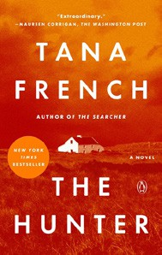

Ann Napolitano, Dial Press Trade Paperback, $18.99
- The Thursday Murder Club
Richard Osman, Penguin, $18
- The Hunter
Tana French, Penguin, $19
- The Best American Short Stories 2024


Lauren Groff, Heidi Pitlor (Eds.), Mariner Books,
$19.99
- The Vegetarian
Han Kang, Hogarth, $17
- The Housemaid
Freida McFadden, Grand Central, $12.99

OTHER PAPERBACK INDIE FAVORITES
The End of the World Is a Cul de Sac: Stories
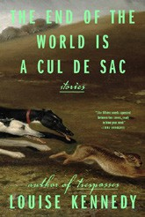

Louise Kennedy, Riverhead Books, $18
“Kennedy displays why she was able to make her name, writing with a delicateness that articulates a great love for these characters as they weave through domestic peril. Her ability to fit complex characters into a short window is remarkable.”
—Richard Dixon, Politics and Prose Bookstore, Washington, DC
January 1, 2025
For the week ending December 29, 2024 based on sales in hundreds of independent bookstores nationwide.
PAPERBACK

RANK | NONFICTION
  - The Backyard Bird Chronicles


Amy Tan, Knopf, $35
  - Braiding Sweetgrass
Robin Wall Kimmerer, Milkweed Editions, $20
  - On Tyranny
Timothy Snyder, Crown, $12
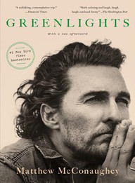

  - The Art Thief: A True Story of Love, Crime, and a Dangerous Obsession Michael Finkel, Vintage, $18
  - Say Nothing: A True Story of Murder and Memory in Northern Ireland
Patrick Radden Keefe, Vintage, $20
  - Greenlights
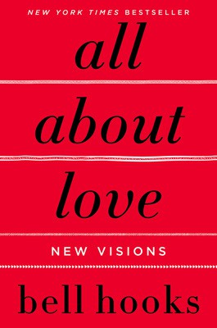

Matthew McConaughey, Crown, $20
  - All About Love: New Visions
bell hooks, Morrow, $16.99
  - The Hundred Years’ War on Palestine
Rashid Khalidi, Metropolitan Books, $19.99
  - Democracy Awakening: Notes on the State of America


Heather Cox Richardson, Penguin, $18
  - The Body Keeps the Score
Bessel van der Kolk, M.D., Penguin, $19
  - The 2025 Old Farmer’s Almanac
Old Farmer’s Almanac, $10.95
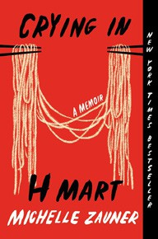

  - Emperor of Rome: Ruling the Ancient World
Mary Beard, Liveright, $21.99
  - The Field Guide to Dumb Birds of North America
Matt Kracht, Chronicle, $15.95
  - Crying in H Mart: A Memoir
Michelle Zauner, Vintage, $17
  - Killers of the Flower Moon
David Grann, Vintage, $18 Debut
On the Rise

MASS MARKET Indies Introduce
- 1984 George Orwell, Signet, $10.99
- The Way of Kings Brandon Sanderson, Tor, $12.99
- Mistborn: The Final Empire Brandon Sanderson, Tor, $10.99
- Dune Frank Herbert, Ace, $10.99
- Animal Farm George Orwell, Signet, $9.99
- Dune Messiah Frank Herbert, Ace, $9.99
- The Name of the Wind Patrick Rothfuss, DAW, $10.99
- The Exchange John Grisham, Vintage, $10.99
- The Hitchhiker’s Guide to the Galaxy Douglas Adams, Del Rey, $8.99
- The Left Hand of Darkness Ursula K. Le Guin, Ace, $10.99

