RANK | HARDCOVER

- The Serviceberry: Abundance and Reciprocity in the Natural World




Robin Wall Kimmerer, John Burgoyne (Illus.), Scribner, $20
- Be Ready When the Luck Happens: A Memoir
Ina Garten, Crown, $34
- Revenge of the Tipping Point
Malcolm Gladwell, Little, Brown and Company, $32


- The Message
Ta-Nehisi Coates, One World, $30
- Nexus: A Brief History of Information Networks from the Stone Age to AI Yuval Noah Harari, Random House, $35
- What I Ate in One Year
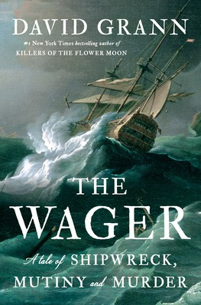

Stanley Tucci, Gallery Books, $35
- The Demon of Unrest
Erik Larson, Crown, $35
- The Wide Wide Sea
Hampton Sides, Doubleday, $35
- The Creative Act: A Way of Being
Rick Rubin, Penguin Press, $32


- The Wager
David Grann, Doubleday, $30
- Patriot: A Memoir
Alexei Navalny, Knopf, $35
- Cher: The Memoir, Part One
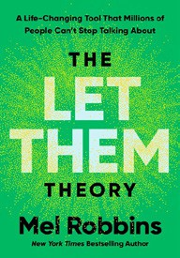

Cher, Dey Street Books, $36
- Atomic Habits
James Clear, Avery, $27
- Ottolenghi Comfort: A Cookbook
Yotam Ottolenghi, Ten Speed Press, $37.99
- The Let Them Theory: A Life-Changing Tool That Millions of People Can’t Stop Talking About

Mel Robbins, Hay House LLC, $29.99
January 1, 2025
For the week ending December 29, 2024 based on sales in hundreds of independent bookstores nationwide.
NONFICTION

RANK | PAPERBACK

  - The Backyard Bird Chronicles


Amy Tan, Knopf, $35
  - Braiding Sweetgrass
Robin Wall Kimmerer, Milkweed Editions, $20
  - On Tyranny
Timothy Snyder, Crown, $12


  - The Art Thief: A True Story of Love, Crime, and a Dangerous Obsession Michael Finkel, Vintage, $18
  - Say Nothing: A True Story of Murder and Memory in Northern Ireland
Patrick Radden Keefe, Vintage, $20
  - Greenlights
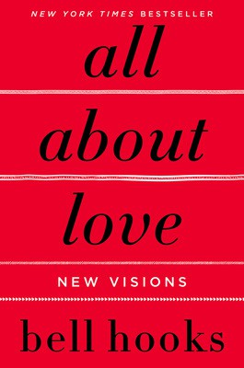

Matthew McConaughey, Crown, $20
  - All About Love: New Visions
bell hooks, Morrow, $16.99
  - The Hundred Years’ War on Palestine
Rashid Khalidi, Metropolitan Books, $19.99
  - Democracy Awakening: Notes on the State of America


Heather Cox Richardson, Penguin, $18
  - The Body Keeps the Score
Bessel van der Kolk, M.D., Penguin, $19
  - The 2025 Old Farmer’s Almanac
Old Farmer’s Almanac, $10.95
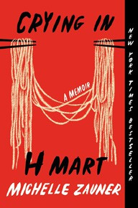

  - Emperor of Rome: Ruling the Ancient World
Mary Beard, Liveright, $21.99
  - The Field Guide to Dumb Birds of North America
Matt Kracht, Chronicle, $15.95
  - Crying in H Mart: A Memoir
Michelle Zauner, Vintage, $17
  - Killers of the Flower Moon
David Grann, Vintage, $18

Debut
On the Rise Indies Introduce

